AGREEMENT TO SALE

THIS AGREEMENT TO SALE is made and executed at Pune, on this _________ day of the month of ______________________________ in the year 2021.

BETWEEN

M/S. OM TIRUPATI DEVELOPERS
A Partnership Firm Registered under the
Indian Partnership Act, 1932,
having its Register Office at: 1552,
Near SaiMandir, Sainathnagar,
Mamurdi, Pune 412101.
PAN: AADFO9382N
Through its Partner & for self

MR. SAGAR OMPRAKASH AGARWAL
Age: 33 years, Occupation: Business

Hereinafter referred to as 'THE PROMOTER'

(which expression unless repugnant to the context or meaning thereof shall mean and include the firm its partners for the time being constituting the firm their respective executors, administrators, successors, assigns, etc.,)
…THE PARTY OF THE FIRST PART

AND

- MR. <<<CUSTOMERNAME>>>.
Age: <<<CUSTOMERAGE>>>Years, Occupation: <<<OCCUPATION>>>
[PAN: <<<PANCARDNO>>>] / [AADHAR: <<<Aadhaar_Card_No>>>]

RESIDING AT: <<<CUSTOMERADDRESS>>>.

- <<<COAPPLICANTTITLE>>>.<<<JC1>>>.
Age: <<<JC1AGE>>> Years, Occupation: . <<<JC1OCCUPATION>>>.
[PAN: . <<<PANNOJC1>>>] / [AADHAR: <<<JC1_Aadhaar_Card_No>>>]

RESIDING AT: <<<JC1_Address>>>

Hereinafter referred to as the ‘ALLOTTEE(S)'

(which expression unless repugnant to the context or meaning thereof shall mean and include his/her/their heirs, executors, administrators and assigns).

AND

1.MR. PARAG NATHABHAI MADHANI
Age about Adult, Occupation: Service

2. MR. BABAN JAGANATH KARANDE
Age: 46 years, Occupation: Service

3. MRS. SANGITA JAGDISH SANKPAL
Age about Adult, Occupation: Housewife

4. SMT. POONAM DEEPAK MARATHE
Age about Adult, Occupation: Housewife
For self and as guardian of Mansi

5. MRS. SUMAN UTTAM KUMBHAR
Age about Adult, Occupation: Housewife

6. MR. VISHAL NARENDRA GHODE
Age about Adult, Occupation: Business

7. MR. KESHAV BALAJI PAWAR
Age about Adult, Occupation: Business

8. MR. NAZIR ABDULMAJIT SHEKH
Age about Adult, Occupation: Business

9. MR. ABHIJIT BHASKAR THORAT
Age about Adult, Occupation: Housewife

10. MR. SUNIL YADAV NARKHADE
Age about Adult, Occupation: Business

11. MRS. ARCHANA SUNIL NARKHEDHE
Age about Adult, Occupation: Housewife

12. MRS. CHANDRAKANT ANNASAHEB SUTAR
Age about Adult, Occupation: Housewife

13. MR. ASHOK GUNDA PATIL
Age about Adult, Occupation: Business

14. MR. RAHUL ANANDRAO FARAKTE
Age about Adult, Occupation: Business

15. MR. PREM RISHALA DHILOD
Age about Adult, Occupation: Business

16. MR. SAGAR YUVRAJ PAWAR
Age about Adult, Occupation: Business

17. MR. VITTAL KISHAN THAMKE
Age about Adult, Occupation: Business
All through their Constituted Attorney

M/S. OM TIRUPATI DEVELOPERS
Through its Partner
MR. SAGAR OMPRAKASH AGARWAL

Hereinafter referred to as the 'CONSENTING PARTY' (which expression unless repugnant to the context or meaning thereof shall mean and include his/her/their heirs, executors, administrators and assigns).
…THE PARTY OF THE THIRD PART

WHEREAS the land at Survey No. 13 belonged to Mr. Dinkar Gopal Joglekar prior to the year 1944;

AND WHEREAS the said Mr. Dinkar Gopal Joglekar sold part of land out of Survey No. 13 to Mr. Ramchandra Govind Risvadkar vide Sale Deed dated 19.06.1944. In furtherance of the same the land sold to Mr. Ramchandra Govind Risvadkar was given Survey No. 13/2 and the land retained by the aforesaid land owners was given Survey No. 13/1. Accordingly the name of Mr. Ramchandra Govind Risvadkar was mutated on the 7/12 extract vide Mutation Entry No. 239;

AND WHEREAS the said Mr. Dinkar Gopal Joglekar died on 15.05.1956 leaving behind him Mr. Vasudev Dinkar Joglekar (son) and Mr. Prabhakar Dinkar Joglekar (son) as his legal heirs. In furtherance of the same their names were mutated on the 7/12 extract vide Mutation Entry No. 303;

AND WHEREAS the said Mr. Prabhakar Dinkar Joglekar died on 18.11.1958 leaving behind him Mr. Chandrakant Prabhakar Joglekar (son), Mr. Shashikant Prabhakar Joglekar (son), Mr. Shrikant Prabhakar Joglekar (son) and Smt. Shalinibai Prabhakar Joglekar (widow) as his legal heirs. In furtherance of the same their names were mutated on the 7/12 extract vide Mutation Entry No. 357;

AND WHEREAS the said Mr. Chandrakant Prabhakar Joglekar, Mr. Shashikant Prabhakar Joglekar, Mr. Shrikant Prabhakar Joglekar and Smt. Shalinibai Prabhakar Joglekar sold their share out of Survey No. 13/1 to Mr. Vasudev Dinkar Joglekar vide Sale Deed dated 05.12.1962. In furtherance of the same the name of Mr. Vasudev Dinkar Joglekar was mutated on the 7/12 extract vide Mutation Entry No. 390;

AND WHEREAS the said Mr. Vasudev Dinkar Joglekar sold part of land out of the Survey No. 13/1 to Mr. Vijay Shankar Shastrabudhe vide Sale Deed dated 16.02.1966. In furtherance of the same the land sold to Mr. Vijay Shankar Shastrabudhe was given Survey No. 13/1B and the land retained by the aforesaid land owner was given Survey No. 13/1A. Accordingly the name of Mr. Vijay Shankar Shastrabudhe was mutated on the 7/12 extract vide Mutation Entry No. 455;

AND WHEREAS the said Mr. Vasudev Dinkar Joglekar sold the land at Survey No. 13/1A to Mr. Abdul Wahidkhan Abdul Majidkhan vide Sale Deed dated 07.01.1969. In furtherance of the same the name of Mr. Abdul Wahidkhan Abdul Majidkhan was mutated on the 7/12 extract vide Mutation Entry No. 490;

AND WHEREAS the said Mr. Abdul Wahidkhan Abdul Majidkhan sold the land admeasuring about 60 R out of Survey No. 13/1A to Mr. Afzal Ibrahimkhan Pathan vide Sale Deed dated 26.07.1989. In furtherance of the same the land sold to Mr. Afzal Ibrahimkhan Pathan was given Survey No. 13/1A/4 and the land retained by the aforesaid land owners was given Survey No. 13/1A/1. Accordingly the name of Mr. Afzal Ibrahimkhan Pathan was mutated on the 7/12 extract vide Mutation Entry No. 1119;

AND WHEREAS in the aforesaid manner Mr. Afzal Ibrahimkhan Pathan became the absolute owner of the land admeasuring about 60 R bearing Survey No. 13/1A/4;

AND WHEREAS the said Mr. Afzal Ibrahim Khan Pathan sold the following land out of Survey No.13/1A/4 to following owners vide Multiple Sale Deeds:

Name of Owners | Sale Deed dated | Serial No. | Area | Mutation Entry No.
Mrs. Rukdan Ibhrahim Khan and others | 01.12.1997 | 1463/1997 | 15 R | 2241
Mr. Namdev Krushana Tilekar | 01.12.1998 | 8522/1998 | 4 R | 2493
Mr. Rajan Nathu Sable | 01.12.1998 | 8523/1998 | 5 R | 2494
Mr. Abhay Kumar Galiya | 01.12.1998 | 8524/1998 | 5 R | 2495
Mr. Dattatray Malhari Taras | 01.12.1998 | 8525/1998 | 5 R | 2496
Mr. Nandkumar M. Lunawat | 01.12.1998 | 8526/1998 | 4.5 R | 2497
Mr. Sadanand Shankar Ghorpade | 01.07.1999 | 4598/1998 | 2708 sq.ft | 2613

AND WHEREAS the said Mr. Rajan Nathu Sable sold land admeasuring about 2.25 R to Mr. Dada Jagannath Thomre vide Sale Deed dated 26.05.2005, which is duly registered in the office of Sub Registrar Haveli No. 18, at Serial No. 4651/2005. In furtherance of the same the name of Mr. Dada Jagannath Thomre was mutated on the 7/12 extract vide Mutation Entry No. 3351;

AND WHEREAS the said Mr. Dada Jagannath Thomre sold land admeasuring about 1.25 R to Mr. Sanpat Ramchandra Shende vide Sale Deed dated 02.09.2009, which is duly registered in the office of Sub Registrar Haveli No. 14, at Serial No. 4186/2009.In furtherance of the same the name of Mr. Sanpat Ramchandra Shende was mutated on the 7/12 extract vide Mutation Entry No. 4061;

AND WHEREAS the said Mr. Sanpat Ramchandra Shende sold land admeasuring about 1.25 R to Mr. Suhas Digambar Sarate vide Sale Deed dated 31.12.2010, which is duly registered in the office of Sub Registrar Haveli No. 14, at Serial No. 11738/2010.In furtherance of the same the name of Mr. Suhas Digambar Sarate was mutated on the 7/12 extract vide Mutation Entry No. 4644;

AND WHEREAS the said Mr. Suhas Digambar Sarate sold land admeasuring about 1.25 R to Mr. Iranna Krushanpa Raichurkar, Mr. Keshaw Vishwanath Salunke and Mr. Santosh Prabhakar Taras vide Sale Deed dated 22.08.2011, which is duly registered in the office of Sub Registrar Haveli No. 14, at Serial No. 8382/2011;

AND WHEREAS the said Mr. Keshaw Vishwanath Salunke sold his share to Mr. Iranna Krushanpa Raichurkar and Mr. Santosh Prabhakar Taras vide Sale Deed dated 12.11.2012, which is duly registered in the office of Sub Registrar Haveli No. 14, at Serial No. 9862/2012;

AND WHEREAS said Mr. Abhay Kumar Galiya sold land admeasuring about 5R out of the said land to Mr. Macchindra D. Late and Mrs. Alka M. Late vide Sale Deed dated 30.12.1999, which is duly registered in the office of Sub Registrar Haveli, at Serial No. 9877/1999. In furtherance of the same the name of Mr. Macchindra D. Late and Mrs. Alka M. Late was mutated on the 7/12 extract vide Mutation Entry No. 2663;

AND WHEREAS the said Mr. Nandkumar M. Lunawat sold land admeasuring about 2300 sq. ft. out of the said land to Mr. Pradip Mahadev Sonar vide Sale Deed dated 29.05.2000, which is duly registered in the office of Sub Registrar Haveli, at Serial No. 4249/2000. In furtherance of the same Mr. Pradip Mahadev Sonar was mutated on 7/12 extract vide Mutation Entry No. 3299;

AND WHEREAS the said Mrs. Rukdan Ibhrahim Khan died on 16.05.2004 leaving behind her Mr. Yunus Ibhrahim Khan (son), Mr. Barakat Ibhrahim Khan (son), Mr. Sikandar Ibhrahim Khan (son), Mr. Afzal Ibhrahim Khan (son), Mr. Akbar Ibhrahim Khan (son), Mrs. Feroza Anvar Khan (daughter) and Mrs. Farida R. Khan (daughter) as her legal heirs. In furtherance of the same their name was mutated on the 7/12 extract vide Mutation Entry No. 3349;

AND WHEREAS the said Mr. Yunus Ibhrahim Khan, Mr. Barakat Ibhrahim Khan, Mr.Sikandar Ibhrahim Khan, Mr. Afzal Ibhrahim Khan, Mr. Akbar Ibhrahim Khan, Mrs. Feroza Anvar Khan and Mrs. Farida R. Khan assigned development rights of land admeasuring about 26822 sq.ft i.e. 2493 sq. mtr out of Survey No.13/1A/4 in favour of Mr. Giridhari Chandwaani and Mrs. Vineeta D. Sharma (partners of M/s. Goldfinger Ventures) vide Development Agreement dated 12.12.2006, which is duly registered in the office of Sub Registrar Haveli No. 17, at Serial No. 10024/2006 and Power of Attorney dated 12.12.2006, which is duly registered in the office of Sub Registrar Haveli No. 17, at Serial No. 10025/2006;

AND WHEREAS the said Mr. Sadanand Shankar Ghorpade, Mr. Namdev Krushna Tilekar, Mr. Rajan Nathu Sable, Mr. Dattatray Malhari Taras, Mr. Nandkumar M. Lunawat, Mr. Pradip Mahadev Sonar, Mr. Macchindra D. Late, Mrs. Alka M. Late assigned development rights of land admeasuring about 25177.68 sq. ft. i.e 2340 sq. mtr out of Survey No.13/1A/4 in favour of Mr. Giridhari T. Chandwani and Mrs.Vineeta D. Sharma (partners of M/s. Goldfinger Ventures) vide Development Agreement dated 12.12.2006, which is duly registered in the office of Sub Registrar Haveli No. 17, at Serial No. 10028/2006 and Power of Attorney dated 12.12.2006, which is duly registered in the office of Sub Registrar Haveli No. 17, at Serial No. 10029/2006;

AND WHEREAS the said Mr. Sadanand Shankar Ghorpade, Mr. Namdev Krushna Tilekar, Mr. Rajan Nathu Sable, Mr. Dattatray Malhari Taras, Mr. Nandkumar M. Lunawat, Mr. Pradip Mahadev Sonar, Mr. Macchindra D. Late, Mrs. Alka M. Late, Mr. Afzal Ibrahim Khan Pathan, Mr. Yunus Ibhahim Khan, Mr. Barkat Ibhrahim Khan, Mr. Sikandar Ibhrahim Khan, Mr. Akbar Ibhrahim Khan, Mr. Feroza Anvar Khan, Mrs. Farida R. Khan through their Power of Attorney holder and for themselves Mr. Giridhari T. Chandwani and Mrs. Vineeta D. Sharma and Mr. Afzal Ibhrahim Khan Pathan with the consent of M/s. Goldfinger Ventures sold the following land vide Multiple Sale Deed:

Name of the Owner | Haveli No | Sale Deed  dated | Serial No. | Area  in  sq. ft. | Mutation Entry No.
Mr. Dattatray Rajaram Bodke and Mrs. Sangita Bhagwan Bodke | 14 | 21.10.2010 | 9065/2010 | 17000 | 4415
Mrs.Suman Uttam Kumbhar | 14 | 21.10.2010 | 9063/2010 | 1000 | 4441
Mr. Rahul Anandrao Farakte | 14 | 21.10.2010 | 9053/2010 9053/2010 | 1410 | 4445
Mr.Suresh Shankaar Gharal | 14 | 21.10.2010 | 9061/2010 | 1000 | 4446
Mrs.Sangita Jagdish Sankpal | 14 | 21.10.2010 | 9051/2010 | 1000 | 4447
Mr. Sandip Dnyaneshwar Gopale | 14 | 02.11.2010 | 9571/2010 | 1670 | 4448
Mr. Vinit Narendra Ghode | 14 | 02.11.2010 | 9573/2010 | 1255 | 4450
Mr. Chandrakant Annasaheb Sutar and Mr. Ashok Gunda Patil | 14 | 18.11.2010 | 9924/2010 | 1910 | 4451
Mr.Ajitkumar Tukaram Pawar | 14 | 19.10.2010 | 9062/2010 | 1250 | 4453
Mr. Prem Rishala Dhilod | 14 | 21.10.2010 | 9058/2010 | 1000 | 4454
Mr.Nazir Abdulmajit Shekh | 14 | 02.11.2010 | 9575/2010 | 1500 | 4455
Mr.Keshav Balaji Pawar | 14 | 02.11.2010 | 9576/2010 | 1255 | 4457
Mr.Dipak Shivaji Marathe | 14 | 02.11.2010 | 9574/2010 | 1255 | 4458
Mrs.Archana Sunil Narkhedhe | 14 | 02.11.2010 | 9572/2010 | 945 | 4460
Mr.Sunil Yadav Narkhadebab | 14 | 19.08.2010 | 9048/2010 | 1900 | 4461
Mr. Sagar Yuvraj Pawar | 14 | 21.10.2010 | 9054/2010 | 1410 | 4448
Mr. Rahul Mahadev Patil | 14 | 21.10.2010 | 9055/2010 | 6000 | 4634

AND WHEREAS the said Mr. Dattatray Rajaram Bodke and Mrs. Sangita Bhagwan Bodke sold land admeasuring about 2000 sq. ft. to Mr. Baban Jaganath Karande vide Sale Deed dated 28.12.2010, which is duly registered in the office of Sub Registrar Haveli No. 14, at Serial No. 11539/2010. In furtherance of the same Mr. Baban Jaganath Karande name was mutated on the 7/12 extract vide Mutation Entry No. 4577;

AND WHEREAS out of aforesaid owner Mr. Dattatray Rajaram Bodke and Mrs. Sangita Bhagwan Bodke sold land admeasuring about 4000 sq. ft. out of said land to Mr. Parag Nathabhai Madhani vide Sale Deed dated 27.12.2010, which is duly registered in the office of Sub Registrar Haveli No. 14, at Serial No. 11538/2010. In furtherance of the same Mr. Parag Nathabhai Madhani name was mutated on the 7/12 extract vide Mutation Entry No. 4584;

AND WHEREAS the said Mr. Sandip Dnyaneshwar Gopale sold land admeasuring about 1000 sq. ft. to Mr. Vilas Pandurang Khatal and Mr. Babari Jagannath Methkari vide Sale Deed dated 31.12.2010, which is duly registered in the office of Sub Registrar Haveli No. 14, at Serial No. 11739/2010. In furtherance of the same Mr. Baban Jaganath Karande name was mutated on the 7/12 extract vide Mutation Entry No. 4684;

AND WHEREAS the said Mr. Vinit Narendra Ghode died on 06.09.2012 leaving behind him Smt. Vidhi Vinit Ghode (widow) as his only legal heirs. In furtherance of the same Smt. Vidhi Vinit Ghode name was mutated on the 7/12 extract vide Mutation Entry No. 5118;

AND WHEREAS the said Smt. Vidhi Vinit Ghode sold land admeasuring about 1255 sq. ft. to Mr. Vishal Narendra Ghode vide Sale Deed dated 10.10.2013, which is duly registered in the office of Sub Registrar Haveli No. 5, at Serial No. 9059/2013. In furtherance of the same Mr. Vishal Narendra Ghode name was mutated on the 7/12 extract vide Mutation Entry No. 5279;

AND WHEREAS the said Mr. Suresh Shankaar Gharal and Mr. Ajitkumar Tukaram Pawar sold land admeasuring about 1125 sq. ft. to Mr. Vittal Kisanrao Thamke vide Sale Deed dated 30.08.2012, which is duly registered in the office of Sub Registrar Haveli No. 17, at Serial No. 8775/2012. In furtherance of the same Mr. Vittal Kisanrao Thamke name was mutated on the 7/12 extract vide Mutation Entry No. 5181;

AND WHEREAS the said Mr. Suresh Shankaar Gharal and Mr. Ajitkumar Tukaram Pawar sold land admeasuring about 1125 to Mr. Vittal Keshav Thamke vide Sale Deed dated 30.08.2012, which is duly registered in the office of Sub Registrar Haveli No. 17, at Serial No. 8778/2012. In furtherance of the same Mr. Vittal Keshav Thamke name was mutated on the 7/12 extract vide Mutation Entry No. 5181;

AND WHEREAS the said Mr. Suresh Shankaar Gharal and Mr. Ajitkumar Tukaram Pawar sold land admeasuring about 1125 to Mr. Abhijit Bhaskar Thorat vide Sale Deed dated 30.08.2012, which is duly registered in the office of Sub Registrar Haveli No. 17, at Serial No. 8779/2012. In furtherance of the same Mr. Abhijit Bhaskar Thorat name was mutated on the 7/12 extract vide Mutation Entry No. 5182;

AND WHEREAS the said Mr. Rahul Mahadev Patil sold land admeasuring about 6000 sq. ft. to Mr. Iranna Krushanpa Raichurkar and Mr. Santosh Prabhakar Taras vide Sale Deed dated 21.08.2013, which is duly registered in the office of Sub Registrar Haveli No. 14, at Serial No. 6264/2013. In furtherance of the same Mr. Iranna Krushanpa Raichurkar and Mr. Santosh Prabhakar Taras name was mutated on the 7/12 extract vide Mutation Entry No. 5364;

AND WHEREAS the following owners assigned development rights of the said land in favour of M/s. Om Tirupati Developers in the following manner:

Land Owner | Date | SRO No. | Development Agreement | Power of Attorney | Area in sq. ft
Mr. Parag Nathabhai Madhani | 30.06.2014 | 24 | 5228/2014 | 5229/2014 | 4000
Mr.Baban Jaganath Karande | 16.07.2014 | 24 | 5775/2014 | 5776/2014 | 2000
Mrs. Sangita Jagdish Sankpal | 26.04.2014 | 24 | 4079/2014 | 4080/2014 | 1000
Mr. Dipak Shivaji Marathe, Mrs. Suman Uttam Kumbhar, Mr. Vishal Narendra Ghode, Mr.Keshav Balaji Pawar, Mr. Nazir Abdulmajit Shekh, Mr. Abhijit Bhaskar Thorat | 11.06.2014 | 5 | 4867/2014 | 4868/2014 | 7390
Mr. Sunil Yadav Narkhade, Mrs. Archana Sunil Narkhedhe, Mrs. Chandrakant Annasaheb Sutar and Mr. Ashok Gunda Patil | 18.06.2014 | 24 | 4868/2014 | 4869/2014 | 4755
Mr. Rahul Anandrao Farakte | 14.07.2015  27.07.2015 | 24 | 5730/2015  read with correction Deed  6092/2015  (correction Deed) | 5731/2015 | 1410
Mr. Prem Rishala Dhilod | 13.07.2015 | 24 | 5710/2015 | 5711/2015 | 1000
Mr. Sagar Yuvraj Pawar | 05.11.2015 | 24 | 8952/2015 | 8953/2015 | 1410
Mr. Vittal Keshav Thamke | 06.01.2015 | 24 | 280/2015 | 281/2015 | 1125

AND WHEREAS the said Mr. Dipak Shivaji Marathe died on 25.09.2015 leaving behind him Smt. Poonam Dipak Marathe (widow) and Miss. Mansi Dipak Marathe (daughter) as his legal heirs. In furtherance of the same their names were mutated on the 7/12 extract vide Mutation Entry No. 5706;

AND WHEREAS the said Smt. Poonam Dipak Marathe forself and as guardian of Miss. Mansi Dipak Marathe confirmed the aforesaid Development Agreement dated 11.06.2014, which is duly registered in the office of Sub Registrar Haveli No. 5, at Serial No. 4867/2014 and Power of Attorney dated 11.06.2014, which is duly registered in the office of Sub Registrar Haveli No. 5, at Serial No. 4868/2014 in favour of M/s. Om Tirupati Developers vide Consent Deed dated 11.02.2016, which is duly registered in the office of Sub Registrar Haveli No. 24, at Serial No. 1262/2016 on 15.03.2016 and Power of Attorney dated 11.02.2016, which is duly registered in the office of Sub Registrar Haveli No. 24, at Serial No.1263/2016 on 15.03.2016;

AND WHEREAS the said Mr. Vilas Pandurang Khatal and Mr. Babari Jagannath Methkari sold 1000 sq. ft. out of the said land to M/s. Om Tirupati Developers vide Sale Deed dated 02.03.2015, which is duly registered in the office of Sub Registrar Haveli No. 24, at Serial No. 1825/2015;

AND WHEREAS in the aforesaid manner M/s. Om Tirupati Developers i.e. Promoter partly acquired development rights and Mr. Irranna Krishnappa Raichurkar and Mr. Santosh Prabhakar Taras (Partners of M/s. Om Tirupati Developers) and M/s. Om Tirupati Developers i.e. Promoter became absolute owner of the land which is more particularly described in the 'Schedule IA' written hereunder (hereinbefore and hereinafter called and referred to as the 'entire said land' for the sake and brevity and convenience);

AND WHEREAS the Promoter herein further has decided to construct Four building/wings in the PHASE I, on the land which is more particularly described in the 'Schedule IB' written hereunder (hereinbefore and hereinafter called and referred to as the 'project land' for the sake and brevity and convenience), which project land is part of the entire said land;

AND WHEREAS the Promoter has entered into a standard Agreement with an Architect registered with the Council of Architects and such Agreement is as per the Agreement prescribed by the Council of Architects;

AND WHEREAS the Promoter has appointed a structural Engineer for the preparation of the structural design and drawings of the buildings and the Promoter accepts the professional supervision of the Architect and the structural Engineer till the completion of the building/buildings;

AND WHEREAS the Pimpri Chinchwad Municipal Corporation has sanctioned building plans pertaining to the present project vide Commencement Certificate No. B.P./Mamurdi/7/2016 dated 21.03.2016 and revised Commencement Certificate No. B.P./Mamurdi/24/2021 dated 30.07.2021.

AND WHEREAS the Additional Collector, Pune granted permission for the Non Agricultural use of the part of the said land, vide its Sanad Order dated 27.10.2016 in case no. PCMC/SR/Sanad/266/15;

AND WHEREAS the Promoter has registered the Project under the provisions of the Real Estate (Regulation &Development) Act, 2016 with the Real Estate Regulatory Authority bearing Certificate No. P52100022252

AND WHEREAS the Allottee(s) has applied to the Promoter for allotment of flat more particularly described in the ‘Schedule II’ written hereunder (herein after called and referred to as the ‘said flat’ for the sake of brevity and convenience) from the Promoter and the Promoter has agreed to allot the said flat to the Allottee(s) herein on the basis of the carpet area and on the terms and conditions mentioned herein below;

AND WHEREAS the Parties relying on the confirmations, representations and assurances of each other to faithfully abide by all the terms, conditions and stipulations contained in this Agreement and all applicable laws, are now willing to enter into this Agreement on the terms and conditions appearing hereinafter;

AND WHEREAS, under section 13 of the said Act the Promoter is required to execute a written Agreement for sale of the said flat with the Allottee(s), being in fact these presents and also to register said Agreement under the Registration Act, 1908;

NOW THEREFORE, THIS AGREEMENT WITNESSETH AND IT IS HEREBY AGREED BY AND BETWEEN THE PARTIES HERETO AS FOLLOWS:

- DEFINITIONS:

  - Unless the context herein otherwise provides, the following terms shall have the meaning assigned thereto:

  - ‘agreement’ means this agreement, including the schedules and annexures attached hereto and any agreed amendments thereto.

  - ‘approvals’ shall mean and include all licenses, permits, approvals, clearances, sanctions and consents obtained/to be obtained from or granted/to be granted by the competent authorities to develop the said land and/or the said Project or any part thereof and/or sell/transfer of the said flat but not be limited to the sanctioned layout plans, Commencement Certificates, Revised Commencement Certificates and Completion Certificates, etc. as mentioned hereto.

  - ‘concerned local authority’ shall mean and include the authorities within the local limits of the said land, who are empowered by law to grant various no objection certificates, permissions, sanctions, approvals, certificates related to commencement and/or completion of construction on the said land.

  - ‘RERA’ shall mean Real Estate (Regulation and Development) Act, 2016 and any amendments made thereto from time to time.

  - ‘PCMC’ shall mean Pimpri-Chinchwad Municipal Corporation i.e. the Sanctioning Authority.

  - ‘Person’ means any individual, proprietary firm, partnership firm, limited liability partnership firm, corporation, company, unincorporated organization, association of persons, trust or other entity including a government or a political sub-division or an agency or instrumentality thereof.

  - ‘Plan(s)’ shall mean, the building plans sanctioned or to be sanctioned by PCMC.

  - ‘Project land’ shall mean land more particularly described in the Schedule I written hereunder on which the Building(s) as registered under RERA is/are being constructed.

  - ‘said flat’ is more particularly described in the Schedule II written hereunder.

  - 'carpet area' of the said flat means the net usable floor area of the said flat, excluding the area covered by the external walls, areas under services shafts (if any) and exclusive attached terrace/balcony (if any) appurtenant to the said flat for exclusive use of the Allottee(s) but includes the area covered by the internal partition walls of the flat. Allottee(s) is aware that due to the skirting and variation in plaster, the carpet area varies. The variation may be approximately three percent.

  - ‘Proportionate share’: shall mean proportion to the carpet area of the said flat to the total carpet area of all the flats in the Project.

- INTERPRETATION:

  - Headings to clauses, sub-clauses and paragraphs are for information only and shall not form part of the operative provisions of this Agreement or the Schedules and shall be ignored in construing the same.

  - In this Agreement, unless inconsistent with the context or meaning thereof, reference to the singular includes a reference to the plural and vice versa, and reference to any gender includes a reference to all other genders.

  - The words ‘hereof’, ‘herein’ and ‘hereunder’ and words of similar import, when used generally in this Agreement, refer to this Agreement as a whole and not to any particular provision of this Agreement.

  - Where a word or phrase is defined, other parts of speech and grammatical forms of that word or phrase shall have the corresponding meanings.

  - Any reference to ‘writing’ includes printing, typing, lithography and other means of reproducing words in visible form.

  - In construing this Agreement references to Recitals, Sections, Clauses, Annexures or Schedules are references to Recitals, Sections, Clauses, Annexures or Schedules of and to this Agreement. The Recitals, Schedules and annexures contained herein shall constitute an integral operative part of this Agreement.

  - Reference to any law or to any provision thereof shall include references to any such law as it may, after the date hereof, from time to time, be amended, supplemented or re-enacted, and any reference to statutory provision shall include any subordinate legislation rules and regulations framed thereunder from time to time under that provision.

  - Reference to the word ‘include’ and ‘including’ shall be construed without limitation.

  - Any reference to the masculine, the feminine and the neutral shall include each other.

  - In determination of any period of days for the occurrence of an event or the performance of any act or thing shall be deemed to be exclusive of the day on which the event happens or the act or thing is done and if the last day of the period is not a working day, then the period shall include the next following working day.

- AGREEMENT:

  - The Allottee(s) hereby agree(s) to purchase from the Promoter and the Promoter hereby agree(s) to sell to the Allottee(s) the said flat on basis of carpet area being Apartment bearing No. “<<<UNITNAME>>>”, on the <<<FLOOR>>> Floor, in the Building No. “<<<BUILDING>>>” of the project known as “MAGIA AVENUE PHASE 1” (hereinafter referred to as “the said Apartment” / “the Said Flat”) for the consideration of Rs. <<<AGGPAID>>>/- (Rupees <<<AGGPAIDTEXT>>> Only) including all other expenses and taxes mentioned in these presents.

  - The present Agreement shall supersede and prevail over all other prior communications, writings and/or cost sheets, agreed and/or executed by and between the parties.

  - The Promoter has the right to enter into this Agreement and has not committed or omitted to perform any act or thing, whereby the right, title and interest of the Allottee(s) created herein, may prejudicially be affected.

  - The Promoter has not entered into any agreement or any arrangement with any person with respect to the project land, including the Project and the said flat which will, in any manner, affect the rights of Allottee(s) under this Agreement;

  - The Promoter confirms that the Promoter is not restricted in any manner whatsoever from selling the said flat to the Allottee(s) in the manner contemplated in this Agreement.

- CONSIDERATION:

  - The aforesaid consideration has been duly negotiated and accepted by the Allottee(s) and the same being concessional and discounted price of the said flat, the Allottee(s) has agreed to pay the total agreed consideration in the manner mentioned herein below:

Amount | Percentage | Stage of Payments
Rs. <<<AgreementValue_10_Per>>>/- | 10% | At the time of Booking
Rs. <<<AgreementValue_10_Per>>>/- | 10% | On or before execution of the present Agreement.
Rs.<<<AgreementValue_15_Per>>>/- | 15% | At the time of Plinth
Rs.<<<AgreementValue_5_Per>>>/- | 5% | At the time of commencement of First Slab
Rs.<<<AgreementValue_5_Per>>>/- | 5% | At the time of commencement of Second Slab
Rs.<<<AgreementValue_5_Per>>>/- | 5% | At the time of commencement of Third Slab
Rs.<<<AgreementValue_5_Per>>>/- | 5% | At the time of commencement of Fourth Slab
Rs.<<<AgreementValue_5_Per>>>/- | 5% | At the time of commencement of Fifth Slab
Rs.<<<AgreementValue_5_Per>>>/- | 5% | At the time of commencement of Sixth Slab
Rs.<<<AgreementValue_5_Per>>>/- | 5% | At the time of commencement of Seventh Slab
Rs.<<<AgreementValue_5_Per>>>/- | 5% | At the time of commencement of Eighth slab
Rs.<<<AgreementValue_5_Per>>>/- | 5% | At the time of commencement of brick work
Rs.<<<AgreementValue_5_Per>>>/- | 5% | At the time of commencement of plaster work
Rs.<<<AgreementValue_10_Per>>>/- | 10% | At the time of commencement of flooring
Rs.<<<AgreementValue_5_Per>>>/- | 5% | At the time of commencement of possession or on after receipt of occupancy certificate or completion certificate
Rs. <<<AGREEMENTVALUE>>> | TOTAL CONSIDERATION (100%)

  - The Allottee(s) herein shall pay the aforesaid amount on the due date or within seven days from the Promoter giving the written intimation to the Allottee(s) calling upon the Allottee(s) to make the payment.

  - It is hereby agreed that the time for payment as specified above is the essence of this contract and on failure of the Allottee(s) to pay the same on due dates, it shall be deemed that the Allottee(s) has/have committed breach of this Agreement and in that case the Promoter shall be entitled to take necessary action against the Allottee(s).

  - The Allottee(s) agree(s) not to question or challenge the said discounted consideration, the same been agreed on lump-sum basis after considering all aspects and other terms of the agreement.

  - Payment of any instalment, if made in advance, shall be adjusted to the instalments as mentioned herein above. No interest shall be paid by the Promoter for such advance payments made by the Allottee(s) or Housing Finance Companies/Banks, etc., as the aforesaid total agreed consideration is arrived considering the fact that the Allottee(s) has/have accepted the aforesaid stages of payment.

  - The total agreed consideration is escalation-free, save and except escalations/increases, due to increase on account of development charges payable to the Competent Authority and/or any other increase in charges which may be levied or imposed by the Competent Authority, Local Bodies/Government from time to time. The Promoter undertakes and agrees that while raising a demand on the Allottee(s) for increase in development charges, cost or levies imposed by the Competent Authorities etc., the Promoter shall enclose the said notification, order, rule, regulation, etc. published/issued in that behalf to that effect along with the demand letter being issued to the Allottee(s), which shall only be applicable on subsequent payments.

  - The Promoter shall confirm the final carpet area that has been allotted to the Allottee(s) after the construction of the Building is complete and the occupancy certificate is granted by the Competent Authority, by furnishing details of the changes, if any, in the carpet area, subject to a variation cap of three percent. The total price payable for the carpet area shall be recalculated upon confirmation by the Promoter. If there is any reduction in the carpet area within the defined limit then Promoter shall refund the excess money paid by Allottee(s) within forty-five days with annual interest at the rate specified under RERA from the date when such an excess amount was paid by the Allottee(s). If there is any increase in the carpet area allotted to Allottee(s), the Promoter shall demand additional amount from the Allottee(s) as per the next milestone of the Payment Plan. All these monetary adjustments shall be made at the same rate per square meter as agreed in this Agreement.

  - The Allottee(s) authorize(s) the Promoter to adjust/appropriate all payments made by the Allottee(s) under any head(s) of dues against lawful outstanding, if any, in the Allottee(s) name as the Promoter may in its sole discretion deem fit and the Allottee(s) undertakes not to object/demand/direct the Promoter to adjust his payments in any manner.

  - The deduction of amount made by the Allottee(s) on account of Tax Deducted at Source (TDS) as may be required under prevailing law while making any payment to the Promoter under this Agreement shall be acknowledged/credited by the Promoter, only upon Allottee(s) submitting original TDS certificate and the amount mentioned in the certificate is reflected on the Income Tax Department website. Provided further that at the time of handing over the possession of the flat, if any such certificate is not produced, the Allottee(s) shall pay equivalent amount as interest free deposit with the Promoter, which deposit shall be refunded by the Promoter on the Allottee(s) producing such certificate within 4 months of the possession. Provided further that in case the Allottee(s) fails to produce such certificate within the stipulated period of 4 months, the Promoter shall be entitled to appropriate the said deposit against the receivable from the Allottee(s).

- MODE OF PAYMENT:

The Allottee(s) shall make all the payments by local Account Payee cheques, demand draft, RTGS, NEFT or by any other mode of online payment in favour of ‘M/S. OM TIRUPATI DEVELOPERS’ payable at Pune or at par. Only after the amount has been credited to the bank account of the Promoter, the Promoter shall give effect of the same to the account of the Allottee(s) with such amount after deducting the commission of the Bank (if any) charged by the bank of the Promoter.

- DELAY IN PAYMENT:

  - The Allottee(s) shall make timely payments of the instalment and other dues payable by the Allottee(s) and meeting the other obligations under the Agreement. Time is essence for the aforesaid payment.

  - Without prejudice to the right of the Promoter, to take action for breach arising out of the delay in the payment of the instalments on the due dates, the Allottee(s) shall be bound and liable to pay interest at the rate of the State Bank of India's highest Marginal Cost of Lending Rate plus two percenton all the amounts which become due and payable by the Allottee(s) to the Promoter till the date of actual payment. Provided that in case the State Bank of India's marginal Cost of Lending Rate is not in use it would be replaced by such benchmark lending rates which State Bank of India may fix from time to time for lending to the general public.

  - Provided that tender of the principle amounts and interest or tender of the interest and expenses thereof, shall not itself be considered as waiver of the right of the Promoter under this Agreement, nor shall it be construed as acceptance of the delay by the Promoter.

- TITLE:

  - The Promoter has made full and true disclosure to the Allottee(s) of the title of the said land as well as the encumbrances and litigations, presently known to the Promoter. The Promoter has also disclosed to the Allottee(s) nature of its right, title and interest to construct building(s) and to develop the said land. The Promoter has also given inspection of all the relevant documents as specified under RERA and MOFA. The Allottee(s) having acquainted with all the facts and rights of the Promoter pertaining to the said land has entered into this Agreement.

  - The Promoter has clear and marketable title free from encumbrances with respect to the project land and has the requisite rights to carry out development upon the project land and also has actual, physical and legal possession of the project land for the implementation of the Project.

  - There are no litigations pending before any Court of law with respect to the project land or Project except if any disclosed in the title report.

  - No notice from the Government or any other local body or authority or any legislative enactment, government ordinance, order, notification (including any notice for acquisition or requisition of the project land) has been received or served upon the Promoter in respect of the project land and/or the Project.

  - The Promoter herein had also requested the Allottee(s) to carry out the search and to investigate the title of the said land. The Allottee(s) hereinafter has/have investigated the title of the Promoter to the said land and after being completely satisfied has/have entered into the present Agreement. The Allottee(s) henceforth shall not be entitled to challenge or question the title and the right/authority of the Promoter in respect of the said land and to enter into this agreement.

- SANCTIONED BUILDING PLAN:

  - The Promoter herein has lawful rights and has obtained requisite approvals from the concerned local authority(s) in respect of the plans, the specifications, elevations, sections of the said building(s)to carry out development of the Project and shall obtain the balance and requisite approvals from various authorities from time to time, so as to obtain Building Completion Certificate or Occupancy Certificate of the said Building.

  - The Promoter herein shall construct or get constructed and complete the construction of the said building(s) on the said land in accordance with the plans, designs approved or to be approved by the concerned authority, which have been seen by the Allottee(s), subject to such alterations, revisions and modifications as the Promoter in its sole discretion may think fit and necessary or may be required by the concerned local authority/Government to be made in it or any of it.

  - The Promoter hereby agrees to observe, perform and comply with all the terms, conditions, stipulations and restrictions, if any, which may have been imposed by the concerned local authority at the time of sanctioning the said plans or thereafter and shall, before handing over possession of the said flat to the Allottee(s), obtain from the concerned local authority occupancy and/or completion certificates in respect of the said flat.

  - The Promoter shall have to obtain prior consent in writing of the Allottee(s) if such alterations and/or modifications adversely and materially affect the internal layout of the said flat. The Allottee(s) herein shall have no right to withhold or refuse such permission without any reasonable cause and shall give such permission as and when required by the Promoter herein.

  - Promoters have disclosed the full potential of development of the said land and the Allottee(s) hereby gives irrevocable and specific consent to local planning or competent authorities to revise any change as the Promoters may deem fit to suit the development potential.

  - The Allottee(s) hereby gives irrevocable and specific consent to the Promoter foramalgamating adjoining plot(s) and submitting revised building plans for any new building(s) on any such amalgamated plot(s).

  - The Allottee(s) hereby give(s) irrevocable consent to the Promoter herein to make such alterations, modifications and revisions in the sanctioned plan(s) of the said building(s) as the Promoter in its sole discretion thinks fit and proper and/or such modifications, revisions and alterations which are necessary in pursuance of any law, rules, regulations, order, or request made by the local authority, planning authority, Competent Authority or Government or any officer of any local authority and for that matter the Promoter shall be entitled to prepare new/revised layout and building plans by adding new floors/buildings, even by shifting the locations of the buildings, open space, internal roads, position of dust bins, transformer plinths, pumping stations, etc., on the said land and to submit the same to the requisite authorities and obtain their sanctions and also further revise or amend the said revised plans.

  - The Allottee(s) shall fully co-operate with the Promoter to enable the Promoter to make any addition, alteration, construct new structure(s) on the said land in accordance with the plans sanctioned or which may be hereafter sanctioned by the local body and to sell to various persons.

  - All approvals, licenses and permits issued by the competent authorities with respect to the Project, project land and said building(s) are valid and subsistingand have been obtained by following due process of law. Further, all approvals, licenses and permits to be issued by the competent authorities with respect to the Project, project land and said building(s) shall be obtained by following due process of law and the Promoter has been and shall be, at all times, in compliance with all applicable laws in relation to the Project, project land, Building(s) and common areas.

- USE:

  - The Allottee(s) shall use the said flat or any part thereof or permit the same to be used only for residential purpose.

  - The Allottee(s) shall use parking space (if allotted) only for purpose of keeping or parking vehicle.

- POSSESSION:

  - The Promoter shall give possession of the flat to the Allottee(s) on or before 28.05.2023. If the Promoter fails or neglects to give possession of the flat to the Allottee(s) on account of wilful default, on the aforesaid date, then the Promoter shall be liable on demand of the Allottee(s) to refund to the Allottee(s) the amounts already received by the Promoter in respect of the flatalong with interest at the rate of State Bank of India's highest marginal cost of lending rate plus two percent, from the date the Promoter received the sum till the date the amounts and interest thereon is repaid to the Allottee(s). Provided that in case the State Bank of India's marginal cost of lending rate is not in use, it would be replaced by such benchmark lending rates which State Bank of India may fix from time to time for lending to the general public. If the Allottee(s) does not intend to withdraw from the project, the Promoter agrees to pay to the Allottee(s) interest as specified above, on all the amounts paid by the Allottee(s), for every month of delay, till the handing over of the possession.

  - The Allottee(s) shall take possession of the said flat within 15 days of the written notice from the Promoter to the Allottee(s) intimating that the said flat is ready for use and occupancy. Upon receiving a written intimation from the Promoter, the Allottee(s) shall take possession of the said flat from the Promoter by executing necessary indemnities, undertakings and such other documentation as required by the Promoter.

  - The Promoter shall be entitled to reasonable extension of time for giving delivery of said flat on the aforesaid date, if the completion of building in which the said flat is to be situated is delayed on account of:

    - war, civil commotion or act of God;
    - any notice, order, rule, notification of the Government and/or other public or Competent Authority/court;
    - Non-availability of steel, cement, other building materials, water, electric supply or labour
    - Delay in grant of NOC/permission/license connection/installation and any services such as lifts, electricity and water connection and meters to the project/flat, road NOC or completion/occupancy certificate from appropriate authority.
    - Delay or default in payment of taxes, dues, expenses, charges, consideration by the Allottee(s) under these presents.
    - Pendency of any litigation or order of the Court.
    - Anyactbeyond control of the Promoter.

- DEFECT LIABILITY:

  - If within a period of five years from the date of handing over the flat to the Allottee(s), the Allottee(s) brings to the notice of the Promoter any structural defect in the said flat or the building in which the said flat is situated or any defects on account of workmanship, quality or provision of service, then, wherever possible, such defects shall be rectified by the Promoter at own cost and in case it is not possible to rectify such defects, then the Allottee(s) shall be entitled to receive from the Promoter, compensation for such defect in the manner as provided under RERA.

  - The word defect herein above stated shall not mean defects caused by normal wear and tear, negligent use of the said flat or the building(s) by the Allottee(s), abnormal fluctuations in the temperatures, abnormal heavy rains, damages from natural calamity, defect caused due to any unauthorized change made by the Allottee(s) in the flat and/or building and/or is due to any factor beyond the reasonable control of the Promoter etc. If there is any damage to electrical equipment due to voltage fluctuations or due to any reason beyond the control of the Promoter then, the rectification of the same shall be done either through maintenance amount or through individual account of the Allottee(s) as the case maybe.

  - It is clarified and agreed between the parties that normal wear and tear includes minor hairline cracks on the external and internal walls excluding the RCC structure which happens due to variation in temperature of more than 20°C and which do not amount to structural defects and hence cannot be attributed to either bad workmanship or structural defect.

  - The Allottee(s) shall not carry out alterations of whatsoever nature in the said flat or in the fittings therein, in particular it is hereby agreed that the Allottee(s) shall not make any alterations in any of the fittings, pipes, water supply connections or any of the erection (including Flooring/Dado) in the Toilets/Kitchen as this may result in seepage of the water. If any of such work is carried out without the written consent of the Promoter, the defect liability shall become void.

  - It is further clarified and agreed between the parties that where the manufacturer warranty ends before the defects liability period and such warranties are covered under the maintenance of the said flat/ building(s), and if the annual maintenance contracts are not done/ renewed by the Allottee/s or the Ultimate Organization, the Promoter shall not be responsible for any defects occurring due to the same.

  - It is expressly agreed that before any liability of defect is claimed by or on behalf of the Allottee(s), it shall be necessary to appoint an expert who shall be nominated surveyor to survey and assess the same and shall then submit a report to state the defects in materials usedand in the workmanship executed keeping in mind the aforesaid agreed clauses of this agreement.

- TAXES AND OTHER EXPENSES:

  - The Allottee(s) herein is well aware that, the Central Government of India has imposed Goods and Services Tax (GST) with effect from 01.07.2017 and same has to collected by the Promoter from the buyer of the apartments and paid to the State and Central Government under the provisions of Goods & Service Tax Act, 2017 and rules & clarifications made thereunder from time to time. Considering the aforesaid provisions, whatever GST rate is fixed by the State & Central Government from time to time same has to be paid by the Allottee(s) herein for the transaction in respect of the said flat between the Promoter and Allottee(s).

  - The Allottee(s) shall be liable to bear and pay from the date of effective completion of the building(s) or the date handing over possession of the said flat, which ever is earlier, the proportionate share (i.e. in proportion to the carpet area of the said flat) of outgoings in respect of the local taxes, N.A. taxes, betterment charges or such other levies by the concerned local authority and/or Government, water charges, insurance premium, electricity bills for common lights, water pumps, lifts, etc., repairs and salaries of clerks, bill collectors, watchmen, sweepers and all other expenses necessary and incidental to the management and maintenance of the common areas and amenities.

  - If at any time, after execution of this agreement the Central Government, State Government, Local authority, Revenue Authority, any other authority, any court, Judicial Authority, Quasi Judicial Authority by way of any statute, rule, regulation, notification, order, judgment, executive power etc. levies any direct and/or indirect tax, duty, charges, premium, levies, cess, surcharge, demands, welfare fund or any fund, betterment tax, sales tax, transfer tax, turnover tax, works contract tax, service tax, Value Added Tax, Local Body Tax,Goods and Service Tax, penalties and is put in force or shall be in force prospectively or retrospectively, in respect of the said land, said flatand/or for execution of the said agreement or other document registered or the transaction herein, shall exclusively be borne and paid (and if the same is paid by the Promoter then reimbursed) by the Allottee(s). The Allottee(s) hereby indemnifies the Promoter from all such levies, cost and consequences. The Promoter shall not be liable and/or responsible for payment thereof. The Allottee(s) shall be liable to reimburse the same, to the Promoter together with penalty (if any) and interest from the date of payment made by the Promoter. It is agreed that the Promoter shall have the right to claim such amount along with other claims such as compensation, losses, burden undergone or undertaken. It is further agreed that there shall always be a charge of the Promoter on the said flat against the aforesaid amount payable by the Allottee(s) to the Promoter.

  - The Allottee(s) shall pay any additional increased taxes, insurance etc. which are imposed by the concerned local authority and/or the Government and/or other public authority on account of change of user of the said flat by the Allottee(s).

  - It is agreed and understood between the parties herein that the Allottee(s) shall contribute towards expenses for stamp duty, registration charges, other incidental charges for execution and registration of this Agreement, the conveyance deed or any other agreement. The Promoter shall not be liable to bear the aforesaid expenses for the same.

  - It is agreed and understood between the parties herein that the aforesaid amount, expenses, charges shall be borne and paid by the Allottee(s) in addition to the consideration and other charges enumerated herein. The Allottee(s) agree, assure, undertake, affirm and confirm unto the Promoter that the Allottee(s) shall indemnify the Promoter against all claim(s), charge(s), expense(s) and loss(s) incurred by the Promoter, in case the Allottee(s) fails, neglects or avoids to make the payments mentioned in this Agreement.

- MAINTENANCE:

  - The Allottee(s) herein shall pay to the Promoter, an amount of Rs.2/- per sq.ft. (Rupees Two rupees per sq.ft_Only) alongwith GST in advance for 24 months towards temporary maintenance charges, prior to grant of possession of the said flat by the Promoter to the Allottee(s). The said advance shall be utilized for the common maintenance including but not restricted to common security, common electricity, maintenance of lift, cleaning, water charges and other common areas and amenities from the date of obtaining Completion Certificateor handing over possession of the first flat in the project, whichever is earlier.

  - It is hereby agreed that the Promoter shall maintain the project only out of the advance received from the Allottee(s) and also the Promoter has the sole right to discontinue the maintenance at any time, after giving prior notice of thirty days.

  - Without prejudice to the above covenants, in the event of the Promoter or Ultimate Organization, finds that the aforesaid maintenance is insufficient for maintaining the project, the Allottee(s) shall be liable to bear, pay and contribute such additional charges as may be levied and demanded by the Promoter or the Ultimate Organization. Failing which, the Promoter shall be entitled to discontinue the maintenance of the project.

  - The Promoter or Ultimate Organization shall be entitled to claim reasonable interest on the arrears of such charges from the defaulting Allottee(s), without prejudice to the other rights and powers of the Promoter or Ultimate Organization.

  - It is specifically agreed between the parties hereunto that the Promoter is not responsible/liable to pay or share in the aforesaid expenses, outgoings, maintenance etc. in respect of the unsold flats in the project.

  - The Allottee(s) is made aware of by the Promoter and the Allottee(s) undertakes to maintain all the common areas and amenities enumerated herein below in the present project from the date of handover of management to the Ultimate Organization thereof. The Allottee(s) together with the Ultimate Organization thus formed shall keep the Promoter and the local authority indemnified from any liability arising out of non-functioning or violation of law pertaining to the common areas and amenities.

- PROVISION FOR WATER AND ELECTRICITY:

  - The Promoter will be applying to the concerned authorities for water connections for the project and electricity meter for the said flat and common areas. In case there is delay or shortage in obtaining the water and electricity connections from the concerned department then the Promoter may provide water and electricity supply through any other temporary arrangements. In the aforesaid event, if there is any improper, insufficient, irregular supply of water and/or electricity, the Promoter shall not be held responsible for the same and the same shall not be considered as defect or deficiency in service on part of the Promoter. The Allottee(s) hereby consent for such temporary arrangement that may be made in the said interim period. The Promoter shall be entitled to deduct the expenses along with applicable taxes for such temporary arrangement of water and/or electricity from the temporary maintenance charges paid by the Allottee(s) to the Promoter, until the temporary maintenance charges are completely utilized. Thereafter, the Allottee(s) shall pay proportionate charges as demanded, determined and decided by the Promoter along with necessary taxes applicable thereon, failing which, the Promoter shall be entitled to discontinue the aforesaid supply.

- FLOOR SPACE INDEX (F.S.I.):

  - The Promoter hereby declares that the Promoter has planned to utilize Floor Space Index of the entire said l and permissible TDR or FSI available on payment of premiums or FSI available as incentive FSI by implementing various scheme as mentioned in the Development Control Regulation or based on expectation of increased FSI which may be available in future on modification in Development Control Regulations, which are applicable to the said Project and entire said land. The Promoter has disclosed the Floor Space Index, proposed to be utilized on the project land in the said Project and the Allottee(s) has agreed to purchase the said flat based on the proposed construction and sale of flats to be carried out by the Promoter by utilizing the proposed FSI and on the understanding that the declared proposed FSI shall belong to Promoter only.

  - The Promoter shall be entitled to float, utilize and transfer the excess, additional, increased, unutilized and/or balance TDR and/or FSI of the said land to any other land and visa-versa.

  - Notwithstanding any thing contained in this Agreement the Promoter shall be entitled to utilize any balance and/or additional FSI and/or TDR/land potential for construction of new building/s or extension of the present building/s on any open area and/or on terraces above the present building/s, either prior to or after completion of building/s and even after conveyance of the said land. The Promoter shall also be entitled to transfer or assign the said right/s to any other person. The said land and/or building/s shall be conveyed subject to the rights, always being with the Promoter.

  - In case the land or any portion of the said land is acquired by any authority before execution of the conveyance, then the Promoter alone shall be entitled to take compensation for the same or get FSI/TDR in lieu of compensation.

- SPECIFICATION:

The specifications of the said flat and the fixtures, fittings and the amenities to be provided by the Promoter in the said flat are described in the ‘Schedule III’ hereunder written. The Allottee(s) shall not be entitled to demand any extra fittings, fixtures or amenities other than those agreed to be provided.

- COMMON AND RESTRICTED AREAS:

  - The Promoter has ex-gratia provided the common areas and facilities appurtenant to the said flat. The nature, extent and description of the common and restricted areas and facilities, are more particularly described in the ‘Schedule IV’ written hereunder. The Promoter shall be entitled to declare all other areas as restricted or reserved areas and facilities and/or alienate and dispose off other areas and facilities in such manner as the Promoter thinks fit.

  - It is distinctly agreed by and between the parties that the common areas and amenities which are to be provided by the Promoter shall form and be utilized by all the Allottee(s) in the entire project and that the Allottee(s) or the ultimate organization of the flat holders shall not claim ownership or any other rights therein.

  - It is further agreed by and between the parties that the construction of the common areas and amenities which are to be provided by the Promoter shall be completed after the construction of all the Buildings/Wings in the project is completed. The Allottee/s shall not raise any objection or dispute for the same.

  - At the time of execution of the conveyance deed the Promoter shall handover lawful, vacant, peaceful, physical possession of the common areas to the Ultimate Organization.

- RIGHT TO ALLOT:

  - The Promoter has disclosed that as per the Development Control Rules applicable to the said project, the Promoter herein has to provide certain car parking spaces, scooter parking spaces and cycle parking spaces for use of the Allottee(s) in the said Project. However considering the fact that the parking spaces available are insufficient and the same may cause disputes between the Allottee(s) in the project, regarding parking of their vehicles, therefore to avoid such disputes, the Promoter herein at the request and demand of the Allottee(s) has decided not to provide separate scooter parking and cycle parking, in order to avoid inter-se disputes between the Allottee(s) in the said Project.

  - The Purchaser herein after going through the Development Control Rules as to required parking area and the parking arrangement proposed by the Promoter, the Purchaser herein by executing the present Agreement, with due diligence has accepted the aforesaid arrangement made by the Promoter and has/have given consent for the parking arrangement proposed by the Promoter.

  - The Allottee(s) agree(s) that in order to avoid inter-se disputes between the flat holders in the Project, the Open/sheltered/covered parking in the Project shall be allotted by the Promoter in the Building(s) on stilt or in open areas in the Project alongside the Building(s), roads, gardens (if any), compound wall, side margins etc.

  - The Allottee(s) shall use the parking space, if allotted, only for the purpose for keeping or parking the Allottee(s) own two or four wheeler light vehicle, however the Allottee(s) shall not be entitled to park inside the project or in the said car parking any heavy vehicles such as trucks, bull dozers, buses, tractors, etc. and further that the Allottee(s) shall not be entitled to park his/her/their any two or four wheeler vehicles in the common marginal spaces, which is/are not allotted for parking two/four wheeler vehicle and further none of the occupants is/are entitled to have entry of any public vehicles without prior written consent from the Promoter till handing over the administration to the Ultimate Organization and thereafter from the managing committee of such Ultimate Organization.

  - Further in case the Allottee(s) is given the right of exclusive use of car parking, the Allottee(s) agrees that if for any reason the allotment of the Car Parking gets cancelled then the Allottee(s) shall not be entitled to ask for refund of any amount or compensation as price herein agreed is only for the flat and allotment is made ex-gratia for beneficial enjoyment of the Allottee(s) and to avoid inter-se dispute between the flat Holders. The Allottee(s) further agrees that he/she/they will not challenge any allotment of any parking space made by the Promoter to any other Allottee(s).

- ULTIMATE ORGANIZATION:

  - It is hereby made clear that the ultimate organization of Allottee(s) shall be an Association of Apartment Owners, under the provisions of the Maharashtra Apartment Ownership Act, 1970.
  - This agreement itself is a Declaration by the Allottee(s) as provided under Maharashtra Apartment Ownership Act, 1970 read with Maharashtra Apartment Ownership Rules 1972 thereby submitting his/her/their flat to the provisions of the said Act.
  - The Promoter shall be entitled to amend, substitute, modify, terminate and cancel and/or revise the bye-laws and the declaration for which the Allottee(s) has/have given his/her/their irrevocable consent.
  - It is understood between parties herein that the Promoter at the request and demand of majority Allottee(s), may at its sole discretion, form a co-operative housing society, under the provisions of the Maharashtra Co-operative Societies Act, 1960. However all the expenses thereof shall be borne and paid by the Allottee(s) proportionately.
  - In the event the ultimate organization the administration of the property is handed over before the sale and disposal of all the flat(s) in the building(s) all the powers, authorities and right of the Allottee(s) herein shall be always subject to the Promoter’s overall right to sell unsold flats and all other rights thereon it is specifically agreed between the parties hereto that for the unsold flats the Promoter herein shall and will not be liable or required to contribute towards the common expenses or maintenance charge or any amount under any head towards the share in the common expenses in respect of the unsold tenements nor will be Promoter or the new incoming Allottee(s) be liable and required to pay any transfer charges, premium, etc.

- CONVEYANCE:

Unless prevented by the circumstances beyond the control of the Promoter, it is agreed that the said land along with the building(s) constructed thereon, will be conveyed by the Promoter herein within one year from and after (a) Obtaining the full and final completion certificate in respect of the entire project and utilization of entire FSI and TDR/land potential permissible to be utilized on the entire said land as per development control rules (irrespective of previous sanction or not of FSI) (b) Sale of all flats in all building(s) in the project and (c) After receiving the entire amount & all dues from all the Allottee(s) including all taxes, maintenance charges, outgoings, stamp duty, registration fees etc.

- UNDERTAKING BY THE ALLOTTEE(S):

  - The Allottee(s) with intention to bring all persons into whosoever hands the said flat may come, do hereby covenant with the Promoter as follows:

  - To maintain the said flat at Allottee(s) own cost in good and tenantable repair and condition from the date of possession and shall not do or cause to be done anything in or to the said flat or the building in which the said flat is situated, staircase or any passages which may be against the rules, regulations or bye-laws of the concerned local or any other authority or change/alter or make addition in or to the said flat and/or the building in which the said flat is situated and the said flat itself or any part thereof, without the consent of the local authorities, if required.

  - Not to store inside/outside the said flat/building surrounding area any goods which are of hazardous, combustible or dangerous nature or are too heavy as to cause damage to the construction or structure of the building or storing of which goods is objected to by the concerned local or other authority and shall not carry or caused to be carried heavy packages to upper floors, which may damage or are likely to damage the staircases, common passages or any other structure of the building including entrances of the building and in case any damage is caused to the building in which the said flat is situated or to the said flat or any fatality on account of negligence or default of the Allottee(s) in this behalf, the Allottee(s) shall be liable for all the consequences of the breach.

  - To carry out at his own cost all internal repairs to the said flat and maintain the said flat in the same condition, state and order in which it was delivered by the Promoter, provided that for the defect liability period such repairs shall be carried out by the Allottee(s) with the written consent and the supervision of the Promoter and shall not do or cause to be done anything contrary to the rules and regulations and bye-laws of the concerned local authority or other public authority. And in the event of the Allottee(s) committing any act in contravention of the above provisions, the Allottee(s) shall be responsible and liable for the consequences thereof to the concerned authority and/or other public authority.

  - Not to demolish or cause to be demolished and not to make at any time or cause to be made any addition or alteration of whatsoever nature in or to the said flat or any part thereof, or in or to the building in which said flat is situated and not to make any alteration in the elevation and outside colour scheme of the building and shall keep the portion, sewers, drains, pipes and appurtenances thereto in good tenantable repair and condition and in particular, so as to support shelter and protect other parts of the building and shall not chisel or in any other manner cause damage to the columns, beams, walls, slabs or RCC, pardis or any other structure in the said flat without the prior written permission of the Promoter and/or the Ultimate Organization, as the case may be.

  - After possession of the said flat the Allottee(s) has/have agreed to carry out regular and periodical inspection of the structure, beams, columns, projections, drainage lines, water lines, electrical lines, lift, power back up, pumps etc. and to carry out necessary repairs as and when required.

  - Not to do or cause to be done any act or thing which may render void or voidable any insurance of the said land and the building or any part thereof or whereby any increase in premium shall become payable in respect of the insurance.

  - Not to throw dirt, rubbish, rags, garbage or other refuse or permit the same to be thrown from the said flat in the compound or any portion of the said land and the building.

  - Pay to the Promoter within fifteen days of demand by the Promoter, share of the Allottee(s) towards security deposit demanded by the concerned local authority or Government for giving water, electricity or any other service connection to the building in which the said flat is situated.

  - To bear and pay the local taxes, NA taxes, water charges, insurance and such other levies, if any, from the date of possession of the said flat and also any additional increased taxes, insurance etc. which are imposed by the concerned local authority and/or the Government and/or other public authority on account of permitted change of user of the said flat by the Allottee(s)other than for purpose for which it is sold.

  - The Allottee(s) until conveyance shall not let, sub-let, give on leave and license basis, transfer, assign or part with Allottee(s) interest or benefit factor of this agreement or part with the possession of the said flat until all the dues payable by the Allottee(s) to the Promoter under this agreement are fully paid up and only if the Allottee(s) had not been guilty of breach of or non-observance of any of the terms and conditions of this agreement and until the Allottee(s) has intimated in writing to the Promoter and obtained written consent thereof.

  - The Allottee(s) shall observe and perform all the rules and regulations which the flat may adopt at its inception and the additions, alterations or amendments thereof that may be made from time to time for protection and maintenance of the said building and the flats therein and for the observance and performance of the Building Rules, Regulations and Bye-Laws for the time being of the concerned local authority and of the Government and other public bodies. The Allottee(s) shall also observe and perform all the stipulations and conditions laid down by the Ultimate Organization regarding the occupation and use of the flat in the building and shall pay and contribute regularly and punctually towards the taxes, expenses or other outgoings in accordance with the terms and conditions of this agreement.

  - Till a conveyance of the project land on which the building in which the said flat is situated is executed, the Allottee shall permit the Promoter and their surveyors and agents, with or without workmen and others, at all reasonable times, to enter into and upon the project land or any part thereof to view and examine the state and condition thereof. The Allottee(s) shall not obstruct the development work for any reason and in any way.

  - In the event of the Promoter carrying out any work of additions and/or alterations as per instructions of the Allottee(s),the Allottee(s) shall keep the Promoter harmless and indemnified from all or any actions if taken by any person or authority or incidentals thereof. The Promoter shall not be bound to obtain completion/occupation certificate as per such additions or alterations which work shall be done by the Allottee(s) at his own costs and risk.

  - If the Allottee(s) shall desire to fit grill(s) to the balconies and/or windows then the Allottee(s) shall do so at his/her/their own costs only as per the designs and specifications approved by the Promoter. The Allottee(s) shall not fit any grills or enclose the car parking space, if allotted, for exclusive use of the Allottee(s).

  - The Allottee(s) shall fit the Air – Conditioners, chimneys, hanging telephone and telex wires, electric connection, fax, teleprinter, computer, devices which requires external wiring cables, lines, dish antennas in the spaces prescribed by the Architect of the Promoter and location of the same shall be restricted to the above-mentioned space only.

  - There shall be no canopy or name-board projections in the front of or ahead of any structure or on any part of the Building(s).

  - The elevations and finishing material of the Building(s), both externally and internally, will not be permitted to be changed under any circumstances.

  - Not to fix any hooks, nails or electrical decorative lighting/fixtures etc. on the exterior orlobbies of the Building(s), on any occasions of marriages/festivals etc. withoutthe prior permission of the Promoter.

  - No neon sign boards or electronic board(s) will be permitted to be displayed in anyplace in the compound or in any of the open space or on the top of any Building(s).

- OTHER CONDITIONS:

  - It is specifically understood that the brochure(s), compact disk, online advertisements, hoardings, etc. published by Promoter from time to time in respect of the project is just advertisement material and contain various features such as furniture layout in flat, vegetation, plantation, shown around the building, scheme, vehicles, colours, etc. are to increase the aesthetic value only and are not facts. These specification/amenities are not agreed to be developed or provided and the same shall not be considered in any manner as agreement between Promoters and Allottee(s).

  - The Allottee(s) is/are aware that the perspectives/elevation plans shown on the plans and/or in brochures are tentative and are likely to undergo change in course of construction. The Allottee(s) shall have no objection/complaints whatsoever on that account.

  - The Allottee(s) is/are hereby prohibited from raising any objection in the matter of allotment or sale accommodation/flat/garage/car parking etc., on the ground of religion/caste/creed or nuisance/annoyance/inconvenience for any profession/trade/business etc. that has been or will be permitted by law or by local authority in the concerned locality.

  - The Allottee(s) authorizes and empower the Promoter to make representation by executing such documents and forms as may be necessary, for procuring electricity connection, water connection and meter for the said flat in the name of Allottee(s), municipal Assessment of the said flat in the name of Allottee(s). The Allottee(s) undertakes to bear all the expenses at actuals for the same, as levied by the Competent Local Authority for entire financial year and at actuals as levied by the Competent Local Authority, even if the possession of the said flat is taken or given later.

  - The Allottee(s) understands that the work of the development and construction on the said land by the Promoter may continue even after grant of possession of the said flat to the Allottee(s). The Allottee(s) shall not make any claims of any nature, relating to or on account of nuisance, annoyance, damages or compensation in this respect.

  - Nothing contained in this agreement is intended to be nor shall be constructed as a grant, demise or assignment in law of the said flat or of building(s) or a part thereof. The Allottee(s) shall have no claim save and except in respect of the said flat hereby agreed to be sold to the Allottee(s) and all common, area and facilities will remain the property of the Promoter until the conveyance.

  - Any delay tolerated or indulgence shown or commission on the part of the Promoter in enforcing the terms of this Agreement or any forbearance or giving of time to the Allottee(s) by the Promoter of any breach or non-compliance nor shall the same in any manner prejudice the rights of the Promoter.

  - The Promoter has not undertaken any responsibility nor has agreed anything with the Allottee(s) orally or otherwise and there is no implied agreement or covenant on the part of the Promoter other than the terms and conditions expressly provided under this agreement.

  - The Allottee(s) herein represents, assures and declares that neither the Allottee(s) nor the members of the family are debarred or disentitled to acquire the said flat under any statute, notification, and rule for the time being in force.

  - The Allottee(s) herein is/are aware of the fact that the Promoter herein has entered or will enter into similar or separate agreement(s) with several other person(s) and party(s). The Allottee(s) has/have given irrevocable consent for the same.

  - The Allottee(s) has/have read and understood all the terms and conditions of indemnity bonds/undertakings, etc. given by the Promoter to the Collector/Corporation or any other authority and terms and conditions mentioned in Commencement Certificate, NA order and Completion Certificate (if any) and Allottee(s) agrees that this agreement is subject to the said terms and are also binding on the Allottee(s).

  - The Promoter shall have a first charge and/or lien on the said flat in respect of any amount payable by the Allottee(s) under the terms and conditions of this Agreement.

  - The Promoter shall be entitled to allot by way of lease or license an portion of the said land to any Government/semi Government/Local authority/MSEDCL or to any private party or parties etc. for operational services such as electricity, water, drainage, roads, access, telephone, dish antenna, cable T.V. etc. The Allottee(s) shall not be entitled to raise any objection or grievance about the same.

  - The Allottee(s) is/are fully aware that the Promoter may have to construct some flats in the project for Maharashtra Housing and Area Development Authority and the Occupants/Allottee(s) of the such flats shall be member of the Ultimate Organization formed by the Promoter for the entire project. Also the Occupants/Allottee(s) of the such flats shall be entitled to use and enjoy all the common areas and amenities provided by the Promoter. The Occupants/Allottee(s) of the such flats shall be liable to bear necessary maintenance charges along with the other flat/flat Allottee(s).

  - All phase wise construction has been made and executed for the convenience of the Promoter. No separate fencing and/or gate will be allowed for separating any particular phase of building(s) for whatsoever reason. All Allottee(s) in all phase(s) and building(s) shall have free access to all other phases and building(s).

- INVESTOR’S CLAUSE:

The Parties hereto confirm that the Allottee(s) has/have agreed to Purchase the said flat as an Investor and hence the Allottee(s) reserve his/her/their right to claim stamp duty set of/adjustment of the amount already paid of these presents in the event the Allottee(s) resells the said flat to a subsequent Allottee(s). That as per the amended provisions of the Bombay Stamp Act 1958, the Investor Allottee(s) is entitled to the Stamp Duty benefit.

- NAME OF THE HOUSING SCHEME:

The name of the Project shall be Magia Avenue Phase I and this name shall not be changed without the written consent of the Promoter.

- FINANCE:

  - The Allottee(s) hereby consent(s) and authorize(s) the Promoter for raising any finance by way of mortgage on the said land or project or any portion thereof, as and when deemed necessary by the Promoter.

  - After the Promoter executes this Agreement he shall not mortgage or create a charge on the said flat and if any such mortgage or charge is made or created then notwithstanding anything contained in any other law for the time being in force, such mortgage or charge shall not affect the right and interest of the Allottee(s) who has taken or agreed to take such said flat.

  - The Allottee(s) may obtain finance from any bank/financial institution or any other source for purchase of the flat, but the Allottee(s) obligation to purchase the flat pursuant to this Agreement shall not be contingent on the Allottee(s) ability or competency to obtain such finance and the Allottee(s) will remain bound by the terms of this Agreement. The Allottee(s) hereby agree(s) that in case he has availed of any loan facility for the purchase of flat, then upon execution and registration of Conveyance Deed in respect of the flat, the original Conveyance Deed shall be received by the Promoter on behalf of the Allottee(s) from the registration office directly and shall be deposited with the concerned lending institution to create equitable mortgage on the flat in accordance with the terms of grant of the loan.

- NOTICE:

  - All notices to be served on the Allottee(s) as contemplated by this agreement shall be deemed to have been duly served if sent to the Allottee(s) by E-Mail, Courier, Registered Post, Under Certificate of Posting or Ordinary Post at the address(s)of the Allottee(s) as specified in the title of this agreement or at the address intimated in writing by the Allottee(s) by registered post after execution of this agreement.

  - In case there are Joint Allottee(s) all communications shall be sent by the Promoter to the Allottee(s) whose name appears first and at the address given by the Allottee(s) which shall for all intents and purposes be considered as properly served on all the Allottee(s).

  - It shall be the duty of the Allottee(s) and the Promoter to inform each other of any change in address subsequent to the execution of this Agreement in the above address by Registered Post failing which all communications and letters posted at the above address shall be deemed to have been received by the Promoter or the Allottee(s), as the case may be.

- SEVERABILITY:

If any provision of this Agreement shall be determined to be void or unenforceable under the Act or the Rules and Regulations made thereunder or under other applicable laws, such provisions of the Agreement shall be deemed amended or deleted in so far as reasonably inconsistent with the purpose of this Agreement and to the extent necessary to conform to Act or the Rules and Regulations made thereunder or the applicable law, as the case may be, and the remaining provisions of this Agreement shall remain valid and enforceable as applicable at the time of execution of this Agreement.

- BINDING EFFECT:

Forwarding this Agreement to the Allottee(s) by the Promoter does not create a binding obligation on the part of the Promoter or the Allottee(s) until, firstly, the Allottee(s) signs and delivers this Agreement with all the schedules along with the payments due as stipulated in the Payment Plan within 30 (thirty) days from the date of receipt by the Allottee(s) and secondly, appears for registration of the same before the concerned Sub-Registrar as and when intimated by the Promoter. If the Allottee(s) fails to execute and deliver to the Promoter this Agreement within 30 (thirty) days from the date of its receipt by the Allottee(s) and/or appear before the Sub-Registrar for its registration as and when intimated by the Promoter, then the Promoter shall serve a notice to the Allottee(s) for rectifying the default, which if not rectified within 15 (fifteen) days from the date of its receipt by the Allottee(s), application of the Allottee(s) shall be treated as cancelled and all sums deposited by the Allottee(s) in connection therewith including the booking amount shall be returned to the Allottee(s) without any interest or compensation whatsoever.

- ENTIRE AGREEMENT:

  - This Agreement, along with its schedules and annexures, constitutes the entire Agreement between the Parties with respect to the subject matter hereof and supersedes any and all understandings, any other agreements, allotment letter, correspondences, arrangements whether written or oral, if any, between the Parties in regard to the said flat.

  - This Agreement may only be amended through written consent of the Parties.

- SUBSEQUENTALLOTTEE(S):

It is clearly understood and so agreed by and between the Parties hereto that all the provisions contained herein and the obligations arising hereunder in respect of the Project shall equally be applicable to and enforceable against any subsequent Allottee(s) of the said flat in case of a transfer, as the said obligations go along with the said flat for all intents and purposes.

- FURTHER ASSURANCES:

  - Both Parties agree that they shall execute, acknowledge and deliver to the other such instruments and take such other actions, in additions to the instruments and actions specifically provided herein, as may be reasonably required in order to effectuate the provisions of this Agreement or of any transaction contemplated herein or to confirm or perfect any right to be created or transferred hereunder or pursuant to any such transaction.

  - The Allottee(s) and/or Promoter shall present this Agreement as well as the conveyance at the proper registration office of registration within the time limit prescribed by the Registration Act and the Promoter will attend such office and admit execution thereof.

- DISPUTE RESOLUTION:

Any dispute between parties shall be settled amicably. In case of failure to settle the dispute amicably, the same shall be referred to the Competent Authority as per the provisions of the Real Estate (Regulation and Development) Act, 2016, Rules and Regulations, thereunder.

- TRANSFER OF PROJECT:

The Promoter shall have right to transfer the project to any third party/entity subject to due compliance of the conditions as laid down under Section 15 of The Real Estate Act, 2016.

- CHANGEIN CONSULTANTS:

The Promoters shall have every right to appoint new Architect and/or Structural engineer as per his discretion and choice.

- TERMINATION OF AGREEMENT:

  - If the Allottee(s) herein violates any terms and conditions of this agreement for whatsoever reason including non-payment of agreed consideration within stipulated period as mentioned hereinabove then, the Promoter shall have absolute right and authority to terminate this agreement, after deducting an amount of Rs. 25000/- towards penalty/compensation, by giving prior notice in writing of its intention to terminate this agreement, by stating specific default, breach(s) of the terms and conditions being ground behind intention of termination of the agreement and the Allottee(s) herein within reasonable time may get the default rectified and which period will not be more than 15 days from the receipt of such notice. After giving notice in writing, if the Allottee(s) herein fail to rectify the default/breach of terms and conditions within aforesaid stipulated period, then this transaction shall stands cancelled and right, title, interest of the Allottee(s) under this agreement towards the said flat shall also stand cancelled and the Allottee(s) shall have only right to receive the refund of the amount paid to the Promoter without any interest or compensation after deducting the aforesaid amount.

  - For whatsoever reason if the Allottee(s) herein desire to terminate this agreement/transaction in respect of the said flat then, the Allottee(s) herein shall issue 15 days prior notice to the Promoter as to the intention of the Allottee(s) and on such receipt of notice the Promoter herein shall be entitled to deal with the said flat with prospective buyers.

  - It is specifically agreed between the parties hereto that, if the transaction in respect of the said flat between the Promoter and Allottee(s) herein is terminated as stated hereinabove, then all the instruments under whatsoever head executed between the parties hereto or between the Promoter and Allottee(s) herein shall stands automatically cancelled.

  - On termination of transaction in respect of the said flat as aforesaid the Allottee(s) herein shall be entitled to receive the amount being refund of consideration paid by the Allottee(s) to the Promoter after re-transfer of the said flat by the Promoter.

  - If the Promoter is able to re-transfer the said flat for the same consideration or higher consideration as compared to the consideration agreed between Promoter and Allottee(s) herein then, the Allottee(s) is/are entitled to receive and Promoter is bound to pay the entire part consideration paid by the Allottee(s) to the Promoter in pursuance of this Agreement without any interest, after deducting the aforesaid amount.

  - If the Promoter is able to re-transfer the said flat for a lesser consideration then the consideration agreed between Promoter and Allottee(s) herein then, the Promoter shall be entitled to deduct such differential amount of consideration from the amount paid by the Allottee(s) to the Promoter towards the consideration of the said flat and shall refund balance amount without any interest and accordingly the Allottee(s) herein shall be entitled to receive the same, after deducting the aforesaid amount.

  - The Allottee(s) is/are not entitled to receive refund of amount paid by the Allottee(s) to the Promoter towards GST, Service Tax, VAT or any other taxes, cesses, Stamp Duty, Registration Fee, etc.

  - If the Allottee(s) has/have availed housing loan against the said flat from any Bank/financial institute, etc. then the Allottee(s) is/are not entitled to receive the aforesaid refund till producing No-Dues Certificate and/or Release Deed executed by such Bank/financial institute for releasing the encumbrance of loan and interest thereon on said flat.

  - Without prejudice to the aforesaid conditions, it is further agreed between the parties hereto that on termination of this agreement and transaction between the parties hereto as aforesaid, the Allottee(s) shall only have the right to claim the refund of the amount as stated above on execution of Cancellation Deed and in such an event all other rights under this agreement of the Allottee(s) herein stands automatically extinguished.

  - This Agreement being registered agreement under the provision of Registration Act 1908, in light of the aforesaid cancellation or termination, the Allottee(s) has to execute proper cancellation deed and admit the execution thereon personally but if the Allottee(s) on termination as aforesaid, within one month fail to execute the cancellation deed and admit the execution personally then for the purpose to execute such cancellation deed and admit the execution, the Allottee(s) herein by executing these present, irrevocably nominate, constitute and appoint the Promoter herein for such cancellation deed or any other document as may required to cancel this transaction in law on termination of this agreement as aforesaid and who is entitled to do the same on refund of amount by cheque/demand draft as aforesaid by post. By executing these presents the Allottee(s) ratify and confirm and agree to ratify and confirm aforesaid act of the Constituted Attorney i.e. the Promoter herein by virtue of the present clause.

- STAMP DUTY AND REGISTRATION CHARGES:

The necessary stamp duty & registration charges and allied expenses for registration of the present Agreement shall be paid by the Allottee(s).

SCHEDULE I

DESCRIPTION OF THE SAID LAND

All that piece and parcel of land bearing Survey No. 13/1A/4 at village Mamurdi, Taluka Haveli, District Pune, within the limits of Pimpri Chinchwad Municipal Corporation land admeasuring about 32340 sq. ft. i.e. 3004.46 sq. mtr. and which land is collectively bounded as follows:

On or towards the East : By approach road
On or towards the South : By remaining land of Survey No. 13/1A/4
On or towards the West : By land of Survey No. 13/1A/1
On or towards the North : By remaining land of Survey No. 13/1A/4

SCHEDULE II
DESCRIPTION OF THE SAID FLAT
Name of the Project | : | Magia Avenue Phase I
Wing | : | A
Flat No. | : | “<<<UNITNAME>>>”
Floor | : | “<<<FLOOR>>>” Floor
Carpet Area of Flat | : | <<<AREA2SQMT>>>Sq. Mtrs.
Terrace Area | : | <<<AREA3SQMT>>> Sq . Mtrs.
Exclusive right to use | : | One Car parking

SCHEDULE – III
SPECIFICATIONS
Structural | Earthquake Resistant Structure
 | AAC blocks for External and internal walls
 | Double coat sand faced Plaster for External walls facing monsoon.
 | POP / Gypsum finish to all internal walls
 | Flooring and wall Tiles
 | 2’*2’ Premium quality Vitrified Tiles for flooring
 | Premium quality wall Tiles for Bathroom/ Toilets up to Lintel level
Kitchen | Granite / Marble kitchen platform with Stainless Steel Sink
 | Designer tiles above Kitchen Platform up to Lintel level
 | Provision for Exhaust fan and water Purifier
 | Enough Power points for water purifier / Fridge /Washing machine
Bathroom / Toilets | Concealed Plumbing in CPVC / UPVC
 | All Branded CP Fittings
 | All Branded Sanitary Fittings
 | Solar water in common bathroom
 | Anti-skid Tiles for Terrace & Bathroom
 | Hot & Cold Mixtures
Doors & Windows | Laminated Main Flush Door
 | Granite / Marble Door Frames for Toilets
 | Granite / Marble at sill level
 | Powder coated Aluminium Sliding Window with Mosquito Mesh
 | M. S. Grills provided for all windows for safety purpose
 | Safety Railing at Dry Balcony & Terrace
Electrification | Concealed Copper Wiring
 | Adequate Electricals Points with premium Modular Switches

SCHEDULE – IV

A] COMMON AREAS & AMENITIES
- Attractive entrance gate with security cabin.
- Lift for each building with backup.
- Children’s play area with swings & slides.
- Attractive entrance lobby for each building.
- Letter box with name plate.
- Society notice board.
- Fire systems.
- Ample parking.
- Amphitheatre.
- Net practice cricket pitch.
- Trained yoga teacher for one year after possession.

Green Service:
- Rain water harvesting.
- Common UGWT/ OHWT.
- Solar water system.

Common Amenities:
- Children’s play area.
- Landscaped garden.
- Senior citizen zone.
- Meditation area.
- Sitting katta.
- Common area with gen-set backup.
- Elegant elevation.

B] RESTRICTEDCOMMON AREAS & AMENITIES:
  - Partition walls between two units shall be limited common property of the said two units.
  - Terraces adjacent to the terrace Flats and above the Building shall exclusively belong to such respective Flat if so specifically allotted by the Promoter.
  - Other exclusive and limited common areas and facilities as mentioned in body if this Agreement.
  - Parking spaces
  - Side margin
  - Top terrace

IN WITNESS WHEREOF the parties hereto have put their respective hands to this Deed on the day and date first mentioned hereinabove.

SIGNED, SEALED AND DELIVERED BY THE WITHIN NAMED THE PROMOTER FORSELF AND AS CONSTITUTED ATTORNEY OF CONSENTING PARTY :
M/S. OM TIRUPATI DEVELOPERS
Through its Partner
MR. SAGAR OMPRAKASH AGARWAL

SIGNED, SEALED AND DELIVERED BY THE WITHIN NAMED ALOTTEE/S/PURCHASE/S:
- MR. <<<CUSTOMERNAME>>>.

- <<<COAPPLICANTTITLE>>>.<<<JC1>>>.

Witnesses :
Sign : | Sign :
Name : | Name:
Address : | Address :

7/12 EXTRACTS

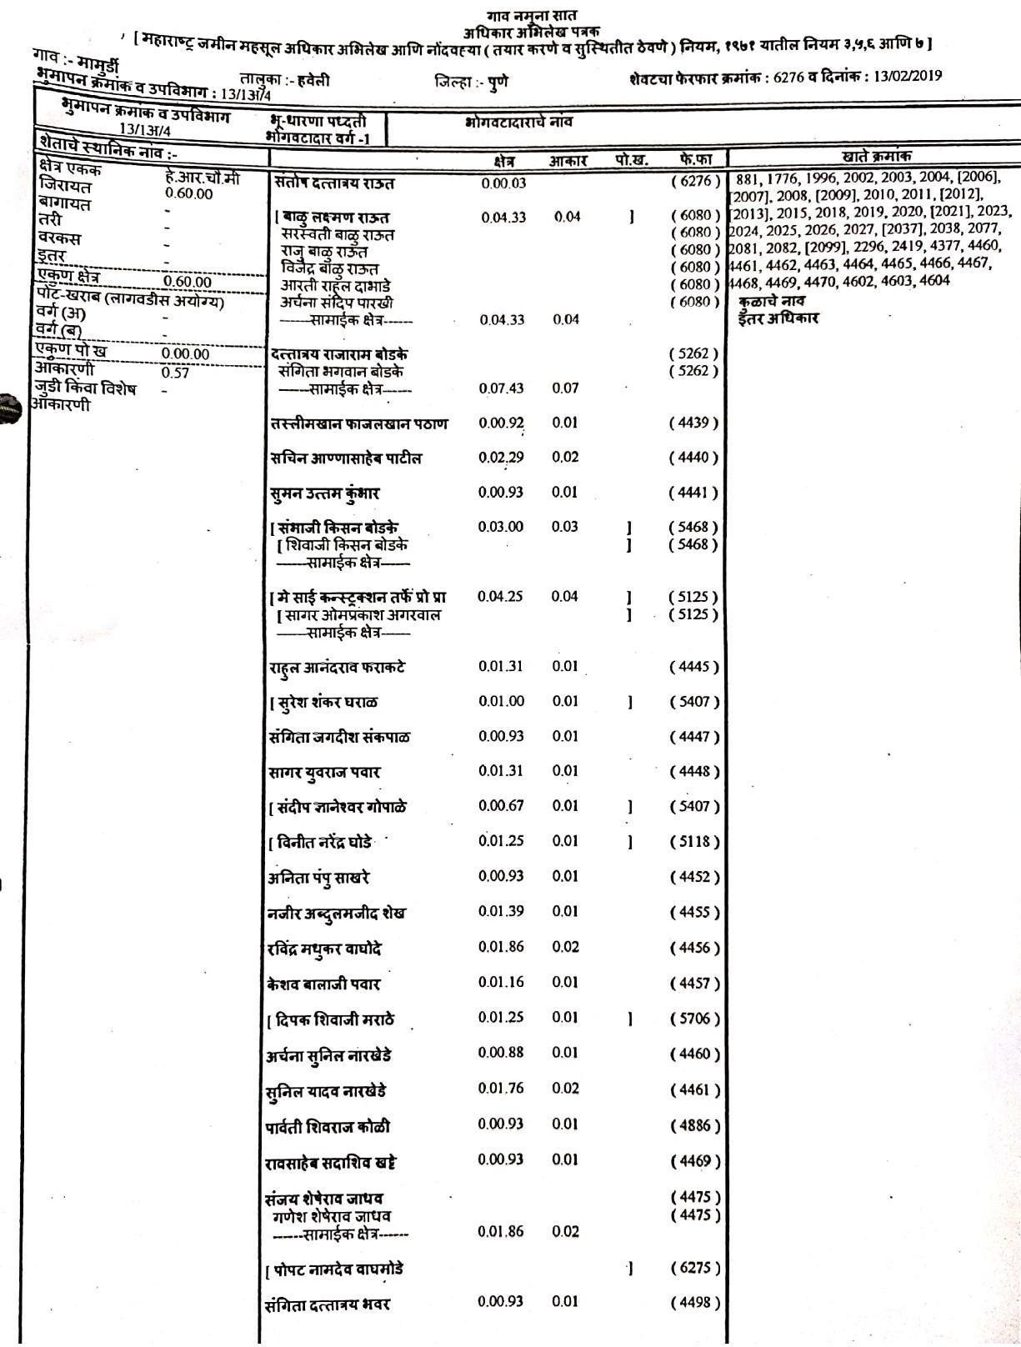

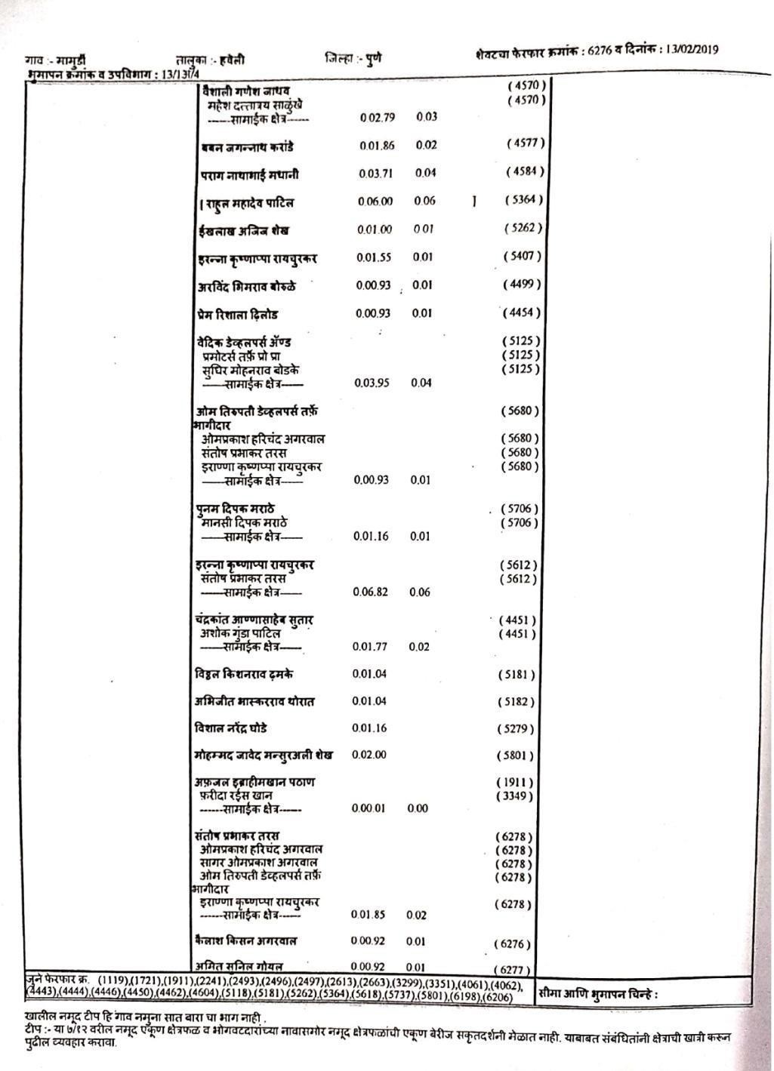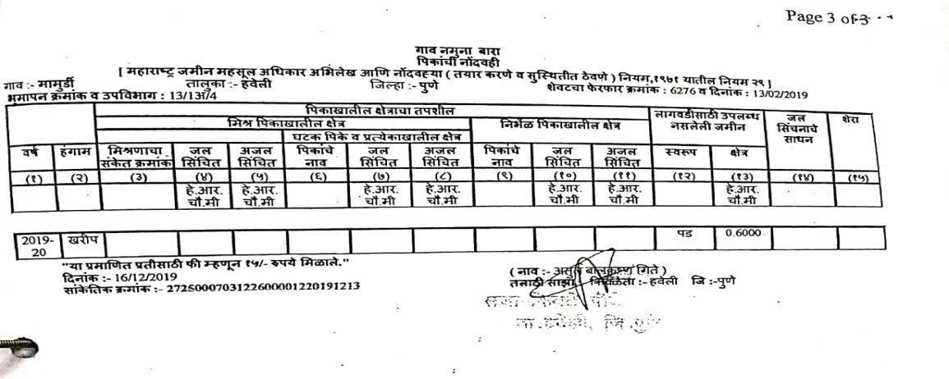

LAYOUT
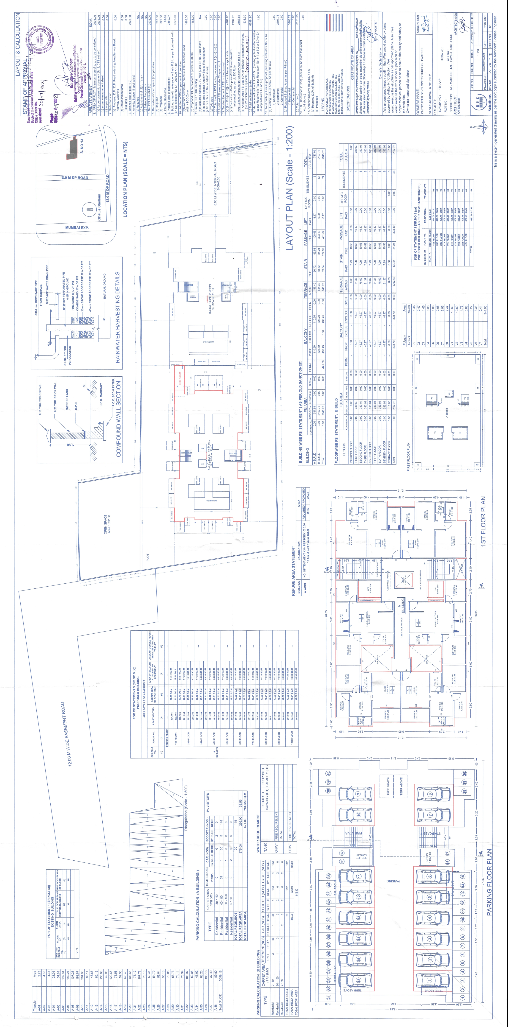
FLOOR PLAN
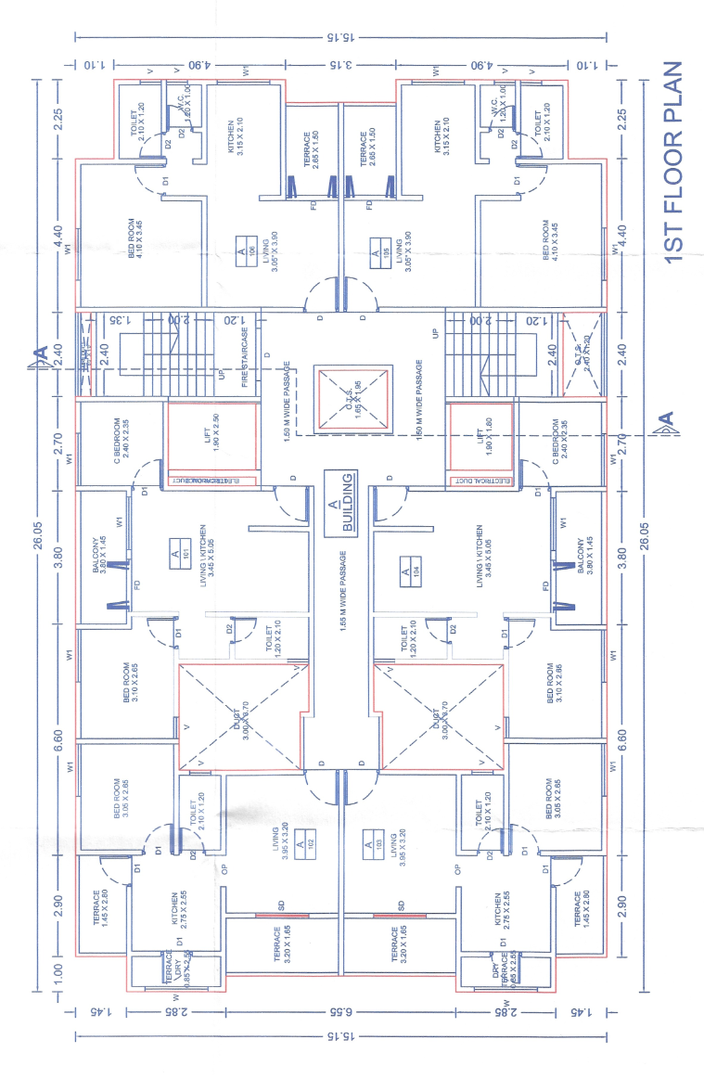
BUILDING : A FLAT NO. 105

COMMENCEMENT CERTIFICATE
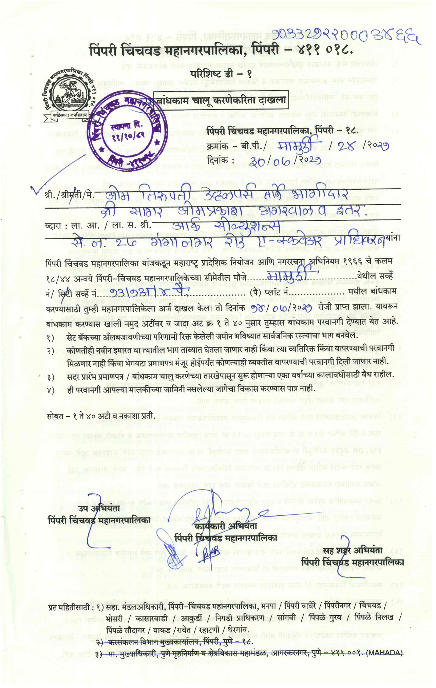
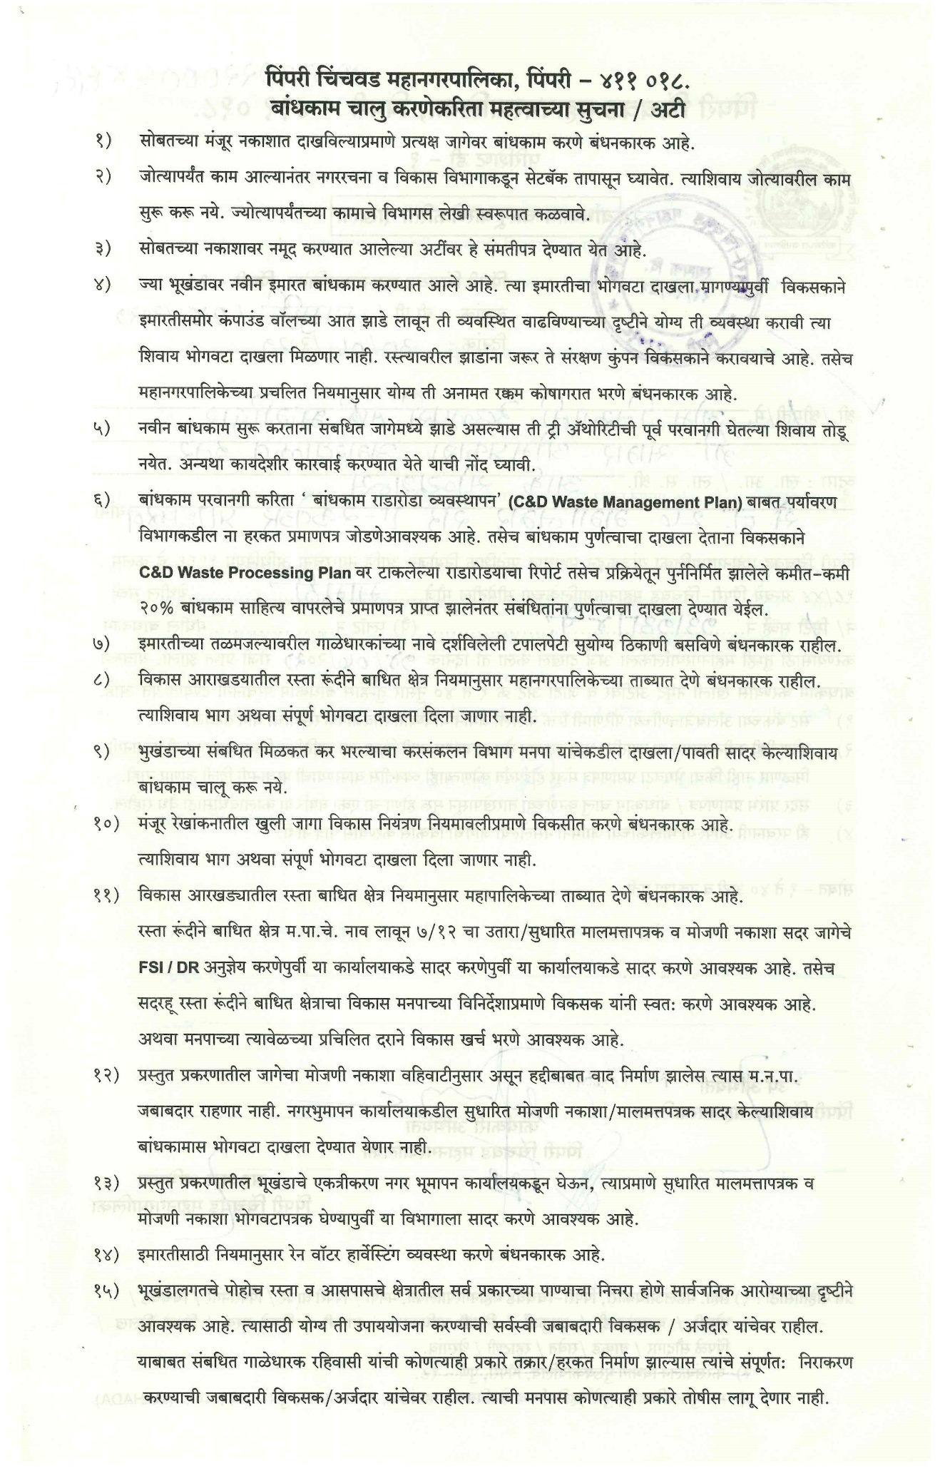
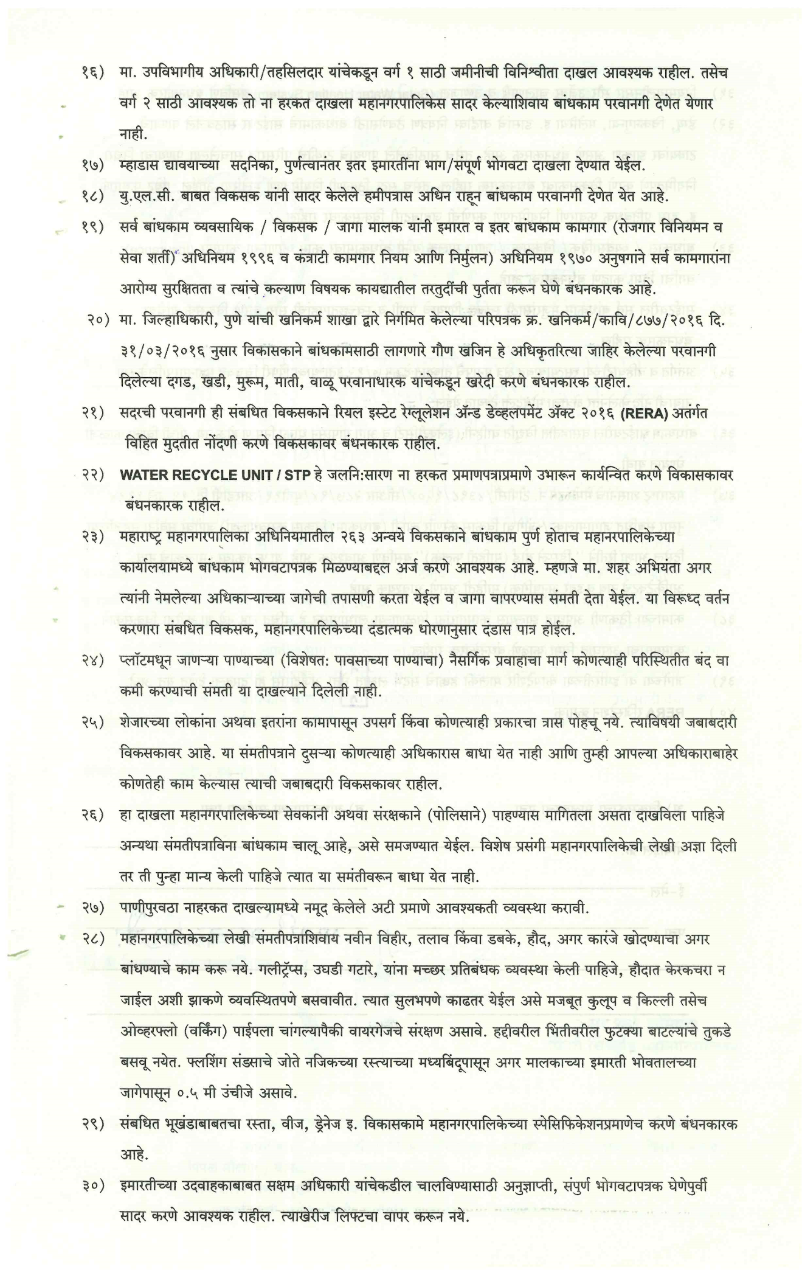
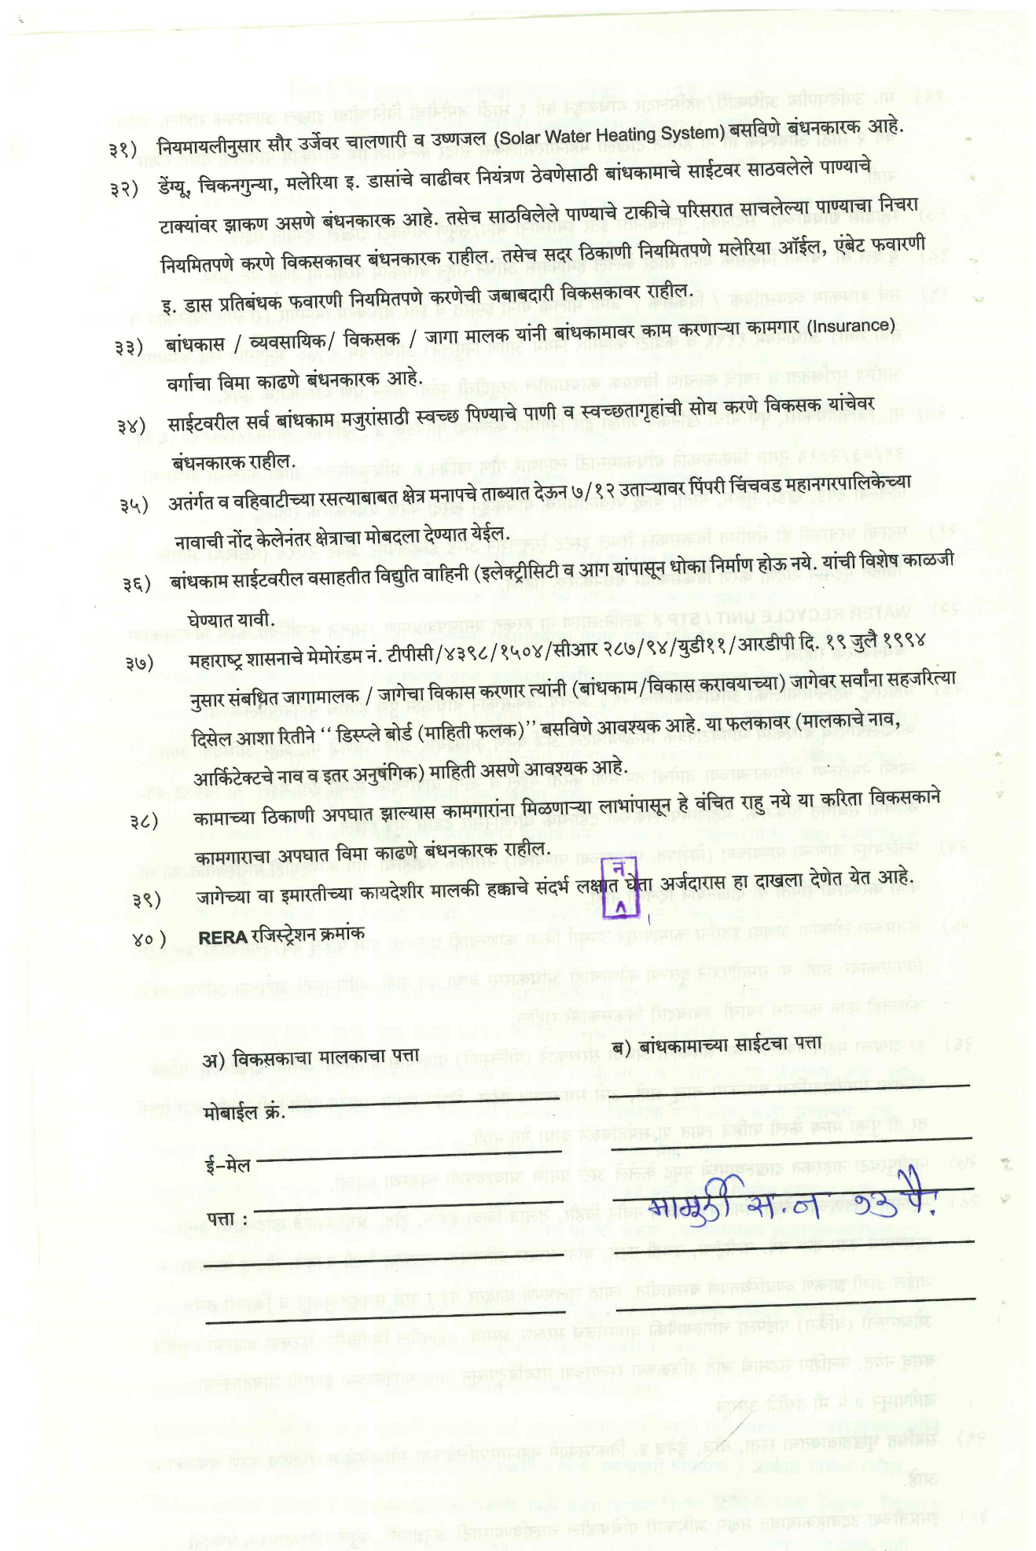

MAHARERA CERTIFCATE
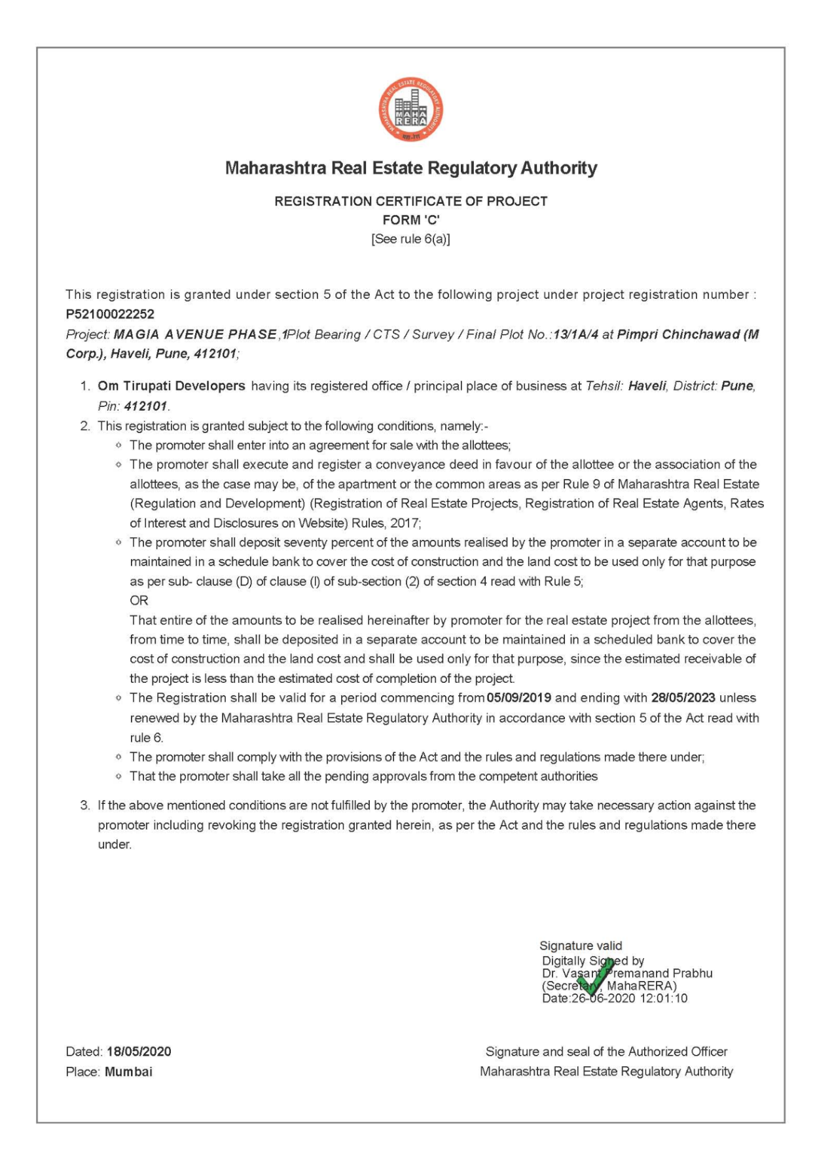

N.A. ORDER
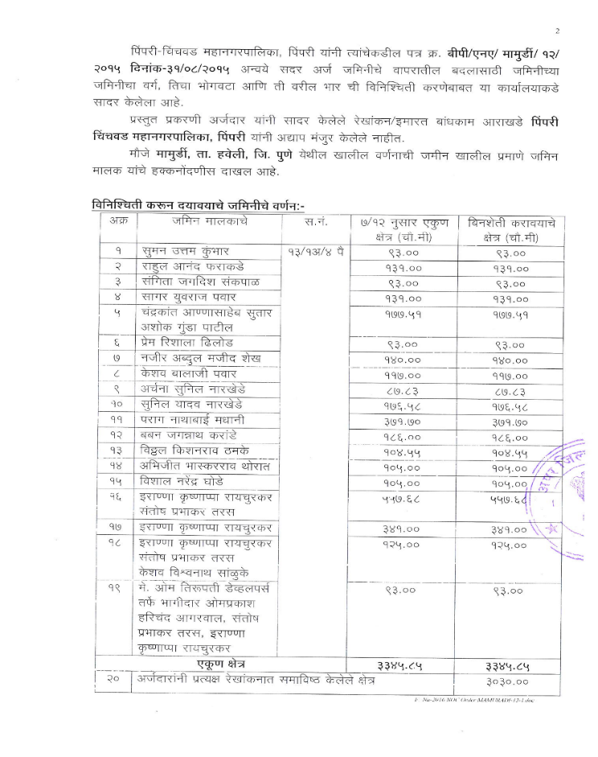

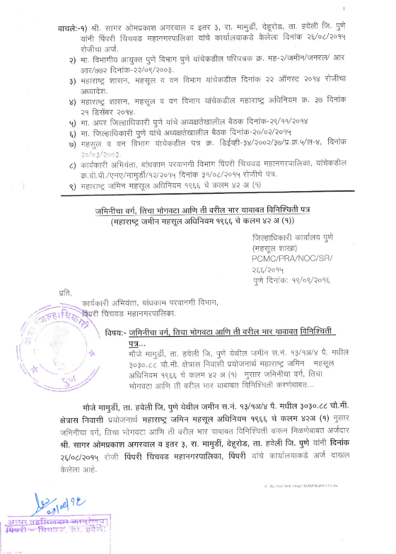
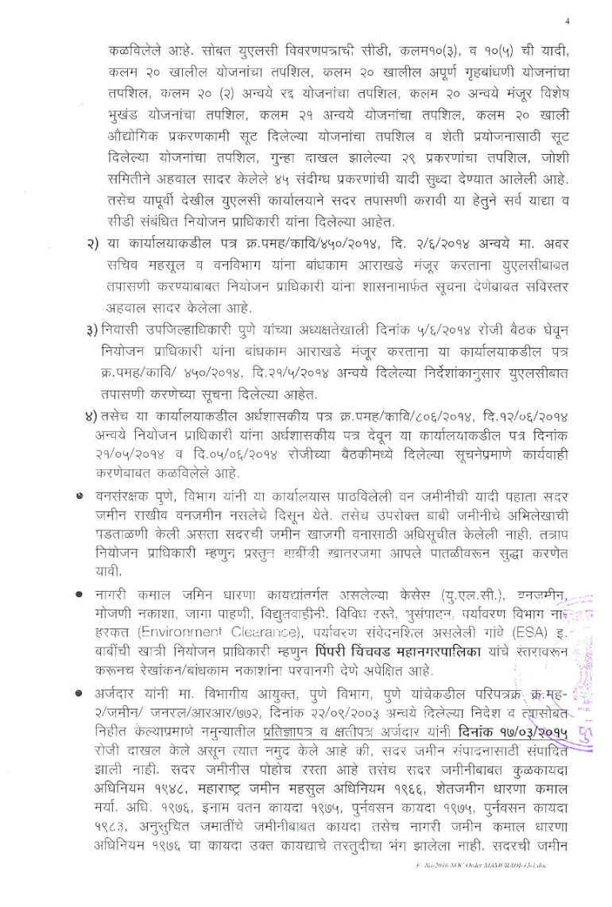

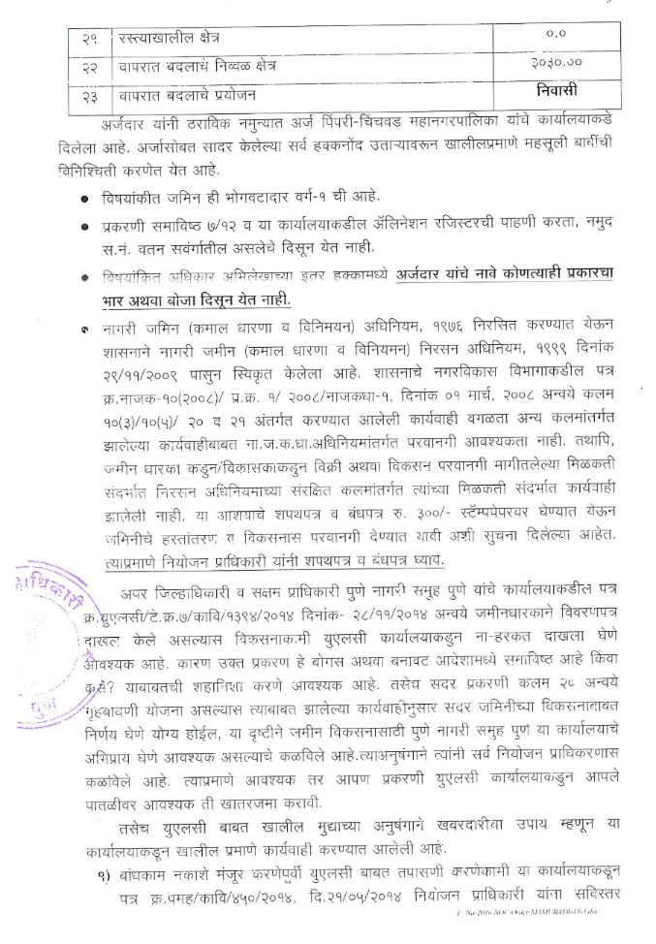

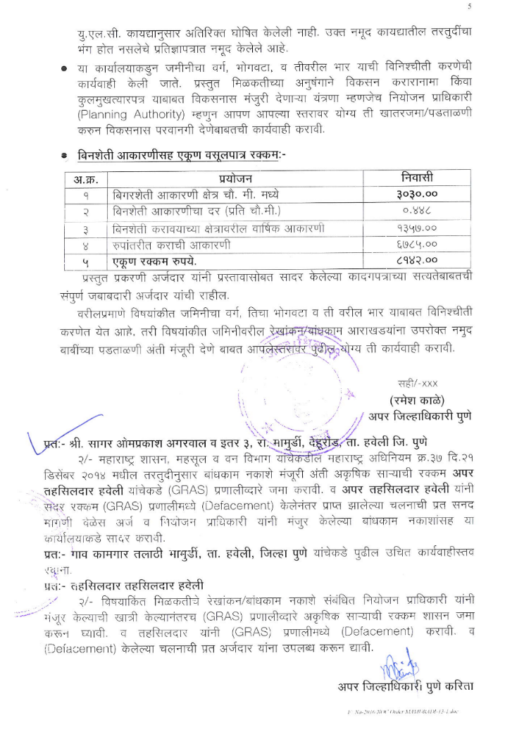

D E C L A R A T I O N

M/S. OM TIRUPATI DEVELOPERS through its partner, do hereby state and declare that I have presented document in the office of Sub-Registrar, Haveli for registration. I state that consenting party Mr. Parag Nathabhai Madhani and others have executed various Power of Attorneys, which are duly registered in the office of Sub Registrar Haveli No. 05 & 24, in favour M/s. OM Tirupati Developers. The said Power of Attorneys are not cancelled. I state that the executants of the said Power of Attorneys are not dead. The said Power of Attorneys are perfectly valid and I am authorized to do the aforesaid act. I state that if the present declaration is found to be false, I am aware that I am liable to be punished under Section 82 of the Registration Act 1908.

MR. SAGAR OMPRAKASH AGARWAL
DECLARANT

