Admin Tool – Reminder Configuration – Error on page load

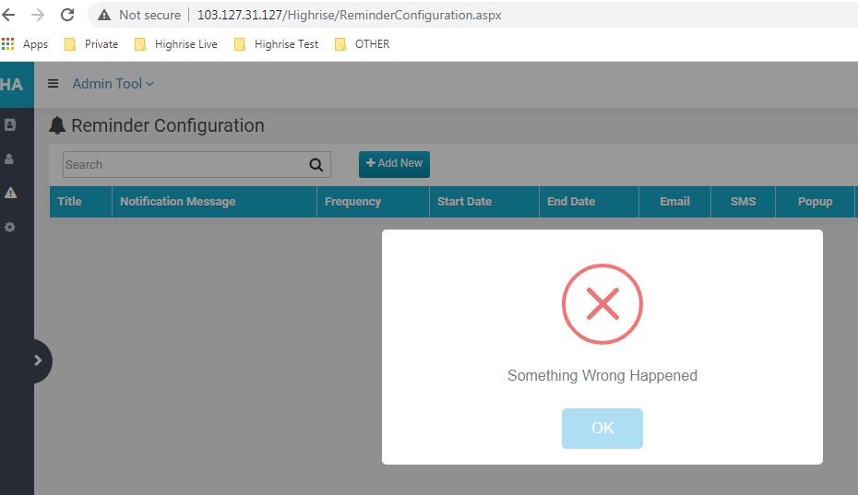

Admin Tool – Hotfix – Error on page load

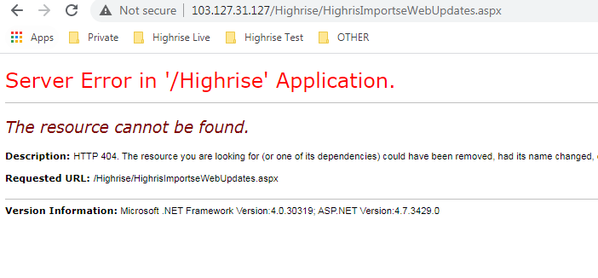

Admin Tool – theme selection – unable to select any

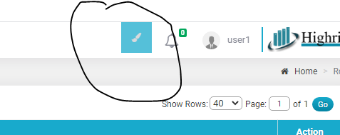

Admin Tool – Reminder view – Error

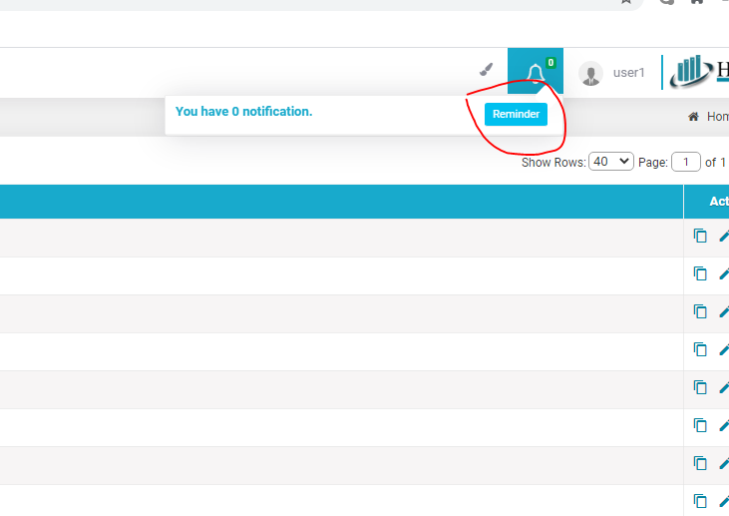

Admin Tool – User Edit – unable to see roles in list (roles are exists)

