**-**

**A**

**Commercial**

**Proposal for**

**-**



**Highrise – Web Version**

**Corporate Lite Suite**

*Submitted to*

**“Sanskruti Lifespaces”**

503, 504 5th Floor, Sanskruti House

Near Maruti Suzuki Showroom,

Bhumkar Chowk,

Mumbai Bangalore Highway,

Wakad Pune 411057

Kind Attention: **Mr. Rahul Patil**

Date of Submission: **4th Feb 2022**

Reference No: **KI/Pune/2021-2022/4143/V1**

# THIS IS A CONFIDENTIAL DOCUMENT

In consideration of you receiving a copy of this document, you agree to keep confidentiality on the contents of this document and shall not, without the prior written approval of Kanix Infotech Pvt. Ltd., disclose to any person the whole or any part of the information contained in, or associated with this document.

Kanix Infotech Private Limited. All rights reserved. **‘**Private & confidential.’

**Table of Content**

THIS IS A CONFIDENTIAL DOCUMENT 1

1. Company Profile 3

2. Brief about client 3

2.1 Requirement Brief – 3

3. Scope of the Proposal 4

4. Product Details - Highrise 4

4.1 Product Introduction 4

4.3 Product Core Modules 6

4.4 Product Functionalities in detail 7

6. Flow Process for Hosting 9

6.1 Flow process for Hosting - On Campus 9

6.2 Flow process of Hosting - Cloud Hosted 9

7.3 Facebook & Property Portal Integration for Highrise 11

8. Return on Investment (ROI) Guidelines – An Illustration 12

8.1 Tangible & non-Tangible Benefits 12

9. Human Resource Cost Guidelines – An Illustration 13

9.1 Human Resource Requirement Guidelines 13

10. An Investment for HIGHRISE 15

10.1 Investment for Highrise License – Web Version - Corporate Suite 15

10.2 Investment on for Highrise License – Client Access License 15

10.3 Investment on for Highrise License – Desktop Version 16

10.4 Investment on for Highrise License – Portals 16

10.5 Investment for Mobile App 16

10.6 Pricing for Professional Services 17

10.7 Hosting on Kanix Cloud 17

10.8 Total Investment for HIGRISE 17

10.9 Payment Schedule 18

10.9 Annual Maintenance Charges 18

10.10 Terms and Conditions 19

11. Infrastructure & Hardware Requirement 20

11.1 IT Infrastructure Requirement Specification 20

11.2 Hardware specification and Internet connectivity requirement at the users end 20

# 1. Company Profile

**Kanix** is a fast growing software product development and marketing company with focus on Construction Industry Vertical. Kanix's product line for Construction Business successfully integrates high-end e-commerce and ERP for large, mid-sized and small businesses. Thousands of Construction Houses worldwide are adding value to their businesses using state-of-art software products of Kanix. We possess very strong domain knowledge in Construction Industry and we are pioneer in business-process reengineering (BPR) and management consultancy.

Kanix was formed in 1998 as Custom Software Development Company by its four Directors. In year 2001 the company took a courageous decision and capped its 32 different product and decided focus and specializes in Construction Industry vertical. After about four years of difficult time the flag ship product of Company Highrise – India’s First Construction ERP Software started showing results of the efforts put in. Today Highrise is the market leader in its segment.

Kanix has its head office and development center in Pune and has branch offices in Mumbai, Delhi, Kolkata, Chennai, Bangalore and Ahmedabad. Kanix has 120 channel partners who help promote Kanix products & help in Implementation & Support.

The Seven ATC (Authorized Training Centers) of Kanix teaches students usage of Kanix products and offer them placement. Due to these ATC’s and huge installation base trained manpower to use Kanix products is amply available.

Kanix has also strong bench strength of consultants who are trained in using Kanix Products and are available on Billing to its clients.

**With the experience of 22+ years in ERP Development** & Implementation Kanix realized that in addition to having a good product it is equally important to have proper implementation. Kanix invented innovative means of ERP implementation and now have grown in confidence to offer its Highrise ERP with “IMPLEMENTATION GAURANTEE” making it the first software company to it.

# 2. Brief about client

Amar Builders established in 1978 is a reputed builder in Pune having number of ongoing and completed projects.

## 2.1 Requirement Brief –

**Client** proposes to automate the operational processes of various departments for better control on the day to day operations by computerization and use of IT and is in search of a readymade software solution which will map on the end to end requirements of the processes of the construction business.

# 3. Scope of the Proposal

This proposal includes product features, solution & pricing for:

1) **Highrise License –Corporate Lite Suit**

# 4. Product Details - Highrise

## 4.1 Product Introduction

Highrise is India’s first Construction ERP; a specialized Internet Ready software solution popularly known as ERP for Construction, Contracting & Real Estate industries. In simple words an ERP is the integrated software solution encompassing all the functional departments of the enterprise. Highrise consists of integrated functions of Accounts & Finance management, Sales, Marketing & CRM Management, Project Estimation, Planning, & Project Management, Purchase, Store & Inventory Control, Labour Contract Management, Human Resource Management, Quality Control, Lease & Mall Management, Tender & Billing Management and Fixed Asset Management. All the above functions share common data thus makes the organization homogenous.

Kanix has invested 17 long years in developing proprietary business process by doing R & D and inculcating all best practices in the software. Highrise enjoys installation base in excess of 2500 spread across India and abroad. The success of Highrise as a product can be gauged from the fact that a number of engineering colleges are teaching Highrise in their curriculum.

With the induction of RERA and GST by Government of India automation in one way has become mandatory for Construction Industry. Highrise fits best between your manual process and proposed Automation. Being a home grown product it caters to practical difficulties faced by the Industry in automation. The Implementation of Highrise is completed in 90 days with a very smooth transit.

Kanix very soon will be GSP/ASP for the GST related operation. Currently GST integration with GST Portal is handled using third party service providers.

Technology is changing at a very fast pace in today’s era. Kanix has kept itself abreast with the pace of technology. Highrise which initially was developed as a client server application is ported on latest .Net Platform with MVC. Mobile Apps are developed for relevant functions like site operations, Customer interface, Approvals. Functions such as Cloud Telephony and call center are built-in to Highrise. Soon we are launching VTC (Vehicle Tracking System) in Highrise.

In technical or software term UI/UX is getting importance these days. Software Companies are doing investments on UI/UX. UI stands for User Interface and UX stands for User Experience in using the software. Kanix has a dedicated team looking after these aspects.

Once we talk about technology user would want to use software from any OS and any Device. Keep this in consideration Highrise Architecture is designed in such a way that it works on any OS like Windows.

IOS, Android and supports devices like Laptop, Tablets and smart phones in a responsive nature.

**4.2 Why Highrise?**

* Serving construction industry since 1997.
* Matured product - Ready to use ERP (Since 14 years) ✓ Successful Installation across India.
* Secured, Scalable, Flexible & Easy to use
* Strong domain knowledge in construction
* Assuring implementation in 3 months
* Built in industry standard business processes / practices
* Configurable alerts, workflows - Management checks & Damage Control
* Data Security & Confidentiality
* Multi level security – Role Based Access Control (RBAC)
* Real time data availability
* Centralized repository - Knowledge bank - Any time Any Where access via Internet

## 4.3 Product Core Modules

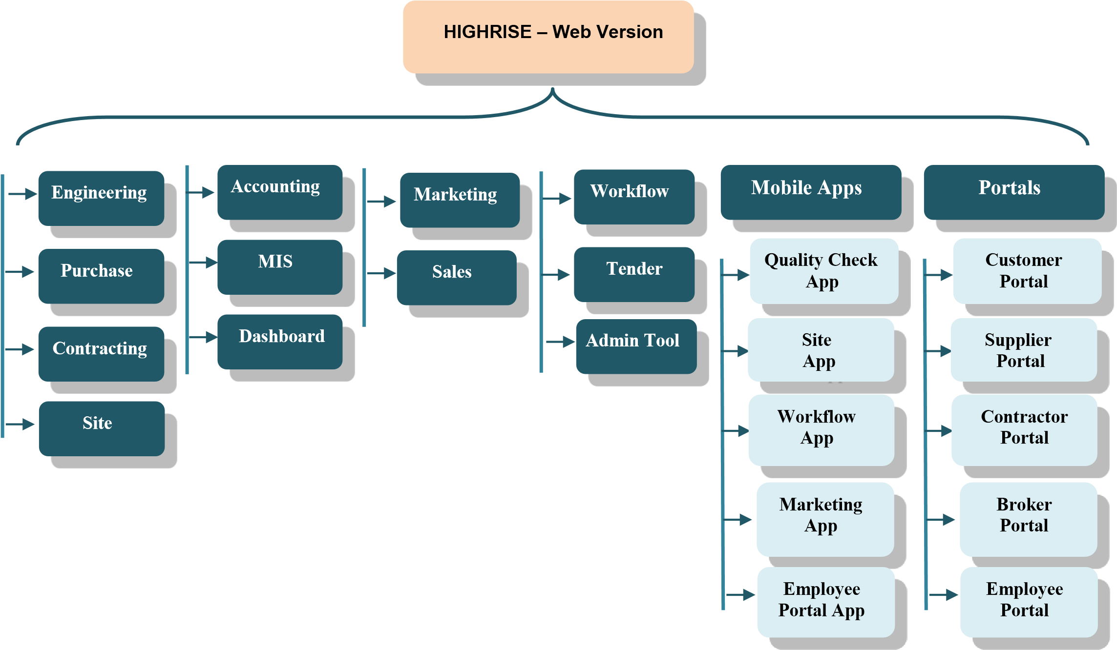

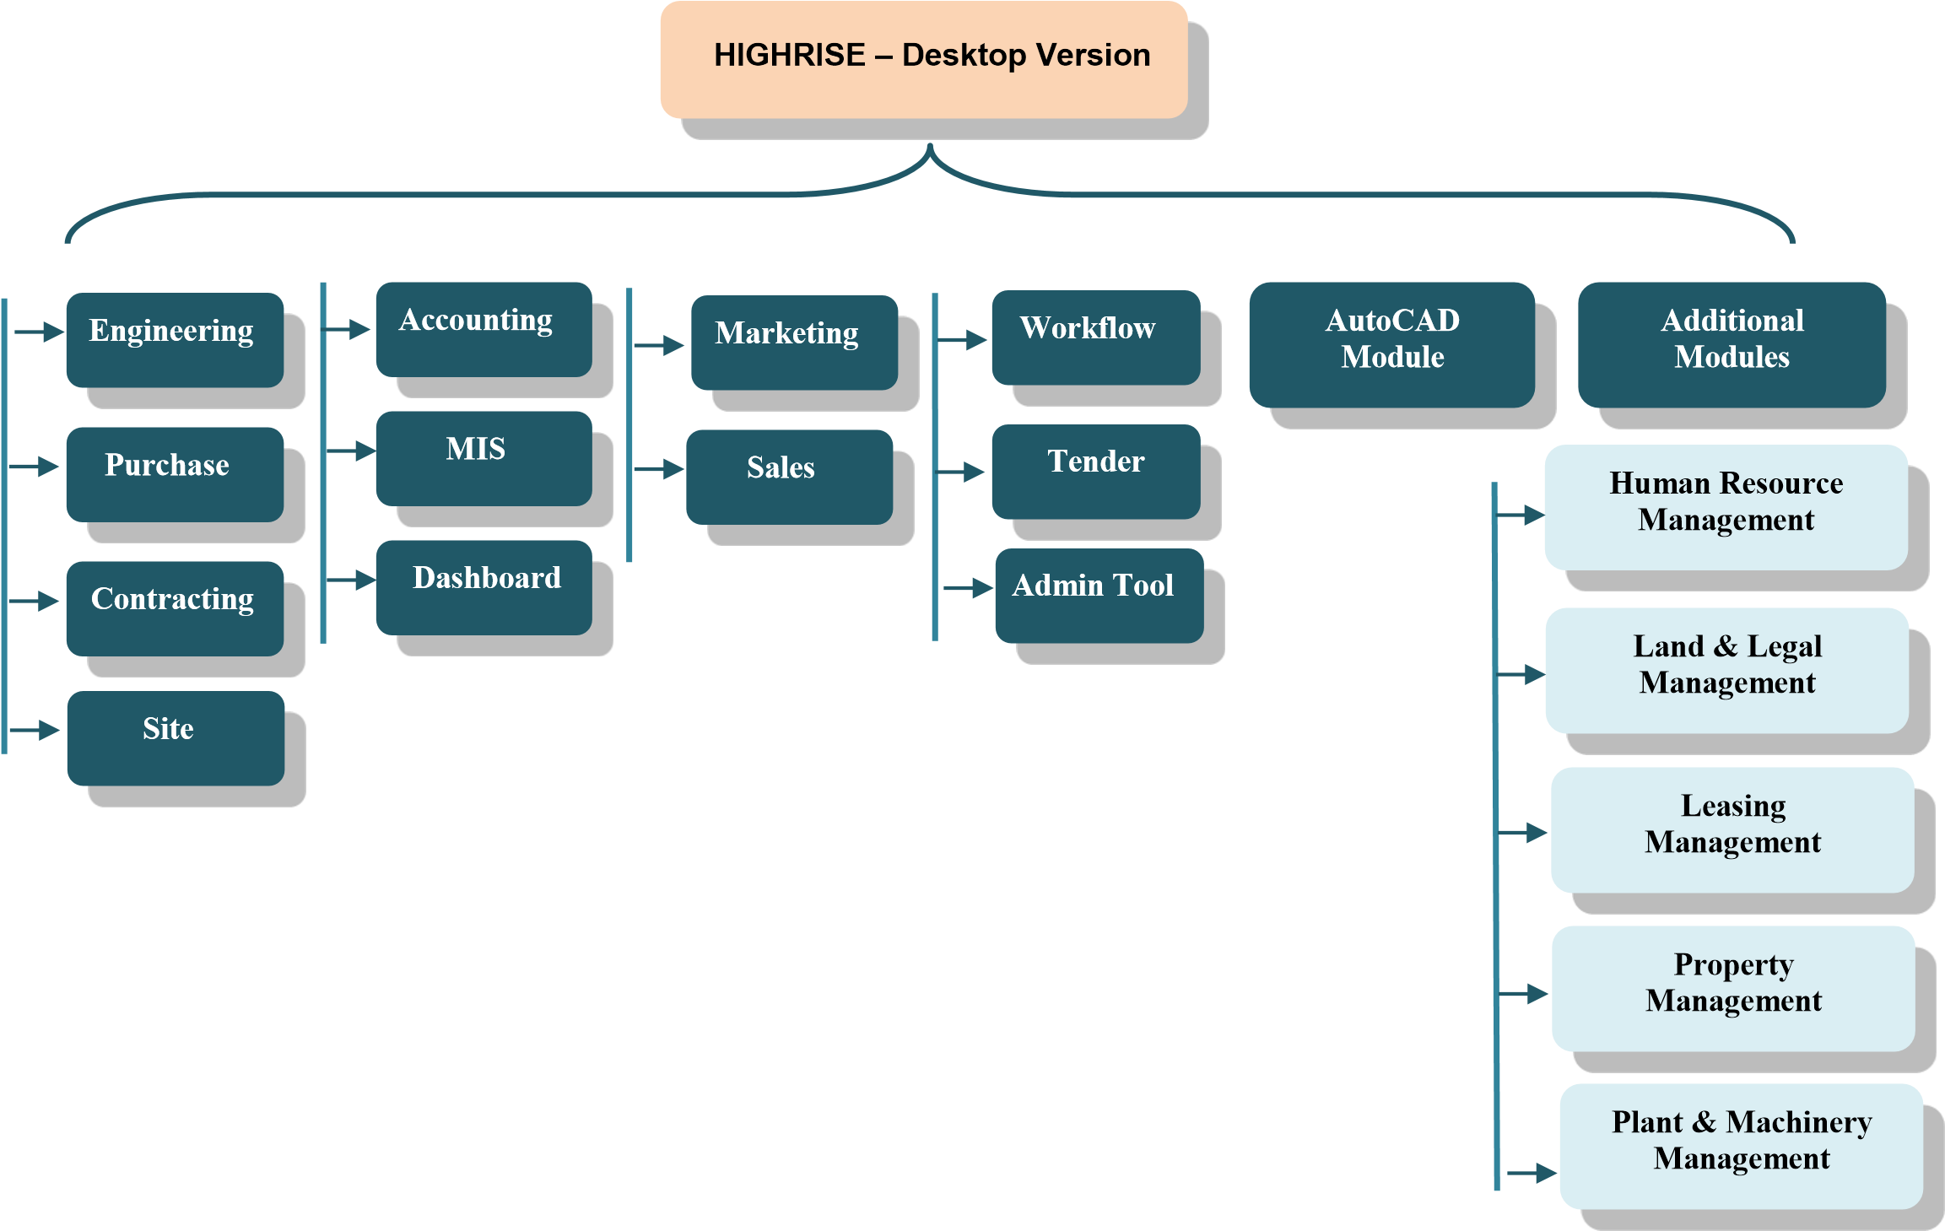

## 4.4 Product Functionalities in detail

|  |  |
| --- | --- |
| **Product Module Name** | **Detail Product Functionalities** |
| **Engineering Module [PCACC7017]** | Budgeting, Estimation, Estimate Versioning, Planning, Project  Management, RERA, Document & Drawing Management |
| **Purchase Module [PCACC7018]** | Supplier registration, Material Requisitions, Enquiry, Quotation, Quotation  Comparative, Rate Management, Purchase Order, Purchase Bills, Taxation, Posting to Accounts |
| **Contracts Module [PCACC7019]** | Contractor Registration, Labour Rates, Work Order & Revisions, RA Bills, Taxation, Advances, Debit / Credit Notes Posting to Accounts |
| **Site**  **Module [PCACC702**  **0]** | Material Requisitions, Material GRN, Material Issue, Inventory Control, Material Transfers, Work Completions, Quality Checks, Departmental Labour |
| **Marketing**  **[PCACC7072]** | Marketing Budgeting, Campaign Management, Lead generation &  Tracking, Follow-ups, Site visits, Digital Marketing, Call Centre Functions |
| **Sales**  **[PCACC7021]** | Sale unit Definitions, Sale Booking, Payment Schedule, Extra Work, Other  Charges, Demand & Reminder Letters, Payment Receipts, Interest  Calculations, Bank NOC, Agreement Printing, Broker Management,  Possessions, Transfers & Cancellations, Taxation, Posting to Accounts |
| **Accounts**  **[PCACC7022]** | Double Entry Bookkeeping, BS. PL, TB, Cash-flow, Branch & Division,  Cost Centre, Schedule II BS, Multi-Company Consolidation, Depreciation,  Interest Calculation, Integrated to all other Modules, VAT, Service Tax, WCT, GST till portal Integration |
| **Work Flow**  **[PCACC7071]** | Configurable work flow, multilevel document & item approvals, SLA & Alerts |
| **Dashboard & MIS** | MIS Reports & User Configurable Dashboard |
| **Admin tool** | User, Security & General Administration of Highrise |

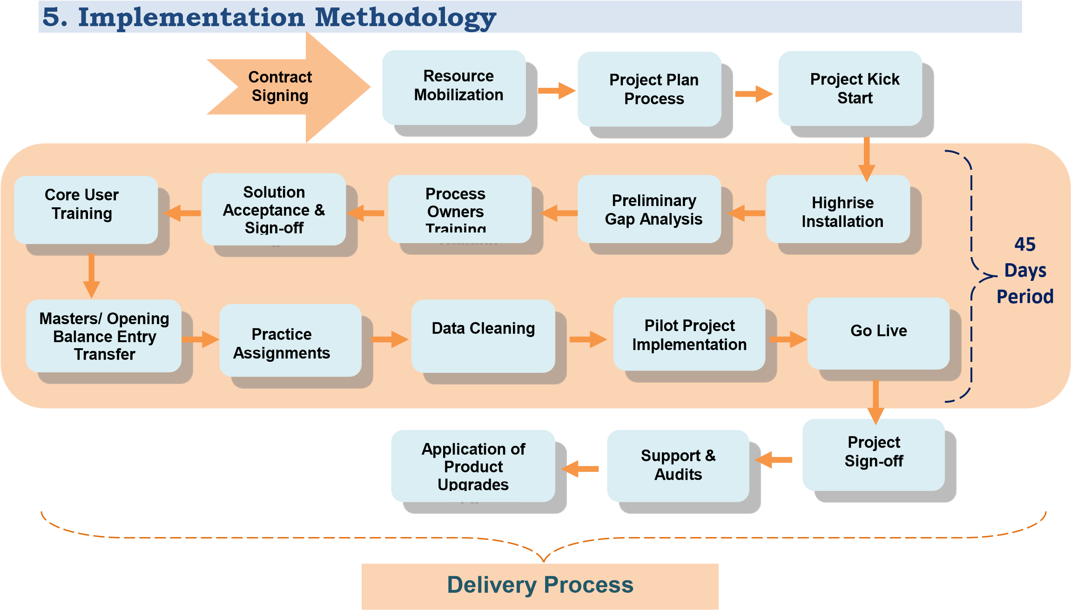

# 6. Flow Process for Hosting

## 6.1 Flow process for Hosting - On Campus

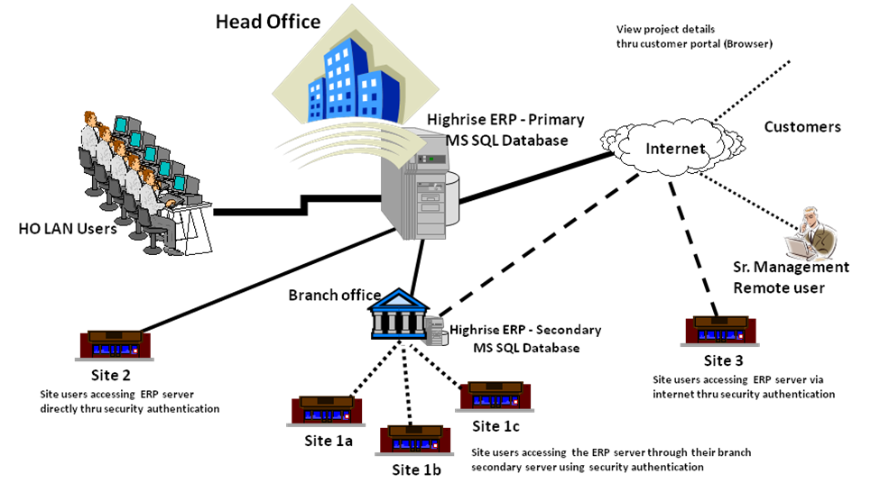

**Remote/ Site/ Branch Users can access directly or via internet via VPN, MS remote**

**Desktop Terminal Client or Browser**

## 6.2 Flow process of Hosting - Cloud Hosted

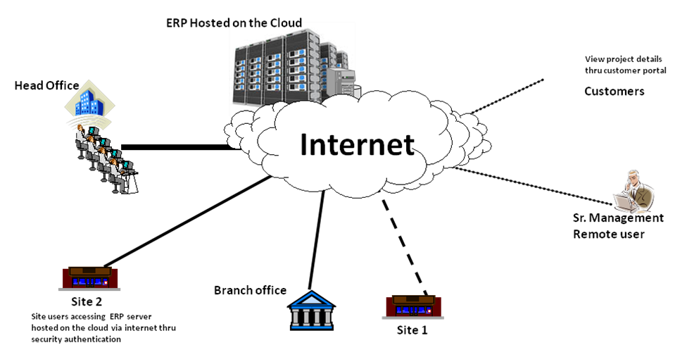

**Remote/ Site/ Branch Users can access ERP Server hosted on the cloud at Hosting**

**Service Provider**

|  |
| --- |
| **7. Add on Integrations** |
| **7.1 Call Centre Function in Highrise** |

### Technology & Background –

The Highrise Call Centre has been designed using internet telephony. When promoting a product using multitude of Campaign and media it becomes difficult to find out the source of Information which lead to this enquiry. In absence of this information it becomes difficult to find out the ROI of various marketing campaigns that we have undertaken and we need to blindly keep on investing money on even non-productive campaigns.

To resolve this Highrise call centre gives a provision of having number of virtual numbers which can be separately assigned to each campaign. When a prospect calls the number (say looking at a Hoarding or a newspaper advertise), Highrise will pick the call with a pre-recorded welcome message and forward the call to the configured physical number. Call routing protocols are configurable to suite the need of individual user. By doing this Highrise comes to know that the enquiry has been generated in response to which marketing campaign. This helps in calculating cost per enquiry for a given campaign by dividing the cost by number of enquiries generated. While forwarding the call Highrise also records the call for future reference and training needs.

Additionally, Highrise also has a provision to assign any number of channels behind each virtual number. This helps in handling spike load of calls and we do not miss any opportunity. To understand this better let’s assume that I have PRI Line with 30 channels and one Virtual Number which I have displayed in the newspaper. I also have five agents attending these calls. One the enquiry call comes in it is routed to these physical numbers in round robin fashion. If the physical number if busy it forwarded to the next physical number, if all the physical numbers are busy the call kept on hold with a pre-recorded message saying “Your Call is important to us. All our executives are busy handling other clients. Please hold the line…..” If the prospect disconnects the phone even then you get a record of all the missed calls that you can contact thereby ensuring that you do not miss on any opportunity.

### Salient Features of Call Centre Function -

* Provision of multiple virtual numbers
* Provision assigning multiple channels to virtual numbers
* Configurable routing protocol for forwarding calls to physical numbers.
* Call recording for incoming and outgoing calls
* Sticky agent – If the prospect calls again Highrise will know that it has data for this number and forwards the call to the same agent who had earlier attended the prospect and automatically opens the prospect case history on his screen.
* Provision for click to call to the call centre agents
* Mobile app to do the calling even on the move but still record it.
* Provision for site visit feedback
* Provision for Payment follow-up with pre-recorded messages.
* Easy way to playback the recorded messages.
* Integrated with Highrise Marketing & Sales Modules

### 7.2 Pricing for Call Centre Function-

|  |  |  |  |
| --- | --- | --- | --- |
| **Parameters** | **Unit** | **Amount (INR)** | **Payment Schedule** |
| Virtual Number with 4 Channels | Per Month | 900/- | One Time |
| PRI Line | Per Month | 8,000/- | One Time |
| Incoming Call (Leg A Only) | 60 Sec Pulse | 0.60/- | As per usage |
| Outgoing Call (Leg A & Leg B) | 60 Sec Pulse | 1.20/- | As per usage |
| Silver & Gold Premium No. | Per No | At actual | At actual |
| One Time Setup Charges | Per Installation | 35,000/- | One Time |

## 7.3 Facebook & Property Portal Integration for Highrise

Highrise can connect to Facebook using the Interio App and collect the lead generated on Facebook & Instagram in a live environment. These leads can then be forwarded to the marketing executives as per the set “Lead Distribution Mechanism” in Highrise. The Marketing Executive will immediately get a SMS & Email upon this assignment. Above procedure will help you reach the prospect within a hour of generation of the lead thereby increasing probability of qualification.

The leads generated through other sources such as property portals & other social media also can be given a similar treatment.

### 7.4 Pricing for Facebook & Property Portal Integration-

|  |  |  |  |
| --- | --- | --- | --- |
| **Plan** | **Task per Month\*** | **Amount (INR)** | **Payment Schedule** |
| Free | 100 | NA | NA |
| Starter | 750 | 1500/- | Per Month |
| Professional | 2000 | 3500/- | Per Month |
| Team | 50000 | 21000/- | Per Month |
| Company | 100000 | 42000/- | Per Month |
| One Time Setup Charges | Per Installation | 10,000/- | One Time |

* Unused Tasks of previous month will not be carried ahead to the next month.

# 8. Return on Investment (ROI) Guidelines – An Illustration

|  |  |  |
| --- | --- | --- |
| **Investment Parameters** |  | **Investment in (INR)** |
| Highrise & Training |  | 1,000,000/- |
| One-time Hardware & Infrastructure |  | 0 |
| Annual HR & Service Expenses |  | 0 |
| **Total Annual Expense** |  | 1,000,000**/-** |
| **Cost of Highrise per Sq. Ft. for 10 Lac Sq. Ft of construction throughput annually is** | **1,000,000/-** | **1.00** |

## 8.1 Tangible & non-Tangible Benefits

|  |  |
| --- | --- |
| **Purchase & Inventory** |  |
| Reduction in wastage | KPI - Base lined |
| Reduced Inventory Holding | KPI - Base lined |
| Better Pricing | KPI - Base lined |
| Mandatory Business Process Compliance | KPI - Base lined |
| Timely escalation of Issues | KPI - Base lined |
| Reduction in events of Delays in Material Receipt | KPI - Base lined |
| **Engineering** |  |
| Accurate Estimates | KPI - Base lined |
| Accurate Project Planning | KPI - Base lined |
| Accurate Project Monitoring | KPI - Base lined |
| Timely Project Completions | KPI - Base lined |
| Better Construction Quality- Quality Checks | KPI - Base lined |
| **Sales & Marketing** |  |
| Improved client records |  |
| Timely Recovery | KPI - Base lined |
| Targeted follow-ups- Better Conversion | KPI - Base lined |
| Better Broker Management |  |
| Better management Directions - Analytical Data available |  |
| **Accounts** |  |
| Integrated Accounts eliminates possibility of errors Reduction in manpower cost |  |
| Better corporate Image - Computerized statements |  |
| Accurate cash flow requirements | KPI - Base lined |
| Improved Liaison with Bankers, Auditors |  |
| **Human Resource** |  |
| Improved Assignment of Roles & Responsibilities | KPI - Base lined |
| Improved establishment of Accountability | KPI - Base lined |
| Assists identification of Training Needs |  |
| Reduction in dependency on Human Resource |  |
| **Business** |  |
| Controlled Operations |  |
| Better Transparency in operations leading to Investor Confidence |  |
| De-Risking Business |  |
| Indemnity against staff turnover |  |
| Better Handling of High Construction Volumes |  |
| Facilitates Controlled Delegation of work |  |
| Helps Business in becoming Process Driven rather than Hero Driven |  |

# 9. Human Resource Cost Guidelines – An Illustration

|  |  |  |
| --- | --- | --- |
| **Volume Analysis** |  | |
| Volume of Construction to be Completed in One year on Model - All Materials Purchased - Work Executed on Departmental Basis |  | **0** |
| Volume of Construction to be Completed in One year on Model - All Materials Purchased - Work Executed on Contract |  | **1,000,000** |
| Volume of Construction to be Completed in One year on Model - All Materials with Contract - Work Executed on Contract |  |  |
| Volume of Construction to be Completed in One year on Model - Major  Materials Purchased (Like Cement & Steel) remaining Materials with Contract - Work Executed on Contract |  | **0** |
| **Implementation Model** |  | |
| Very Aggressive - Shut down all the legacy systems, Recruit Trained Man Power, Chalk out KPI's --------------- **Factor 10** | **0** | |
| Intermediate Approach - Steady Module by Module Implementation with accommodating all the users --------------- **Factor 6** |  | |
| Slow Approach - with implementing organizational changes & process setting side by side of Highrise Implementation. --------------- **Factor 3** |  | |
| *(Type the Factor of the desired Implementation Model in next Column)* | **6.00** | |

## 9.1 Human Resource Requirement Guidelines

|  |  |  |
| --- | --- | --- |
| **Resource**  **Designation/ Position** | **Role & Responsibility** | **Estimated Positions for above Volume (No.)** |
| Estimation Engineers | Laisoning with Architect & Structural Engineer, Estimating & re-estimating the quantities as per the latest drawings, Feeding the estimates in Highrise | **7.5** |
| Project Manager | Shall act as owner of the project and ensure that the project is completed in approved cost & time with the declared quality. Project Planning, Execution & Monitoring. Monitor Highrise MIS and periodically report to the top Management. | **6** |
| Site Engineers | Handling day to day site operations, Monitoring quality of materials & work as per the checklists. Ensure compliance of Project Plan prepared by Project manager and escalate the various issues to the Project manager. Generate Material Indents on Highrise and update completions, Check RA bills submitted by the Contractors | **24** |
| Purchase Manage | Shall ensure timely availability of all the materials on site at the best competitive rate and approved quality. Purchase department is support department and shall follow Organization defined SLA. | **2** |
| Purchase Assistant | Shall ensure timely availability of all the materials on site at the best competitive rate and approved quality. Calling quotations, creating comparative statements, generating purchase orders, entering Purchase bills in Highrise | **4** |
| Store Keeper | Maintain stock in stores. Enter all GRN's & issues in Highrise and ensure that there is discrepancy in the stock shown by Highrise & Physical Stock. | **5** |
| Contract Manager | Calling Tenders / Quotations from Contractors,  Create Comparative, Generate & Issue work orders,  Participate with Project manager for Project Planning.  Negotiating with Contractors & Contract Signing,  Maintaining record of Retention, Advances, Debit  Notes & Credit notes for Contractors. Approving RA Bills. Ensuring quality commitments & compliance from the Contractors | **2** |
| Chief Accountant | Ensure that all the accounts are maintained as per the requirements of Income Tax Department, ROC & the Organization. Interacting with bankers & investors and budget & cash flow monitoring. | **2** |
| Account Assistant | Entering various vouchers in Highrise, Cheque printing, maintenance of various accounts including bank accounts | **10** |
| Sales Manager | Assigning Units, Payment Schedule, Extra Work  Charges, Other Charges in Highrise. Agreement Follow-ups & Broker Management | **5** |
| Recovery InCharge | Generating Demand Letters & Reminder Letters, ensure timely recovery from the customers. Calculate interest on outstanding payments, Escalate cases of no-recovery to the management. Generate payment Receipts. | **5** |
|  | **Total Human Resource Requirement** | **72.5 [Approx. 73 resources]** |

# 10. An Investment for HIGHRISE

## 10.1 Investment for Highrise License – Web Version - Corporate Lite Suite

|  |  |  |  |  |
| --- | --- | --- | --- | --- |
| **Product Code** | **Product / Module Name** | **No. of**  **Quantity/ Users** | **Amount**  **(INR)** | **Investment**  **Amount**  **(INR)** |
| PCACC7017 | Engineering Module | 1 | 3,00,000/- | 3,00,000/- |
| PCACC7018 | Purchase Module | 1 | 3,00,000/- | 3,00,000/- |
| PCACC7019 | Contracts Module | 1 | 3,00,000/- | 3,00,000/- |
| PCACC7020 | Site Module | 1 | 3,00,000/- | 3,00,000/- |
| PCACC7022 | Accounts Module | 1 | 3,00,000/- | 3,00,000/- |
| PCACC7071 | Work Flow Module for approvals, alerts & notifications | 1 | 3,00,000/- | Complimentary |
|  | Dashboard & MIS | 1 | 3,00,000/- | Complimentary |
|  | Admin tool Module | 1 | 3,00,000/- | Complimentary |
| **Total Investment for Highrise Licenses – Web - Corporate Suite** | | | | **15,00,000/-** |
| **Less Special Discount @25% (-)** | | | | **3,75,000/-** |
| **Total Investment for Highrise Licenses – Web - Corporate Suite [A]** | | | | **11,25,000/-** |

## 10.2 Investment on for Highrise License – Client Access License

|  |  |  |  |  |  |  |  |
| --- | --- | --- | --- | --- | --- | --- | --- |
| **Product Code** | **Product / Module Name** | | | | **No. of**  **Quantity/ Users** | **Amount**  **(INR)** | **Investment**  **Amount**  **(INR)** |
| PCCLE3122 | Client Access Licenses [CAL for Web Version] | | | | 20 | 25,000/-  (Per User) | 2,50,000/- |
|  | 1:1 License Free Scheme Valid til | | l |
| 15th Feb 2022 Only |  |
| **Total Investment for Highrise Licenses – Web - Corporate Lite Suite** | | | | | | | 2,50,000/- |
| **Less Special Discount @0% (-)** | | | | | | | **NA** |
| **Total Investment for Highrise Licenses – Web - Corporate Lite Suite [B]** | | | | | | | 2,50,000/- |

## 10.3 Investment on for Highrise License – Desktop Version

|  |  |  |  |  |
| --- | --- | --- | --- | --- |
| **Product Code** | **Product / Module Name** | **Product Quantity** | **Amount (INR)** | **Investment Amount (INR)** |
| DCACC3025 | AutoCAD Interface | 1 | 3,00,000/- | 3,00,000/- |
| **Total Investment for Highrise Licenses – Web - Corporate Suite** | | | | **3,00,000/-** |
| **Less Special Discount @25% (-)** | | | | **75,000/-** |
| **Total Investment for Highrise Licenses – Web - Corporate Suite [C]** | | | | **2,25,000/-** |

## 10.4 Investment on for Highrise License – Portals

|  |  |  |  |  |
| --- | --- | --- | --- | --- |
| **Product Code** | **Product / Module Name** | **Product Quantity** | **Amount (INR)** | **Investment Amount (INR)** |
| PCACC8053 | Customer Portal | 0 | 3,00,000/- | NA |
| PCACC8054 | Broker Portal | 0 | 3,00,000/- | AN |
| **Total Investment for Highrise Licenses – Web - Corporate Suite** | | | | NA |
| **Less Special Discount @25% (-)** | | | | **NA** |
| **Total Investment for Highrise Licenses – Web - Corporate Suite [C]** | | | | **NA** |

## 10.5 Investment for Mobile App

|  |  |  |  |  |
| --- | --- | --- | --- | --- |
| **Product Code** | **Product / Module Name** | **Product Quantity** | **Amount (INR)** | **Investment Amount (INR)** |
| [MAACC1001] | Quality App | 1 | 3,00,000/- | Complimentary |
| [MAACC1003] | Site App | 1 | 3,00,000/- | Complimentary |
| **Total Investment for Highrise Licenses – Web - Corporate Suite** | | | | NA |
| **Less Special Discount @20% (-)** | | | | **NA** |
| **Total Investment for Highrise Licenses – Web - Corporate Suite [C]** | | | | **NA** |

## 10.6 Pricing for Professional Services

|  |  |  |  |
| --- | --- | --- | --- |
| **Professional Services** | **Requirement** | **Amount (INR)** | **Investment Amount (INR)** |
| Implementation Charges | 15 sessions of 8 Hrs each | 3,00,000/- | 3,00,000/- |
| Project Manager |
| Sr. Implementation Engineer |
| Jr. Implementation Engineer |
| On-site Highrise Consultant  (*Minimum three months contract required) | 0 | 60,000/- Per Month | NA/- |
| **Total Investment for Professional Services [E]** | | | **3,00,000/-** |

## 10.7 Hosting on Kanix Cloud

|  |  |  |  |
| --- | --- | --- | --- |
| **Cloud Hosting – Kanix Cloud** | **Unit** | **Amount (INR)** | **Investment Amount (INR)** |
| Hosting on Licences on co-located Server of Kanix | Annual | 2,50,000/- | NA |
| Hosting on Licences on co-located Server of Kanix | Monthly | 35,000/- | NA |
| One-time Setup Charges | One-time | 50,000/- | NA |
| **Total Investment for Kanix Cloud Hosting [F]** | | | **NA** |

## 10.8 Total Investment for HIGRISE

|  |  |
| --- | --- |
| **Total Investment** | **Investment Amount (INR** |
| **Total Investment for Highrise Licenses – Web Version - Corporate Lite Suite [A]** | **11,25,000/-** |
| **Total Investment for Highrise Licenses – Client Access Licenses[B]** | **2,50,000/-** |
| **Total Investment for Highrise Licenses – Desktop Version [C]** | **2,25,000/-** |
| **Total Investment for Mobile App [D]** | **NA** |
| **Total Investment for Professional Services [E]** | **3,00,000/-** |
| **Total Investment for Kanix Cloud Hosting [F]** | **NA** |
| **Total Investment for HIGHRISE** | **19,00,000/-** |

## 10.9 Payment Schedule

|  |  |
| --- | --- |
| **Payment Schedule** | **Percentage** |
| Along with Purchase Order | 75% |
| Within 30 Days from Date of Installation of Base Product | 25% |

## 10.9 Annual Maintenance Charges

|  |  |  |
| --- | --- | --- |
| **Service Name** | **Charges** | **Description** |
| Annual Maintenance Charges | 20% | Covers unlimited telephonic & web support, 15 hours of online Refresh Training and 2 Online Audits Statuary Updates + Functional Updates |
| *Above AMC charges is applicable from second year onwards | | |

## 10.10 Terms and Conditions

1. Supplied Product shall be covered under warranty against programming bugs and nonCompliance with the specifications for a period of one year from date of Installation of the base Product.

1. Product Updates & Support is Included in the price for the first year from date of Installation of base product.

1. Taxes Extra as applicable. Currently 18% GST will be applicable under SAC Code 997331

1. Client is expected to have IT Infrastructure ready in place before start of Implementation

1. Costs of hardware & infrastructure software licenses are not included; Requirements are MS WIN OS, MS SQL Standard, Crystal Report Server License.

1. Implementation will be the joint responsibility of Kanix team & team of Client

1. For SMS Alerts client has to purchase the Transactional SMS packs based on their requirement. Package range from 20 Thousand to 1 Lakh SMS messages at 20 paisa per SMS message.

1. Call centre functions are built-in the web application the client will need to subscribe for virtual numbers. Details of this Call Centre and pricing are given above in section 7.1

1. AMC will be applicable from second year onwards and will be applied as per confirmed category.

1. All required customization will be charges extra.

1. Temporary Licenses shall be issued upon receipt of Purchase Order and Initial Payment with a validity of 90 days. Permanent shall be issued upon receipt of complete license fees.
2. This order nullifies and supersedes all and every other oral and written agreements or commitments of any nature that the parties may have reached prior to the date of this order and shall be final & binding to all in all respect.

# 11. Infrastructure & Hardware Requirement

## 11.1 IT Infrastructure Requirement Specification

|  |  |
| --- | --- |
| **Highrise ERP hosted on Campus (i.e.at HO) - Dedicated server with specification (incl. Microsoft licenses) as indicated** | |
| Server Speed | Quad / Octa Core CPU 2.8 G Hz. & above, Intel Processor Server |
| RAM | 64 GB with scalability option - (more users would mean to increase the RAM) |
| Hard Disk | 1 TB with scalability option |
| OS | Microsoft Win server 2012 & above (either 32 or 64 bit) licenses |
| Database | Microsoft SQL - Standard 2012 & above licenses |
| IIS | Internet Information Services |
| MS Windows  Terminal Services | NA |

## 11.2 Hardware specification and Internet connectivity requirement at the users end

* Any machine or laptop running: Windows XP, Win 7, Win 10 OS, Android, IOS with browser (Home edition OS will not be supported for desktop modules.)
* All the users should have good access to the ERP server hosted on campus or cloud thru a dedicated good bandwidth internet line

### DISCLAIMER

The information contained in this document is for guidance only and does not bind to be legal advice. It is provided on the understanding that Kanix Infotech Pvt. Ltd. is not responsible for the results of any actions taken on the basis of information in this document, nor for any errors or omissions. Kanix Infotech Pvt. Ltd. expressly disclaims all and any liability to any person in respect of anything and of the consequences of anything done or omitted to be done by any person in reliance, whether wholly or in part upon the contents of this document.

All rights reserved. No part of this publication may be reproduced or utilized, stored in a retrieval system, or transmitted in any form or by any means, electronic, mechanical, photocopying, recording or otherwise, without the prior permission of Kanix Infotech Pvt. Ltd.

**STATEMENT OF UNDERSTANDING**

Between

**Sanskruti Lifespaces**

and

**Kanix Infotech Pvt. Ltd.**

This proposal has been prepared in accordance with Kanix’s understanding of as per the given requirements by you. All information contained in this proposal represents Kanix’s best estimates. However, since the actual results in your particular operations may vary from those indicated in the proposal due to variations in software programs, volume environment, personnel, and other factors, the final determination that the proposed products and services meet your requirements must be yours.

This proposal contains confidential information of Kanix Infotech Pvt. Ltd. In consideration of receipt of this response document, you agree not to reproduce or make this information available in any manner to persons outside the group directly responsible for the evaluation of its contents, except as is required by applicable public access regulations or law.

*We are keen to partner with your esteemed organization and look forward to a long term mutually beneficial engagement as your preferred technology partner.*

**---------------------------- End of the Document --------------------------------**