

**- A Commercial Proposal for -**

**Highrise – Web Ultra Lite Suite**

*Submitted to*

**“Amarbhaw Power Pvt Ltd”**

**Rajasthan**

Kind Attention: Mr Vishal Mathur, Ms Nikita

Contact No: +91 88750 97888; e-mail: [vishal.mathur@amarbhawgroup.com](mailto:vishal.mathur@amarbhawgroup.com), [dmeamarbhaw@gmail.com](mailto:dmeamarbhaw@gmail.com)

Date of Submission: **2nd** **July**, 2022

Valid Till: **9th** **July,** 2022

Reference No: **PO/GAN/2022-2023/102/V2**

Prepared by: Nilesh Deshpande (+91 92255 19224/ 982360 1840)

[nilesh.deshpande@kanix.com](mailto:nilesh.deshpande@kanix.com)

**THIS IS A CONFIDENTIAL DOCUMENT**

In consideration of you receiving a copy of this document, you agree to keep confidentiality on the contents of this document and shall not, without the prior written approval of Kanix Infotech Pvt. Ltd., disclose to any person the whole or any part of the information contained in, or associated with this document.

Kanix Infotech Private Limited. All rights reserved. **‘**Private & confidential.’

**Table of Content**

1. Company Profile 2

2. Scope of the Proposal 3

3. Product Details - Highrise 4

3.1 Product Introduction 4

3.2 Why Highrise? 4

4 Product Functionalities in detail 5

5. Flow Process for Hosting 5

5.1 Flow process for Hosting - On Campus 5

5.2 Flow process of Hosting - Cloud Hosted 6

6. Add on Integrations 6

6.1 Call Centre Function in Highrise 6

6.2 Pricing for Call Centre Function- 7

6.3 Facebook & Property Portal Integration for Highrise 7

6.4 Pricing for Facebook & Property Portal Integration- 7

7. Implementation Methodology 8

7.1 Implementation Options 8

8 Investment for HIGHRISE 9

8.1 Investment for Highrise License – Web – Ultra Lite Suite 9

8.2 Investment for Highrise – Client Access License (Users) 9

8.3 Investment for Highrise License – Desktop Version 9

8.4 Investment for Mobile Apps 10

8.5 Investment for HIGHRSIE Portals 10

8.6 Investment for Professional Services 10

8.7 Hosting on Kanix Cloud 10

8.8 Total Investment for HIGRISE 11

8.9 Payment Schedule 11

8.10 Annual Maintenance Charges 11

8.11 Terms and Conditions 11

9. Infrastructure & Hardware Requirement 12

9.1 IT Infrastructure Requirement Specification 12

9.2 Hardware specification and Internet connectivity requirement at the users end 12

# 1. Company Profile

**Kanix** is a fast growing software product development and marketing company with focus on Construction Industry Vertical. Kanix's product line for Construction Business successfully integrates high-end e-commerce and ERP for large, mid-sized and small businesses. Thousands of Construction Houses worldwide are adding value to their businesses using state-of-art software products of Kanix. We possess very strong domain knowledge in Construction Industry and we are pioneer in business-process-reengineering (BPR) and management consultancy.

Kanix was formed in 1998 as Custom Software Development Company by its four Directors. In year 2001 the company took a courageous decision and capped its 32 different product and decided focus and specializes in Construction Industry vertical. After about four years of difficult time the flag ship product of Company Highrise – India’s First Construction ERP Software started showing results of the efforts put in. Today Highrise is the market leader in its segment.

Kanix has its head office and development center in Pune and has branch offices in Mumbai, Delhi, Kolkata, Chennai, Bangalore and Ahmedabad. Kanix has 120 channel partners who help promote Kanix products & help in Implementation & Support.

The Seven ATC (Authorized Training Centers) of Kanix teaches students usage of Kanix products and offer them placement. Due to these ATC’s and huge installation base trained manpower to use Kanix products is amply available.

Kanix has also strong bench strength of consultants who are trained in using Kanix Products and are available on Billing to its clients.

**With the experience of 22+ years in ERP Development** & Implementation Kanix realized that in addition to having a good product it is equally important to have proper implementation. Kanix invented innovative means of ERP implementation and now have grown in confidence to offer its Highrise ERP with “IMPLEMENTATION GAURANTEE” making it the first software company to it.

# 2. Scope of the Proposal

This proposal includes product features, solution & pricing for:

1) **Highrise License –Web Ultra- Lite Suite**

# 3. Product Details - Highrise

## 3.1 Product Introduction

Highrise is India’s first Construction ERP; a specialized Internet Ready software solution popularly known as ERP for Construction, Contracting & Real Estate industries. In simple words an ERP is the integrated software solution encompassing all the functional departments of the enterprise. Highrise consists of integrated functions of Accounts & Finance management, Sales, Marketing & CRM Management, Project Estimation, Planning, & Project Management, Purchase, Store & Inventory Control, Labour Contract Management, Human Resource Management, Quality Control, Lease & Mall Management, Tender & Billing Management and Fixed Asset Management. All the above functions share common data thus makes the organization homogenous.

Kanix has invested 17 long years in developing proprietary business process by doing R & D and inculcating all best practices in the software. Highrise enjoys installation base in excess of 2500 spread across India and abroad. The success of Highrise as a product can be gauged from the fact that a number of engineering colleges are teaching Highrise in their curriculum.

With the induction of RERA and GST by Government of India automation in one way has become mandatory for Construction Industry. Highrise fits best between your manual process and proposed Automation. Being a home grown product it caters to practical difficulties faced by the Industry in automation. The Implementation of Highrise is completed in 90 days with a very smooth transit.

Kanix very soon will be GSP/ASP for the GST related operation. Currently GST integration with GST Portal is handled using third party service providers.

Technology is changing at a very fast pace in today’s era. Kanix has kept itself abreast with the pace of technology. Highrise which initially was developed as a client server application is ported on latest .Net Platform with MVC. Mobile Apps are developed for relevant functions like site operations, Customer interface, Approvals. Functions such as Cloud Telephony and call center are built-in to Highrise. Soon we are launching VTC (Vehicle Tracking System) in Highrise.

In technical or software term UI/UX is getting importance these days. Software Companies are doing investments on UI/UX. UI stands for User Interface and UX stands for User Experience in using the software. Kanix has a dedicated team looking after these aspects.

Once we talk about technology user would want to use software from any OS and any Device. Keep this in consideration Highrise Architecture is designed in such a way that it works on any OS like Windows. IOS, Android and supports devices like Laptop, Tablets and smart phones in a responsive nature.

## 3.2 Why Highrise?

* Serving construction industry since 1997.
* Matured product - Ready to use ERP (for more than 22 years)
* Successful Installation across India.
* Secured, Scalable, Flexible & Easy to use
* Strong domain knowledge in construction
* Assuring implementation in maximum 3 months
* Built in industry standard business processes / practices
* Configurable alerts, workflows - Management checks & Damage Control
* Data Security & Confidentiality
* Multi level security – Role Based Access Control (RBAC)
* Real time data availability
* Centralized repository - Knowledge bank - Any time Any Where access via Internet

# 4 Product Functionalities in detail

|  |  |
| --- | --- |
| **Product Module Name** | **Detail Product Functionalities** |
| **Engineering Module [PCACC7017]** | Budgeting, Estimation, Estimate Versioning, Planning, Project Management, RERA, Document & Drawing Management |
| **Purchase Module [PCACC7018]** | Supplier registration, Material Requisitions, Enquiry, Quotation, Quotation Comparative, Rate Management, Purchase Order, Purchase Bills, Taxation, Posting to Accounts |
| **Contracts Module [PCACC7019]** | Contractor Registration, Labour Rates, Work Order & Revisions, RA Bills, Taxation, Advances, Debit / Credit Notes Posting to Accounts |
| **Site Module  [PCACC7020]** | Material Requisitions, Material GRN, Material Issue, Inventory Control, Material Transfers, Work Completions, Quality Checks, Departmental Labour |
| **Marketing**  **[PCACC7072]** | Marketing Budgeting, Campaign Management, Lead generation & Tracking, Follow-ups, Site visits, Digital Marketing, Call Centre Functions |
| **Sales**  **[PCACC7021]** | Sale unit Definitions, Sale Booking, Payment Schedule, Extra Work, Other Charges, Demand & Reminder Letters, Payment Receipts, Interest Calculations, Bank NOC, Agreement Printing, Broker Management, Possessions, Transfers & Cancellations, Taxation, Posting to Accounts |
| **Accounts**  **[PCACC7022]** | Double Entry Bookkeeping, BS. PL, TB, Cash-flow, Branch & Division, Cost Centre, Schedule II BS, Multi-Company Consolidation, Depreciation, Interest Calculation, Integrated to all other Modules, VAT, Service Tax, WCT, GST till portal Integration |
| **Work Flow [PCACC7071]** | Configurable work flow, multilevel document & item approvals, SLA & Alerts |
| **Dashboard & MIS** | MIS Reports & User Configurable Dashboard |
| **Admin tool** | User, Security & General Administration of Highrise |

# 5. Flow Process for Hosting

## 5.1 Flow process for Hosting - On Campus

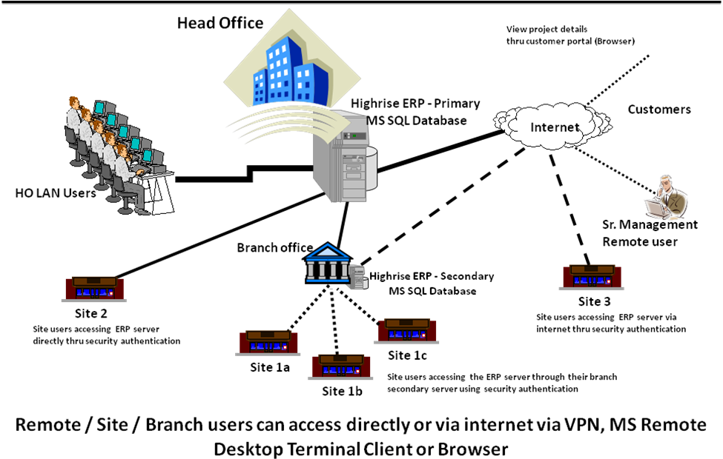

**Remote/ Site/ Branch Users can access directly or via internet via VPN, MS remote Desktop Terminal Client or Browser**

## 5.2 Flow process of Hosting - Cloud Hosted

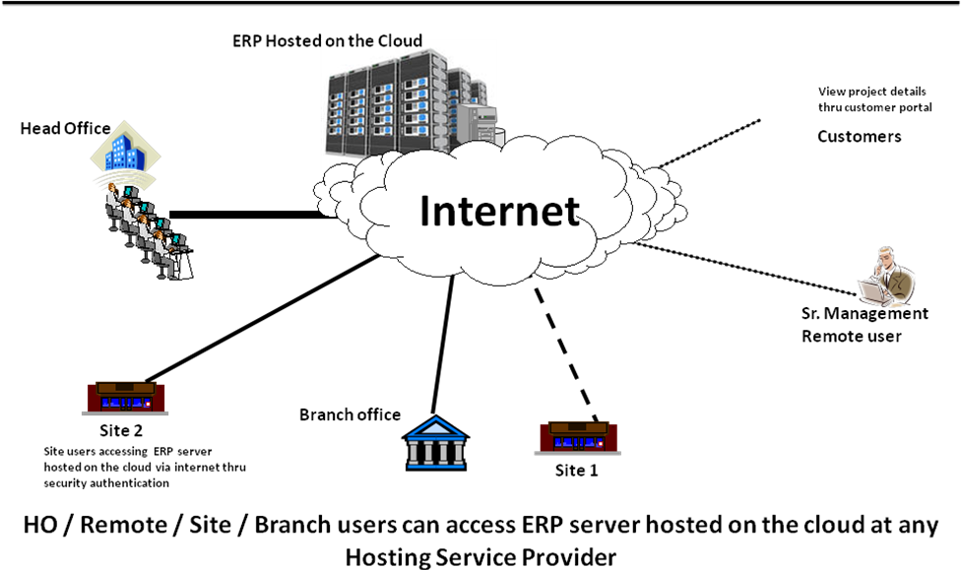

**Remote/ Site/ Branch Users can access ERP Server hosted on the cloud at Hosting Service Provider**

# 6. Add on Integrations

## 6.1 Call Centre Function in Highrise

**Technology & Background –**

The Highrise Call Centre has been designed using internet telephony. When promoting a product using multitude of Campaign and media it becomes difficult to find out the source of Information which lead to this enquiry. In absence of this information it becomes difficult to find out the ROI of various marketing campaigns that we have undertaken and we need to blindly keep on investing money on even non-product campaigns.

To resolve this Highrise call center gives a provision of having number of virtual numbers which can be separately assigned to each campaign. When a prospect calls the number (say looking at a Hoarding or a newspaper advertise), Highrise will pick the call with a prerecorded welcome message and forward the call to the configured physical number. Call routing protocols are configurable to suite the need of individual user. By doing this Highrise comes to know that the enquiry has been generated in response to which marketing campaign. This helps in calculating cost per enquiry for a given campaign by dividing the cost by number of enquiries generated. While forwarding the call Highrise also records the call for future reference and training needs.

Additionally, Highrise also has a provision to assign any number of channels behind each virtual number. This helps in handling spike load of calls and we do not miss any opportunity. To understand this better let’s assume that I have PRI Line with 30 channels and one Virtual Number which I have displayed in the newspaper. I also have five agents attending these calls. One the enquiry call comes in it is routed to these physical numbers in round robin fashion. If the physical number if busy it forwarded to the next physical number, if all the physical numbers are busy the call kept on hold with a prerecorded message saying “Your Call is important to us. All our executives are busy handling other clients. Please hold the line…..” If the prospect disconnects the phone even then you get a record of all the missed calls that you can contact thereby ensuring that you do not miss on any opportunity.

**Salient Features of Call Centre Function -**

* Provision of multiple virtual numbers
* Provision assigning multiple channels to virtual numbers
* Configurable routing protocol for forwarding calls to physical numbers.
* Call recording for incoming and outgoing calls
* Sticky agent – If the prospect calls again Highrise will know that it has data for this number and forwards the call to the same agent who had earlier attended the prospect and automatically opens the prospect case history on his screen.
* Provision for click to call to the call centre agents
* Mobile app to do the calling even on the move but still record it.
* Provision for site visit feedback
* Provision for Payment follow-up with pre-recorded messages.
* Easy way to playback the recorded messages.
* Integrated with Highrise Marketing & Sales Modules

## 6.2 Pricing for Call Centre Function-

|  |  |  |  |
| --- | --- | --- | --- |
| **Parameters** | **Unit** | **Amount (INR)** | **Payment Schedule** |
| Virtual Number with 4 Channels | Per Month | 900/- | One Time |
| PRI Line | Per Month | 8,000/- | One Time |
| Incoming Call (Leg A Only) | 60 Sec Pulse | 0.60/- | As per usage |
| Outgoing Call (Leg A & Leg B) | 60 Sec Pulse | 1.20/- | As per usage |
| Silver & Gold Premium No. | Per No | At actual | At actual |
| One Time Setup Charges | Per Installation | 35,000/- | One Time |

## 6.3 Facebook & Property Portal Integration for Highrise

Highrise can connect to Facebook using the Interio App and collect the lead geneated on Facebook & Instagram in a live environment. These leads can then be forwarded to the marketing executives as per the set “Lead Distribution Mechanism” in Highrise. The Marketing Executive will immediately get a SMS & Email upon this assignment. Above procedure will help you reach the prospect within a hour of generation of the lead thereby increasing probability of qualification.

The leads generated through other sources such as property portals & other social media also can be given a similar treatment.

## 6.4 Pricing for Facebook & Property Portal Integration-

|  |  |  |  |
| --- | --- | --- | --- |
| **Plan** | **Task per Month\*** | **Amount (INR)** | **Payment Schedule** |
| Free | 100 | NA | NA |
| Starter | 750 | 1500/- | Per Month |
| Professional | 2000 | 3500/- | Per Month |
| Team | 50000 | 21000/- | Per Month |
| Company | 100000 | 42000/- | Per Month |
| One Time Setup Charges | Per Installation | 10,000/- | One Time |

* Unused Tasks of previous month will not be carried ahead to the next month.

# 7. Implementation Methodology

**Contract**

**Signing**

**Resource Mobilization**

**Project Plan Process**

**Project Kick Start**

**60 Days Period**

**Go Live**

**Pilot Project Implementation**

**Data Cleaning**

**Masters/ Opening Balance Entry Transfer**

**Practice Assignments**

**Core User Training**

**Solution Acceptance & Sign-off**

**Process Owners Training**

**Preliminary Gap Analysis**

**Highrise**

**Installation**

**Application of Product Upgrades**

**Support & Audits**

**Project**

**Sign-off**

**Delivery Process**

# 7.1 Implementation Options

**Option 1**

**“AS IS” & “TO BE” Approach**

Mid & Small size Client Companies with first time ERP usage should adapt to this approach.

In this Approach the processes of client company are taken as “AS IS” and the processes in ERP are considered “TO BE”. The Implementation is aimed at adapting the processes in the ERP and nominal GAP Analysis is done.

This is the most recommended approach as the ERP has all the good practices & processes built-in in addition it fast & economical and has very high success ratio if industry map with the ERP is good.

Actual implementation is done by user training and making the pilot project GO-Live.

**Option 2**

**Blue Print Approach**

Large & Mid-size Client Companies should prefer this approach.

In this Approach the processes at the client are studied by the team of professional by taking user & management interviews and a business process document or sometimes called as SOP (Standard operating processes) is created. The process mapping is then done between the SOP designed for the client and the processes present in the software. This exercise is called Gap-Analysis. Identified Gaps are closed by undertaking customisation in the ERP.

Actual implementation is then done by user training and making the pilot project GO-Live.

**Option 3**

**Self-Learning & Billed Resource Approach**

Client Companies with strong IT background or companies with less complicated working environment can adapt this approach.

In this Approach the users in Client Company will be self-learning the ERP using the training videos. They can also avail the service of hiring a billed trained ERP consultant on monthly basis.

# 8 Investment for HIGHRISE

## 8.1 Investment for Highrise License – Web – Ultra Lite Suite

|  |  |  |  |  |
| --- | --- | --- | --- | --- |
| **Product Code** | **Product / Module Name** | **Quantity** | **Amount (NR)** | **Investment Amt (INR)** |
| PCACL7017 | Engineering Module | 1 | 2,00,000/- | 2,00,000/- |
| PCACL7018 | Purchase Module | 1 | 2,00,000/- | 2,00,000/- |
| PCACL7019 | Contracts Module | 1 | 2,00,000/- | 2,00,000/- |
| PCACL7020 | Site Module | 1 | 2,00,000/- | 2,00,000/- |
| PCACL7072 | Marketing Module | 0 | 2,00,000/- | NA |
| PCACL7021 | Sales Module | 0 | 2,00,000/- | NA |
| PCACL7022 | Accounts Module | 1 | 2,00,000/- | 2,00,000/- |
| PCACL7071 | Work Flow Module for approvals, alerts & notifications | 1 | 2,00,000/- | 2,00,000/- |
| PCACL8001 | HR Module | 0 | 2,00,000/- | NA |
|  | Dashboard & MIS | 1 | 2,00,000/- | Complimentary |
|  | Admin tool Module | 1 | 2,00,000/- | Complimentary |
| **Total Investment for Highrise Licenses – Web Ultra Lite Suite** | | | | **12,00,000/-** |
| **Less Discount @ 40%** | | | | **4,80,000/-** |
| **Total Investment for Highrise Licenses – Web Ultra Lite Suite [A]** | | | | **7,20,000/-** |

## 8.2 Investment for Highrise – Client Access License (Users)

|  |  |  |  |  |
| --- | --- | --- | --- | --- |
| **Product Code** | **Product / Module Name** | **Users** | **Amount (INR)** | **Investment Amt (INR)** |
| PCCLE3122 | Client Access Licenses | 5 | 25,000/- | 1,25,000/- |
| PCCLE3122 | Client Access Licenses (Buy 1 Get 1 Free + additional consideration) | 10 | 25,000/- | Complimentary |
| **Total Investment for Highrise Licenses – Web Ultra- Lite [B]** | | | | **1,25,000/-** |

## 8.3 Investment for Highrise License – Desktop Version

|  |  |  |  |  |
| --- | --- | --- | --- | --- |
| **Product Code** | **Product / Module Name** | **Quantity** | **Amount (INR)** | **Investment Amt (INR)** |
| PCSTO2023 | Plant and Machinery Management | 0 | 2,00,000/- | NA |
| PCACC3007 | AutoCAD Interface | 0 | 2,00,000/- | NA |
| PCCLS4002 | Tender Module | 0 | 2,00,000/- | NA |
| PCACC7109 | Property Management System | 0 | 2,00,000/- | NA |
| PCACC7026 | Leasing Module | 0 | 2,00,000/- | NA |
| PCACC7053 | Land & Legal Module | 0 | 2,00,000/- | NA |
|  | Tally Interface Tool | 1 | 2,00,000/- | 2,00,000/- |
| **Total Investment for Highrise Licenses – Desktop Modules** | | | | 2,00,000/- |
| **Less Discount @ 50%** | | | | 1,00,000/- |
| **Total Investment for Highrise Licenses – Desktop Modules (C)** | | | | 1,00,000/- |

## 8.4 Investment for Mobile Apps

|  |  |  |  |
| --- | --- | --- | --- |
| **Mobile App Modules** | **Quantity** | **Amount (INR)** | **Investment Amount (INR)** |
| Quality Check App | 0 | 2,00,000/- | NA |
| Site App | 0 | 2,00,000/- | NA |
| Employee (HR) App | 0 | 2,00,000/- | NA |
| Workflow App | 0 | 2,00,000/- | NA |
| **Total Investment for Mobile App [D]** | | | **NA** |

## 8.5 Investment for HIGHRSIE Portals

|  |  |  |  |  |
| --- | --- | --- | --- | --- |
| **Product Code** | **Product / Module Name** | **Quantity** | **Amount (INR)** | **Investment Amount (INR)** |
| PCACC8051 | Supplier Portal | 0 | 3,00,000/- | NA |
| PCACC8052 | Employee Portal | 0 | 3,00,000/- | NA |
| PCACC8053 | Customer Portal | 0 | 3,00,000/- | NA |
| **Total Investment for HIGHRISE Portals (E)** | | | | **NA** |

## 8.6 Investment for Professional Services

|  |  |  |  |
| --- | --- | --- | --- |
| **Professional Services** | **Requirement** | **Amount (INR)** | **Investment Amount (INR)** |
| “AS IS” “TO BE” Approach  Implementation Charges | Classroom Trainings, Practice Assignments, Existing project Go-Live (Project Management.) | 2,50,000/- | 2,00,000/-  (Discounted) |
| On-site Highrise Consultant  (*Minimum three month contract required) |  | 85,000/-  Per Month | NA/- |
| Online full time Highrise Consultant  (*Minimum two months contract required) |  | 65,000/-  Per Month | NA/- |
| **Total Investment for Professional Services [F]** | | | **2,00,000/-** |

## 8.7 Hosting on Kanix Cloud

|  |  |  |  |
| --- | --- | --- | --- |
| **Cloud Hosting – Kanix Cloud** | **Unit** | **Amount (INR)** | **Investment Amount (INR)** |
| Hosting on Licences on co-located Server of Kanix | Annual | 3,60,000/- | NA |
| Hosting on Licences on co-located Server of Kanix | Monthly | 45,000/- | NA |
| One-time Setup Charges | One-time | 50,000/- | NA |
| **Total Investment for Kanix Cloud Hosting [G]** | | | **NA** |

## 8.8 Total Investment for HIGRISE

|  |  |
| --- | --- |
| **Total Investment** | **Investment Amount (INR)** |
| Total Investment for Highrise Licenses – Web Ultra Lite Suite [A] | 7,20,000/- |
| Total Investment for Highrise Licenses – Client Access Licenses[B] | 1,25,000/- |
| Total Investment for Highrise Licenses – Desktop Modules [C] | 1,00,000/- |
| Total Investment for Highrise Licenses – Mobile Apps [D] | NA |
| Investment for HIGHRSIE Portals [E] | NA |
| Total Investment for Professional Services [F] | 2,00,000/- |
| Total Investment for Kanix Cloud Hosting [G] | NA |
| **Total Investment on HIGHRISE Web Ultra Lite Suite** | **11,45,000/-** |
| **Additional Bargaining Discount** | **75,000/-** |
| **Net Total Investment on HIGHRISE Web Ultra Lite Suite** | **10,70,000/-** |

## 8.9 Payment Schedule

|  |  |
| --- | --- |
| **Payment Schedule** | **Percentage** |
| Along with Purchase Order | 60% |
| At the time of Installation of the base product | 20% |
| 45 days after the date of Installation of the base product | 20% |

## 

## 8.10 Annual Maintenance Charges

|  |  |  |
| --- | --- | --- |
| **Service Name** | **Charges** | **Description** |
| Annual Maintenance Charges | 20% | Telephonic & Web support, online Refresh Training and Online Audits, Statuary Updates + Functional Updates |
| *Above AMC charges of 20% are applicable from second year onwards | | |

## 8.11 Terms and Conditions

1. Supplied Product shall be covered under warranty against programming bugs and non-Compliance with the specifications for a period of one year from date of Installation of the base Product.
2. DATA PORTING: The data that can be mapped can be ported to HIGHRISE ERP at extra cost. The cost of data porting can be correctly estimated only after the data analysis is done by the Kanix Technical Team.
3. Product Updates & Support is Included in the price for the first year from date of Installation of base product.
4. Taxes Extra as applicable. Currently 18% GST will be applicable under SAC Code 997331
5. Client is expected to have IT Infrastructure ready in place before start of Implementation
6. Costs of hardware & infrastructure software licenses are not included; Requirements are MS WIN OS, MS SQL Standard, and Crystal Report Server License.
7. Implementation will be the joint responsibility of Kanix team & team of Client
8. For SMS Alerts client has to purchase the Transactional SMS packs based on their requirement. Package range from 20 Thousand to 1 Lakh SMS messages at 20 paisa per SMS message.
9. All required customization will be charged extra.
10. Temporary Licenses shall be issued upon receipt of Purchase Order and Initial Payment with a validity of 90 days. Permanent shall be issued upon receipt of complete license fees.
11. This order nullifies and supersedes all and every other oral and written agreements or commitments of any nature that the parties may have reached prior to the date of this order and shall be final & binding to all in all respect.
12. All costs such as Lodging, Food, Daily allowance, Domestic Travel of Onsite Highrise consultant shall be extra.
13. The offered product mix includes only those modules for which either their respective price has been considered or they’re offered ‘complimentary’ in the pricing tables. Any other modules/ apps/ portals (Mentioned NA) are not part of this contract and the client will need to buy them separately in case they wish to in the future.
14. For AutoCAD and Tally Interface Tools, Kanix team will inform the customer separately about the Version Compatibility of these tools to be able to integrate with HIGHRISE ERP.

# 9. Infrastructure & Hardware Requirement

## 9.1 IT Infrastructure Requirement Specification

|  |  |
| --- | --- |
| **Highrise ERP hosted on Campus -Dedicated server with specification (incl. Microsoft licenses) as indicated** | |
| Server Speed | Quad / Octa Core CPU 2.8 G Hz. & above, Intel Processor Server |
| RAM | 64 GB with scalability option - (more users would mean to increase the RAM) |
| Hard Disk | 1 TB with scalability option |
| OS | Microsoft Win server 2012 & above (either 32 or 64 bit) licenses |
| Database | Microsoft SQL - Standard 2012 & above licenses |
| IIS | Internet Information Services |

## 

## 9.2 Hardware specification and Internet connectivity requirement at the users end

* Any machine or laptop running: Windows XP, Win 7, Win 10 OS, Android, IOS with browser (Home edition OS will not be supported for desktop modules.)
* All the users should have good access to the ERP server hosted on campus or cloud thru a dedicated good bandwidth internet line

**DISCLAIMER**

The information contained in this document is for guidance only and does not bind to be legal advice. It is provided on the understanding that Kanix Infotech Pvt. Ltd. is not responsible for the results of any actions taken on the basis of information in this document, nor for any errors or omissions. Kanix Infotech Pvt. Ltd. expressly disclaims all and any liability to any person in respect of anything and of the consequences of anything done or omitted to be done by any person in reliance, whether wholly or in part upon the contents of this document.

All rights reserved. No part of this publication may be reproduced or utilized, stored in a retrieval system, or transmitted in any form or by any means, electronic, mechanical, photocopying, recording or otherwise, without the prior permission of Kanix Infotech Pvt. Ltd.

**STATEMENT OF UNDERSTANDING**  Between

**Amarbhaw Power- Rajasthan**

and

**Kanix Infotech Pvt. Ltd.- Pune**

This proposal has been prepared in accordance with Kanix’s understanding of as per the given requirements by you. All information contained in this proposal represents Kanix’s best estimates. However, since the actual results in your particular operations may vary from those indicated in the proposal due to variations in software programs, volume environment, personnel, and other factors, the final determination that the proposed products and services meet your requirements must be yours.

This proposal contains confidential information of Kanix Infotech Pvt. Ltd. In consideration of receipt of this response document, you agree not to reproduce or make this information available in any manner to persons outside the group directly responsible for the evaluation of its contents, except as is required by applicable public access regulations or law.

*We are keen to partner with your esteemed organization and look forward to a long term mutually beneficial engagement as your preferred technology partner.*

**---------------------------- End of the Document --------------------------------**