

**- A Commercial Proposal for -**

**Highrise – Web Lite Suite**

*Submitted to*

**“Sagar Developers”**

**Mumbai**

Kind Attention: **Mr Azban Qureshi**

Contact No: +91 9987852928; e-mail: [sagardevelopers003@gmail.com](mailto:sagardevelopers003@gmail.com)

Date of Submission: **3rd Mar, 2022**

Valid Till: **19th Mar,** **2022**

Reference No: **SH/MUM/2021-2022/2493/V1**

Prepared by: **Anand Korade**

[**anand.korade@kanix.com**](mailto:nilesh.deshpande@kanix.com)

**THIS IS A CONFIDENTIAL DOCUMENT**

In consideration of you receiving a copy of this document, you agree to keep confidentiality on the contents of this document and shall not, without the prior written approval of Kanix Infotech Pvt. Ltd., disclose to any person the whole or any part of the information contained in, or associated with this document.

Kanix Infotech Private Limited. All rights reserved. **‘**Private & confidential.’

**Table of Content**

1. Company Profile 3

2. Scope of the Proposal 4

3. Product Details - Highrise 5

3.1 Product Introduction 5

3.2 Why Highrise? 5

4 Product Functionalities in detail 6

5. Flow Process for Hosting 6

5.1 Flow process for Hosting - On Campus 6

5.2 Flow process of Hosting - Cloud Hosted 7

7. Implementation Methodology 7

7.1 Implementation Options 8

8 Investment for HIGHRISE 9

8.1 Investment for Highrise License – Web Lite Suite 9

8.2 Investment for Highrise – Client Access License (Users) 9

8.3 Investment for Highrise License – Desktop Version 9

8.4 Investment for Mobile Apps 9

8.3 Investment for Professional Services 10

8.4 Total Investment for HIGRISE 10

8.5 Payment Schedule 10

8.6 Annual Maintenance Charges 10

8.7 Terms and Conditions 11

9. Infrastructure & Hardware Requirement 12

9.1 IT Infrastructure Requirement Specification 12

9.2 Hardware specification and Internet connectivity requirement at the users end 12

# 1. Company Profile

**Kanix** is a fast growing software product development and marketing company with focus on Construction Industry Vertical. Kanix's product line for Construction Business successfully integrates high-end e-commerce and ERP for large, mid-sized and small businesses. Thousands of Construction Houses worldwide are adding value to their businesses using state-of-art software products of Kanix. We possess very strong domain knowledge in Construction Industry and we are pioneer in business-process-reengineering (BPR) and management consultancy.

Kanix was formed in 1998 as Custom Software Development Company by its four Directors. In year 2001 the company took a courageous decision and capped its 32 different product and decided focus and specializes in Construction Industry vertical. After about four years of difficult time the flag ship product of Company Highrise – India’s First Construction ERP Software started showing results of the efforts put in. Today Highrise is the market leader in its segment.

Kanix has its head office and development center in Pune and has branch offices in Mumbai, Delhi, Kolkata, Chennai, Bangalore and Ahmedabad. Kanix has 120 channel partners who help promote Kanix products & help in Implementation & Support.

The Seven ATC (Authorized Training Centers) of Kanix teaches students usage of Kanix products and offer them placement. Due to these ATC’s and huge installation base trained manpower to use Kanix products is amply available.

Kanix has also strong bench strength of consultants who are trained in using Kanix Products and are available on Billing to its clients.

**With the experience of 22+ years in ERP Development** & Implementation Kanix realized that in addition to having a good product it is equally important to have proper implementation. Kanix invented innovative means of ERP implementation and now have grown in confidence to offer its Highrise ERP with “IMPLEMENTATION GAURANTEE” making it the first software company to it.

# 2. Scope of the Proposal

This proposal includes product features, solution & pricing for:

1) **Highrise License –Web Lite Suite**

# 3. Product Details - Highrise

## 3.1 Product Introduction

Highrise is India’s first Construction ERP; a specialized Internet Ready software solution popularly known as ERP for Construction, Contracting & Real Estate industries. In simple words an ERP is the integrated software solution encompassing all the functional departments of the enterprise. Highrise consists of integrated functions of Accounts & Finance management, Sales, Marketing & CRM Management, Project Estimation, Planning, & Project Management, Purchase, Store & Inventory Control, Labour Contract Management, Human Resource Management, Quality Control, Lease & Mall Management, Tender & Billing Management and Fixed Asset Management. All the above functions share common data thus makes the organization homogenous.

Kanix has invested 17 long years in developing proprietary business process by doing R & D and inculcating all best practices in the software. Highrise enjoys installation base in excess of 2500 spread across India and abroad. The success of Highrise as a product can be gauged from the fact that a number of engineering colleges are teaching Highrise in their curriculum.

With the induction of RERA and GST by Government of India automation in one way has become mandatory for Construction Industry. Highrise fits best between your manual process and proposed Automation. Being a home grown product it caters to practical difficulties faced by the Industry in automation. The Implementation of Highrise is completed in 90 days with a very smooth transit.

Kanix very soon will be GSP/ASP for the GST related operation. Currently GST integration with GST Portal is handled using third party service providers.

Technology is changing at a very fast pace in today’s era. Kanix has kept itself abreast with the pace of technology. Highrise which initially was developed as a client server application is ported on latest .Net Platform with MVC. Mobile Apps are developed for relevant functions like site operations, Customer interface, Approvals. Functions such as Cloud Telephony and call center are built-in to Highrise. Soon we are launching VTC (Vehicle Tracking System) in Highrise.

In technical or software term UI/UX is getting importance these days. Software Companies are doing investments on UI/UX. UI stands for User Interface and UX stands for User Experience in using the software. Kanix has a dedicated team looking after these aspects.

Once we talk about technology user would want to use software from any OS and any Device. Keep this in consideration Highrise Architecture is designed in such a way that it works on any OS like Windows. IOS, Android and supports devices like Laptop, Tablets and smart phones in a responsive nature.

## 3.2 Why Highrise?

* Serving construction industry since 1997.
* Matured product - Ready to use ERP (Since 14 years)
* Successful Installation across India.
* Secured, Scalable, Flexible & Easy to use
* Strong domain knowledge in construction
* Assuring implementation in 3 months
* Built in industry standard business processes / practices
* Configurable alerts, workflows - Management checks & Damage Control
* Data Security & Confidentiality
* Multi level security – Role Based Access Control (RBAC)
* Real time data availability
* Centralized repository - Knowledge bank - Any time Any Where access via Internet

# 4 Product Functionalities in detail

|  |  |
| --- | --- |
| **Product Module Name** | **Detail Product Functionalities** |
| **Engineering Module [PCACC7017]** | Budgeting, Estimation, Estimate Versioning, Planning, Project Management, RERA, Document & Drawing Management |
| **Purchase Module [PCACC7018]** | Supplier registration, Material Requisitions, Enquiry, Quotation, Quotation Comparative, Rate Management, Purchase Order, Purchase Bills, Taxation, Posting to Accounts |
| **Contracts Module [PCACC7019]** | Contractor Registration, Labour Rates, Work Order & Revisions, RA Bills, Taxation, Advances, Debit / Credit Notes Posting to Accounts |
| **Site Module  [PCACC7020]** | Material Requisitions, Material GRN, Material Issue, Inventory Control, Material Transfers, Work Completions, Quality Checks, Departmental Labour |
| **Marketing**  **[PCACC7072]** | Marketing Budgeting, Campaign Management, Lead generation & Tracking, Follow-ups, Site visits, Digital Marketing, Call Centre Functions |
| **Sales**  **[PCACC7021]** | Sale unit Definitions, Sale Booking, Payment Schedule, Extra Work, Other Charges, Demand & Reminder Letters, Payment Receipts, Interest Calculations, Bank NOC, Agreement Printing, Broker Management, Possessions, Transfers & Cancellations, Taxation, Posting to Accounts |
| **Accounts**  **[PCACC7022]** | Double Entry Bookkeeping, BS. PL, TB, Cash-flow, Branch & Division, Cost Centre, Schedule II BS, Multi-Company Consolidation, Depreciation, Interest Calculation, Integrated to all other Modules, VAT, Service Tax, WCT, GST till portal Integration |
| **Work Flow [PCACC7071]** | Configurable work flow, multilevel document & item approvals, SLA & Alerts |
| **Dashboard & MIS** | MIS Reports & User Configurable Dashboard |
| **Admin tool** | User, Security & General Administration of Highrise |

# 5. Flow Process for Hosting

## 5.1 Flow process for Hosting - On Campus

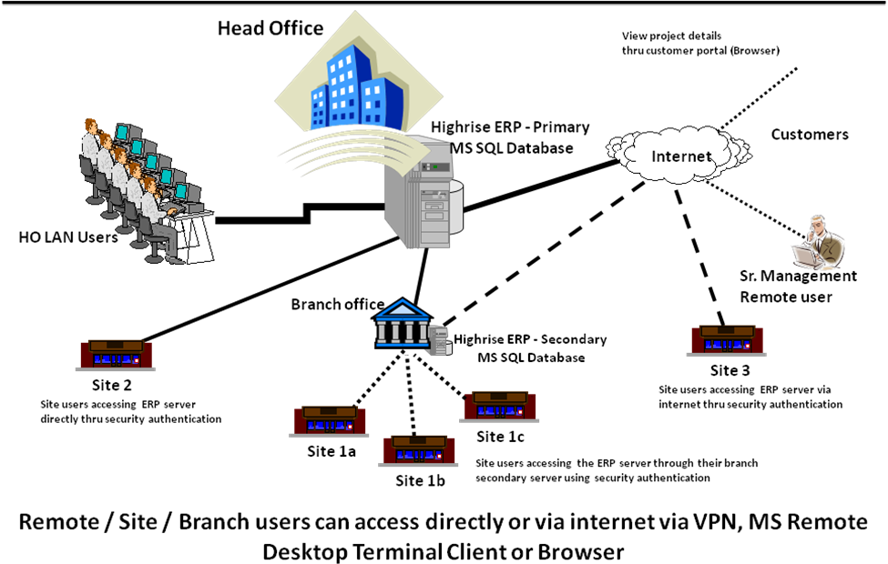

**Remote/ Site/ Branch Users can access directly or via internet via VPN, MS remote Desktop Terminal Client or Browser**

## 5.2 Flow process of Hosting - Cloud Hosted

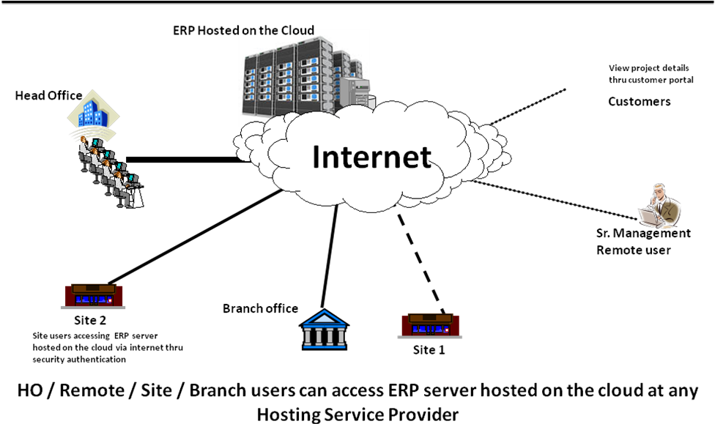

**Remote/ Site/ Branch Users can access ERP Server hosted on the cloud at Hosting Service Provider**

# 7. Implementation Methodology

**Process Owners Training**

**Preliminary Gap Analysis**

**Support & Audits**

**Project**

**Sign-off**

**Project Kick Start**

**Contract**

**Signing**

**Resource Mobilization**

**Project Plan Process**

**60 Days Period**

**Delivery Process**

**Application of Product Upgrades**

**Go Live**

**Pilot Project Implementation**

**Data Cleaning**

**Masters/ Opening Balance Entry Transfer**

**Practice Assignments**

**Core User Training**

**Solution Acceptance & Sign-off**

**Highrise**

**Installation**

# 7.1 Implementation Options

**Option 1**

**“AS IS” & “TO BE” Approach**

Mid & Small size Client Companies with first time ERP usage should adapt to this approach.

In this Approach the processes of client company are taken as “AS IS” and the processes in ERP are considered “TO BE”. The Implementation is aimed at adapting the processes in the ERP and nominal GAP Analysis is done.

This is the most recommended approach as the ERP has all the good practices & processes built-in in addition it fast & economical and has very high success ratio if industry map with the ERP is good.

Actual implementation is done by user training and making the pilot project GO-Live.

**Option 2**

**Blue Print Approach**

Large & Mid-size Client Companies should prefer this approach.

In this Approach the processes at the client are studied by the team of professional by taking user & management interviews and a business process document or sometimes called as SOP (Standard operating processes) is created. The process mapping is then done between the SOP designed for the client and the processes present in the software. This exercise is called Gap-Analysis. Identified Gaps are closed by undertaking customisation in the ERP.

Actual implementation is then done by user training and making the pilot project GO-Live.

**Option 3**

**Self-Learning & Billed Resource Approach**

Client Companies with strong IT background or companies with less complicated working environment can adapt this approach.

In this Approach the users in Client Company will be self-learning the ERP using the training videos. They can also avail the service of hiring a billed trained ERP consultant on monthly basis.

# 8 Investment for HIGHRISE

## 8.1 Investment for Highrise License – Web Lite Suite

|  |  |  |  |  |
| --- | --- | --- | --- | --- |
| **Product Code** | **Product / Module Name** | **Quantity** | **Amount (NR)** | **Investment Amt (INR)** |
| PCACL7017 | Engineering Module | 1 | 2,50,000/- | 2,50,000/- |
| PCACL7018 | Purchase Module | 1 | 2,50,000/- | 2,50,000/- |
| PCACL7019 | Contracts Module | 1 | 2,50,000/- | 2,50,000/- |
| PCACL7020 | Site Module | 1 | 2,50,000/- | 2,50,000/- |
| PCACL7072 | Marketing Module | 1 | 2,50,000/- | 2,50,000/- |
| PCACL7021 | Sales Module | 1 | 2,50,000/- | 2,50,000/- |
| PCACL7022 | Accounts Module | 1 | 2,50,000/- | 2,50,000/- |
| PCACL7071 | Work Flow Module for approvals, alerts & notifications | 1 | 2,50,000/- | Complimentary |
|  | Dashboard | 1 | 2,50,000/- | Complimentary |
|  | Admin tool Module | 1 | 2,50,000/- | Complimentary |
| **Total Investment for Highrise Licenses – Web Lite Suite** | | | | **17,50,000/-** |
| **Less Discount @ 20%** | | | | **3,50,000/-** |
| **Total Investment for Highrise Licenses – Web Lite Suite [A]** | | | | **14,00,000/-** |

## 8.2 Investment for Highrise – Client Access License (Users)

|  |  |  |  |  |
| --- | --- | --- | --- | --- |
| **Product Code** | **Product / Module Name** | **Users** | **Amount (INR)** | **Investment Amt (INR)** |
| PCCLE3122 | Client Access Licenses | 14 | 40,000/- | Complimentary |
| PCCLE3122 | Client Access Licenses | 0 | 40,000/- | NA |
| **Total Investment for Highrise Licenses – Web Lite** | | | | NA |
| **Total Investment for Highrise Licenses – Web Lite [B]** | | | | **NA** |

## 8.3 Investment for Highrise License – Desktop Version

|  |  |  |  |  |
| --- | --- | --- | --- | --- |
| **Product Code** | **Product / Module Name** | **Quantity** | **Amount (INR)** | **Investment Amt (INR)** |
| PCACC3007 | AutoCAD Interface | 0 | 2,50,000/- | NA |
| **Total Investment for Highrise Licenses – Desktop Modules** | | | | NA |

## 

## 8.4 Investment for Mobile Apps

|  |  |  |  |
| --- | --- | --- | --- |
| **Mobile App Modules** | **Quantity** | **Amount (INR)** | **Investment Amount (INR)** |
| Quality Check App | 0 | 2,50,000/- | NA |
| Site App | 0 | 2,50,000/- | NA |
| **Total Investment for Mobile App [D]** | | | NA |

## 8.3 Investment for Professional Services

|  |  |  |  |
| --- | --- | --- | --- |
| **Professional Services** | **Requirement** | **Amount (INR)** | **Investment Amount (INR)** |
| “AS IS” “TO BE” Approach  Implementation Charges (150 Hrs) [ONLINE + OFFLINE] | Online training, Practice Sessions, & Project Go Live | 2,50,000/- + Expenses | 2,50,000/- +Expenses |
| "AS IS" "TO BE" Approach Implementation Charges (120 Hrs) Online | Classroom Trainings, Practice Assignments, Existing project Go-Live | 2,50,000/- | NA/ |
| Self-Learning & Billed Resource Approach- HIGHRISE Training Videos for 2 months + 1 Online HIGHRISE Consultant for 1 month | HIGHRISE Training videos for 2 months- INR 60,000/-  +  1 Online HIGHRISE Supervisor- INR 65,000/- | 1,00,000/- | NA |
| On-site Highrise Consultant  (*Minimum three months contract required) |  | 75,000/-  Per Month | NA/- |
| **Total Investment for Professional Services [F]** | | | **2,50,000/-** |

## 8.4 Total Investment for HIGRISE

|  |  |
| --- | --- |
| **Total Investment** | **Investment Amount (INR)** |
| Total Investment for Highrise Licenses – Web Lite Suite [A] | 14,00,000/- |
| Total Investment for Highrise Licenses – Client Access Licenses[B] | NA |
| Total Investment for Highrise Licenses – Desktop Modules [C] | NA |
| Total Investment for Highrise Licenses – Mobile Apps [D] | NA |
| Total Investment for Professional Services [F] | 2,50,000/- |
| **Net Total Investment on HIGHRISE Web Lite Suite** | **16,50,000/-** |

## 8.5 Payment Schedule

|  |  |
| --- | --- |
| **Payment Schedule** | **Percentage** |
| Along with Purchase Order | 75% |
| On Completion of Go-Live or 60 Days from date of Installation whichever is earlier | 25% |

## 

## 8.6 Annual Maintenance Charges

|  |  |  |
| --- | --- | --- |
| **Service Name** | **Charges** | **Description** |
| Annual Maintenance Charges | 20% | Telephonic & Web support, online Refresh Training and Online Audits, Statuary Updates + Functional Updates |
| *Above AMC charges of 20% are applicable from second year onwards | | |

## 

## 8.7 Terms and Conditions

1. Supplied Product shall be covered under warranty against programming bugs and non-Compliance with the specifications for a period of one year from date of Installation of the base Product.
2. DATA PORTING: The data that can be mapped can be ported to HIGHRISE ERP at extra cost. The cost of data porting can be correctly estimated only after the data analysis is done by the Kanix Technical Team.
3. Product Updates & Support is Included in the price for the first year from date of Installation of base product.
4. Taxes Extra as applicable. Currently 18% GST will be applicable under SAC Code 997331
5. Client is expected to have IT Infrastructure ready in place before start of Implementation
6. Costs of hardware & infrastructure software licenses are not included; Requirements are MS WIN OS, MS SQL Standard, and Crystal Report Server License.
7. Implementation will be the joint responsibility of Kanix team & team of Client
8. For SMS Alerts client has to purchase the Transactional SMS packs based on their requirement. Package range from 20 Thousand to 1 Lakh SMS messages at 20 paisa per SMS message.
9. All required customization will be charged extra.
10. Temporary Licenses shall be issued upon receipt of Purchase Order and Initial Payment with a validity of 90 days. Permanent shall be issued upon receipt of complete license fees.
11. This order nullifies and supersedes all and every other oral and written agreements or commitments of any nature that the parties may have reached prior to the date of this order and shall be final & binding to all in all respect.
12. All costs such as Lodging, Food, Daily allowance, Domestic Travel of Onsite Highrise consultant shall be extra.
13. The offered product mix includes only those modules for which either their respective price has been considered or they’re offered ‘complimentary’ in the pricing tables. Any other modules/ apps/ portals (Mentioned NA) are not part of this contract and the client will need to buy them separately in case they wish to in the future.
14. For AutoCAD and Tally Interface Tools, Kanix team will inform the customer separately about the Version Compatibility of these tools to be able to integrate with HIGHRISE ERP.
15. JURISDICTION: This Contract shall be governed by and construed in accordance with the laws of India. All disputes arising out of or in connection with this Work Contract shall be deemed to have arisen at Pune and only Courts in Pune shall have an exclusive jurisdiction to determine the same.

# 9. Infrastructure & Hardware Requirement

## 9.1 IT Infrastructure Requirement Specification

|  |  |
| --- | --- |
| **Highrise ERP hosted on Campus -Dedicated server with specification (incl. Microsoft licenses) as indicated** | |
| Server Speed | Quad / Octa Core CPU 2.8 G Hz. & above, Intel Processor Server |
| RAM | 64 GB with scalability option - (more users would mean to increase the RAM) |
| Hard Disk | 1 TB with scalability option |
| OS | Microsoft Win server 2012 & above (either 32 or 64 bit) licenses |
| Database | Microsoft SQL - Standard 2012 & above licenses |
| IIS | Internet Information Services |

## 

## 9.2 Hardware specification and Internet connectivity requirement at the users end

* Any machine or laptop running: Windows XP, Win 7, Win 10 OS, Android, IOS with browser (Home edition OS will not be supported for desktop modules.)
* All the users should have good access to the ERP server hosted on campus or cloud thru a dedicated good bandwidth internet line

**DISCLAIMER**

The information contained in this document is for guidance only and does not bind to be legal advice. It is provided on the understanding that Kanix Infotech Pvt. Ltd. is not responsible for the results of any actions taken on the basis of information in this document, nor for any errors or omissions. Kanix Infotech Pvt. Ltd. expressly disclaims all and any liability to any person in respect of anything and of the consequences of anything done or omitted to be done by any person in reliance, whether wholly or in part upon the contents of this document.

All rights reserved. No part of this publication may be reproduced or utilized, stored in a retrieval system, or transmitted in any form or by any means, electronic, mechanical, photocopying, recording or otherwise, without the prior permission of Kanix Infotech Pvt. Ltd.

**STATEMENT OF UNDERSTANDING**

Between

**Sagar Developers- Mumbai**

and

**Kanix Infotech Pvt. Ltd.- Pune**

This proposal has been prepared in accordance with Kanix’s understanding of as per the given requirements by you. All information contained in this proposal represents Kanix’s best estimates. However, since the actual results in your particular operations may vary from those indicated in the proposal due to variations in software programs, volume environment, personnel, and other factors, the final determination that the proposed products and services meet your requirements must be yours.

This proposal contains confidential information of Kanix Infotech Pvt. Ltd. In consideration of receipt of this response document, you agree not to reproduce or make this information available in any manner to persons outside the group directly responsible for the evaluation of its contents, except as is required by applicable public access regulations or law.

*We are keen to partner with your esteemed organization and look forward to a long term mutually beneficial engagement as your preferred technology partner.*

**---------------------------- End of the Document --------------------------------**